**SALESVISTA: E-COMMERCE PLATFORM VISUALIZING**

**SALES DATA FOR GALLERY ERGO**

A Capstone Project Presented to the Faculty of the

College of Information Technology and Computer Sciences

University of the Cordilleras

In Partial Fulfillment

of the Requirements for the Degree

BACHELOR OF SCIENCE IN INFORMATION TECHNOLOGY

by

LOVELY MAE LAOYAN CHOLIN

AISHA GARCIA RAJA

JARED RAINIER MUYANO SANTOS

May 2025

**APPROVAL SHEET**

This project study entitled SALESVISTA: ECOMMERCE PLATFORM VISUALIZING SALES DATA FOR GALLERY ERGO prepared and submitted by AISHA G. RAJA, LOVELY MAE L. CHOLIN, JARED RAINIER M. SANTOS in partial fulfillment of the requirements for the degree BACHELOR OF SCIENCE IN INFORMATION TECHNOLY, has been examined and is recommended for acceptance and approval for oral examination.

MELINDA A BENINSIG, MIT

Adviser

Project Study Committee

MELINDA A. BENINSIG, MIT ZYRA YELL A FAGYAN, BSIT

Member Member

NATIVIDAD B. CONCEPCION, DIT

Chairperson

PANEL OF EXAMINERS

APPROVED by the Committee on Oral Examination on __________________ with a grade of _____________.

NATIVIDAD B. CONCEPCION, DIT

Chairperson

MELINDA A. BENINSIG, MIT ZYRA YELL A FAGYAN, BSIT

Member Member

ACCEPTED AND APPROVED in partial fulfillment of the requirements for the degree BACHELOR OF SCIENCE IN INFORMATION TECHNOLOGY.

MELINDA A. BENINSIG,MIT JEFFREY S. INGOSAN, DIT

IT Program Chair Dean, College of

College of Information Technology Information Technology

and Computer Science and Computer Science

**ABSTRACT**

1. SALESVISTA: E-COMMERCE PLATFORM VISUALIZING SALES

DATA FOR GALLERY ERGO

* 1. Total No. of Pages: 156

1.2. Text No. of Pages: 97

1. Authors: CHOLIN, LOVELY MAE L.

RAJA, AISHA G.

SANTOS, JARED RAINIER M.

1. Type of Document: Capstone Project
2. Type of Publication: Unpublished
3. Accrediting Institution: University of the

Cordilleras Gov.

Pack Road, Baguio City, Philippines.

1. Keywords:

E-commerce platform, Local artists, Art marketplace, Intellectual property protection, Digital selling, Secure transactions, User-centered design, Kanban methodology, Art protection tools

1. Abstracts:

7.1 **Rationale/Background of the Study**

In recent years, digital platforms have transformed the way products are marketed and sold, with e-commerce becoming a vital tool for business growth and customer outreach. However, local artists, especially those offering handcrafted and customized artworks, continue to face significant challenges when attempting to sell their creations online. Generic platforms such as Shopee and Lazada are not tailored to support the unique needs of artists. These platforms often lack personalized product support, secure payment systems, and built-in tools to prevent unauthorized duplication and protect intellectual property.

Gallery ErGo, a small-scale art initiative, represents a community of artists who rely on online exposure and digital transactions to reach a broader

audience. However, without a dedicated platform, these artists remain vulnerable to unfair competition, insecure transactions, and limited visibility. Their work is often overshadowed by mass-produced items, and they lack efficient systems for commission management, order tracking, and customer engagement.

This study aims to address those gaps by designing and developing “SalesVista,” a secure and user-friendly e-commerce platform specifically tailored for local artists. It focuses on improving the overall selling experience through features such as artist profiles, art protection tools, secure checkout systems, and administrative analytics. By implementing these features, the platform not only boosts the visibility and credibility of local artists but also ensures that their artworks are protected and their transactions managed efficiently.

The development of SalesVista is guided by user-centered design principles and the Kanban methodology, allowing the researchers to iteratively gather feedback, adjust features, and create a functional and intuitive system. This platform is expected to serve as a model for future e-commerce solutions designed with the specific needs of artists in mind.

7.2 **Summary**

The main objective of this study was to design and develop a secure, artist-friendly e-commerce website called SalesVista for Gallery ErGo. This platform is intended to support local artists in selling and promoting handcrafted artwork online, addressing common challenges such as security issues, lack of customization, and intellectual property protection.

Specifically, it aimed to achieve the following objectives:

1. to identify the information requirements of the proposed system;

2. to determine the architectural framework of the proposed system;

3. to identify the features of the proposed system; and

4.to measure the extent of usability of the proposed system.

The researchers used the Kanban methodology to guide system development. This approach allowed for efficient requirement gathering, iterative design, client-based feedback, and consistent progress monitoring. Through this process, a functional prototype was developed, featuring tools such as Artist Profile and Product Listing, Secure Checkout, Admin Analytics, and Art Protection Tools. The system’s usability and impact were evaluated through feedback from Gallery ErGo and potential online customers, leading to continuous improvement and positive results.

7.3 **Findings**

The researchers came up with the following findings based on the website created and the data gathered from the objectives of the study:

1. The information requirements that are needed for

the system were credentials, artist profiles, and product listings. The user credentials include name, email, and password. The system requirements were also analyzed for it to run properly and be used on various devices.

1. The researchers used 4+1 architecture which needed

5 UML diagrams for each view which helped in the

development of the proposed system by giving the

researchers ideas on creating web applications. It

contains diagrams or views created using the Unified

Modeling Language, such as the logical view, development

view, process view, physical view, and scenario view.

1. The main features of the system include the

following: Artist Profile, Product Listing, Secure Checkout, Admin Analytics, and Art Protection Tools such as watermarking and download restrictions. The secondary features are Order Tracking, Sales Overview, and Commission Management to improve artist’s experience and functionality.

4. The researchers used the USE (Usefulness, Satisfaction, and Ease of Use) Questionnaire to assess overall system usability across four areas: Usefulness, Ease of Use, Ease of Learning, and Satisfaction. Rated on a 7-point Likert scale, the results showed a positive user experience, with an overall average score of 5.61. Both Gallery ErGo and potential users agreed the system was functional, user-friendly, and easy to learn, confirming its readiness for deployment, with minor areas for improvement noted.

7.4 **Conclusions**

Based on the results of the study, the following conclusions were drawn;

1. The Gallery ErGo website successfully meets its objectives by providing users with relevant information and a functional, accessible platform. It fulfills the content, design, and usability requirements needed by both users and administrators.

2.The study established a solid structural foundation for the website, ensuring intuitive navigation, responsive design, and proper flow of interaction between users and site features.

3.The website’s main features—including artist profiles, secure checkout, and art protection function as intended and provide a reliable and user-friendly experience for both artists and customers.

4.The system’s usability was validated through user feedback, confirming the website's effectiveness and ease of use. The integration of data analytics also supports better business decision-making and contributes to the long-term sustainability of Gallery ErGo in the digital marketplace.

* 1. **Recommendations**

Based on the conclusions of the study for the Gallery ErGo website, the following recommendations may be considered to improve the platform:

1.Future researchers may consider integrating into a more advanced inventory management system to help artists and administrators manage products and sales more efficiently.

2. Future researchers may consider implementing more robust anti-piracy tools and automatic image tracking to further safeguard the intellectual property of artists.

3.Future researchers may consider including a review system to allow customers to share feedback and experiences.

4.Future researchers may consider integrating marketing tools such as email newsletters or promotional campaigns to boost visibility and sales, especially during off-event periods.

**ACKNOWLEDGEMENT**

The researchers would like to express their sincere and utmost gratitude to those who participated in the success of this capstone project.

First and foremost, the researchers would like to thank the Lord, Almighty God, for the knowledge, opportunity, ability, and strength to complete the project.

To Ms. Melinda A. Beninsig, the teacher-in-charge of Capstone 1 and 2 and also the adviser, for her unwavering support, understanding, and patience. Her guidance from the beginning stages until the completion of the manuscript played a vital role in the development of the project.

To Ms. Zyra Yell A. Fagyan, the panel member, for her availability and patience during consultations. Her willingness to provide insights and comments helped the researchers polish and improve their system and paper.

To Dr. Natividad B. Concepcion, the chairperson of the research panel, for being readily available during consultations and for providing constructive advice that contributed to the refinement of the study.

To Ms. Marge Gomez of Gallery ErGo, for sharing the necessary information that served as the foundation for the design and content of the website. Her participation during the interview and openness to collaborate greatly

contributed to the direction and successful development of the system.

Lastly, the researchers extend their deepest gratitude to their families and friends for the unwavering support, encouragement, and motivation that carried them through this journey. Their presence and belief in the researchers made the completion of this project possible.

**L.L.C**

**A.G.R**

**J.M.S**

**DEDICATION**

This capstone project is wholeheartedly dedicated to our loving families and friends, whose unwavering support, patience, and encouragement have been our greatest source of strength throughout this journey. To our mentors and instructors who guided us with wisdom and compassion — thank you for your invaluable time and knowledge. And most of all, to the Almighty God, for granting us the courage, perseverance, and grace to complete this work — all glory and praise to Him. This accomplishment is for everyone who believed in us, even when we doubted ourselves.

**Lovely**

**Jared**

**Aisha**

**TABLE OF CONTENTS**

Page

TITLE PAGE . . . . . . . . 1

APPROVAL SHEET . . . . . . . 2

ABSTRACT . . . . . . . . . 3

ACKNOWLEDGEMENT . . . . . . . 7

DEDICATION . . . . . . . . 9

TABLE OF CONTENTS . . . . . . . 10

LIST OF FIGURES . . . . . . . . 12

LIST OF TABLES . . . . . . . . 14

CHAPTER

1. INTRODUCTION

Background of the Study . . . . 15

Importance of the Study . . . . 30

Objectives of the Study . . . . 34

Definition of Terms . . . . 34

1. METHODOLOGY

Software Development Methodology . . 39

Scope and Delimitation . . . . 48

Data Gathering Techniques . . . 49

Sources of Data . . . . . 50

Software Development Tools . . . 51

1. FINDINGS OF THE STUDY

Information Requirements of the System . 56

Architecture Frameworks of SalesVista . 61

Features of the SalesVista . . . 84

Usability Testing . . . . . 100

1. CONCLUSIONS AND RECOMMENDATIONS

Conclusions . . . . . . 111

Recommendations . . . . . 112

REFERENCES . . . . . . . . 113

APPENDICES

A Communication Letter . . . . 123

B Acceptance Letter . . . . . 124

C TBI Assessment Certification . . . 125

D USE Questionnare . . . . . 126

E Sample Result of Testing . . . . 129

F Tabular Form of the Test Result . . 131

G SalesVista User Manual for user: Customer. 133

H SalesVista User Manual for user: Admin . 139

I Documentation . . . . . . 149

J Important Codes. . . . . . 151

CURRICULUM VITAE . . . . . . . 153

**LIST OF FIGURES**

Figure No. Figure Title Page

1 Kanban Development . . . . . 40

2 Design Thinking . . . . . 46

3 Architecture View Model . . . . 63

4 SalesVista Class Diagram . . . 66

5 SalesVista Package Diagram . . . 68

6 SalesVista Deployment Diagram . . . 70

7 Activity Diagram on Standard Ordering Process 72

8 Activity Diagram on Post Order Actions . 73

9 Activity Diagram on Order Fulfillment . 75

10 Activity Diagram on Custom Commission Order 76

11 Activity Diagram on Handle Customer Commission Request . . . . . 78

12 Activity Diagram on Add/Edit Products . 80

13 Use Case Diagram . . . . . 83

14 Model-View-Controller . . . . 85

15 Dashboard Options . . . . . 86

16 Dashboard Overview . . . . . 87

17 Dashboard Category . . . . . 88

18 Dashboard Products . . . . . 89

19 Manage Products . . . . . 90

20 Manage Orders . . . . . 91

21 Downloadable Sales Table . . . . 92

22 Customer Landing Page . . . . 93

23 Shop Page . . . . . . . 94

24 Product Details . . . . . 95

25 Recommended Products . . . . 96

26 Cart . . . . . . . . 96

27 Checkout . . . . . . . 97

28 Login . . . . . . . 98

29 Checkout Form . . . . . . 99

30 Commission . . . . . . 100

31 Art Protection Feature . . . . 101

32 Slovin’s Formula . . . . . 102

**LIST OF TABLES**

Table No. Table Title Page

1 Software Requirements on Developer Side 58

2 Software Requirements on Customer Side . 59

3 Hardware Requirements on Customer Side . 61

4 Weighted Mean Description . . . 102

5 SALESVISTA Usability: Usefulness . . 103

6 SALESVISTA Usability: Ease of Use . . 105

7 SALESVISTA Usability: Ease of Learning . 107

8 SALESVISTA Usability: Satisfaction . . 108

9 Summary of Result . . . . . 109

Chapter 1

**INTRODUCTION**

**Background of the Study**

The evolution of technology has significantly transformed nearly every aspect of human life, revolutionized industries and reshaping traditional practices in profound ways. One of the notable developments has been the emergence of digital platforms, which have drastically altered how businesses operate and how consumers engage with products and services. The art world, which was traditionally dominated by physical galleries and auction houses, has experienced a considerable shift owing to the digital revolution. Historically, artists have heavily depended on intermediaries such as galleries, agents, and art dealers for showcasing their work. This reliance has led to significant constraints in their reach to potential buyers while also incurring substantial commission fees that can substantially diminish the artist’s earnings. Furthermore, buyers are often constrained by geographical boundaries, limiting their ability to access artworks beyond their local markets, which further narrows the audience for diverse artistic expressions. Many consumers remain unaware of innovative artists and unique works available outside their immediate

vicinity, resulting in a limited exposure to a variety of artistic talents. The landscape of the art market has become one of gatekeeping, raising the barrier for entry and access to potential opportunities for many creatives striving for visibility. With the rapid advancement of digital technologies, however, many barriers have begun to dissolve, allowing artists to present their work to global audiences while bypassing intermediaries. This democratization of the art market through various digital platforms has opened vital opportunities for emerging artists to gain visibility and articulate their creative narratives to a broader audience. Enhanced access facilitates the showcase of a wide array of styles and techniques, promoting greater artistic diversity in ways never before possible. Consumer engagement has also intensified, with an audience increasingly willing to explore art from different cultures and regions. Such developments not only foster cross-cultural exchanges but also enhance appreciation for diverse artistic expressions. The power dynamics between artists and consumers have shifted considerably, enabling artists to establish more direct relationships with their audiences that was previously possible. However, this transition to digital platforms also introduces fierce competitions, as a multitude of artists now vie for the attention of the same potential buyers. The landscape has rapidly evolved into a marketplace where individual creativity must contend with an overwhelming abundance of choices, which can dilute individual artist branding and obscure their uniqueness. As the art market continues to evolve, the need for artists to differentiate themselves has become paramount. Moreover, the structural changes driven by technological advancement have permanently altered the foundations upon which the art industry was built, necessitating both adaptation and innovation among artists.

The emergence of e-commerce has played a critical role in catalyzing this transformation, effectively dismantling many traditional barriers and creating a global marketplace where art can be effortlessly bought and sold. E-commerce, defined as the buying and selling of goods and services over the internet, has experienced exponential growth over the last two decades, fundamentally reshaping commerce as we know it. According to the Library of Congress (2023), the origins of e-commerce can be traced back to the early 1980s, marking the initial entry into online commerce with pioneering platforms like the Boston Computer Exchange. This groundbreaking era paved the way for monumental giants like Amazon, eBay, and many others, who have revolutionized

consumer purchasing behavior and cemented e-commerce's place in global trade. The ability for consumers to seamlessly navigate a vast array of products from the comfort of their own homes has fundamentally transformed how people shop, fostering new purchasing habits that prioritize convenience and accessibility. As e-commerce has steadily evolved, niche markets including the art industry have begun to flourish in this online context. Specialized platforms dedicated to art have proliferated, providing essential marketplaces for artists while also equipping them with the tools necessary to manage their sales and engage directly with potential buyers. This shift has created a significant transformation in consumer behavior, with a growing preference for the ease and convenience that online shopping affords. As more consumers embrace digital purchasing habits, businesses that are slow to adopt these new strategies run the risk of losing considerable market share to their more digitally savvy competitors. In fact, a comprehensive report by the McKinsey Global Institute (2021) emphasizes the urgency for businesses of all sizes to pivot towards e-commerce as means of surviving on the era of digital transformation. The report illustrates how companies that fail to adapt find themselves outperformed by competitors leveraging digital tools with greater efficacy and efficiency. As a result, e-commerce's trajectory has proven to be integral in shaping consumer expectations and business practices alike, thereby laying the groundwork for expansive transformation across large industries. The interplay of technology and commerce is evident in how consumers interact with products, leading to a more dynamic and competitive marketplace. This ongoing digital evolution highlights how critical it is for businesses to remain agile and responsive to changing consumer behaviors and preferences.

Small businesses, often known as the backbone of many economies, contribute significantly to job creation and community development. However, they face numerous challenges in the contemporary business landscape, especially as digital technology and online platforms have become critical components of commerce in recent years. While the global rise of e-commerce has created tremendous opportunities for businesses of all sizes to engage with broader audiences, small enterprises particularly those embedded in creative sectors, encounter significant barriers that often impede their ability to capitalize on these opportunities. Transitioning to online platforms is frequently hampered by lack of essential resources, technical expertise, and scalable solutions for many small

business owners. A report by Gelder (2024) highlights that a considerable number of small businesses struggle to secure the resources or expertise to construct a compelling online presence that aligns with contemporary standards. This vulnerability leads to an uneven playing field, where larger competitors benefit from greater access to capital and advanced technological infrastructure. The challenges small businesses face in managing critical aspects of successful e-commerce operation are multifaceted; they include website development, effective digital marketing strategies, and logistical challenges that accompany the logistics of online retail. Furthermore, maintaining a robust digital presence necessitates continuous updates, effective marketing techniques, security management, and customer support-all tasks that can overwhelm small business owners who often juggle multiple roles. Many of these owners lack dedicated staff or the financial flexibility required to outsource these critical functions. Research indicates that insufficient technical knowledge and resources can lead to missed opportunities for visibility and engagement with potential customers (Bennett & Keating, 2020). This dynamic creates an uphill struggle for small arts and crafts enterprises, which may not have the same access to networks, funding, or mentorship that their larger counterparts enjoy. As a result, small businesses in the arts sector often find themselves navigating a competitive landscape that limits their potential for growth and innovation. Without adequate avenues for support and exploration of digital tools, many small enterprises risk stagnation, unable to evolve their practices to better align with market demands. Such limitations are particularly detrimental in an increasingly digital world, where adaptability is paramount. The intricate relationship between technology and small businesses underscores the urgency for meaningful interventions that can empower these organizations in a rapidly changing marketplace. Fostering an ecosystem that nurtures small businesses will not only enhance their chances of survival but also promote a more diverse and competitive economic landscape.

Amid these challenges, arts and crafts businesses encounter uniquely specialized obstacles, including limited visibility, heightened susceptibility to intellectual property violations, and the formidable task of balancing creative artistry with the practicalities of entrepreneurship. A comprehensive study by Wagner (2020) consistently highlights the transformative potential of e-commerce for artists and craftspeople, emphasizing its

ability to cultivate direct connections with global buyers. These connections enhance financial sustainability for creative practitioners, enabling them to engage meaningfully with a worldwide audience eager for unique expressions of art. However, the benefits of digital platforms do not come without caution; without tailored solutions that specifically address their diverse and varied needs, many of these businesses struggle to achieve the scalability and profitability necessary for long-term success. Unlike traditional mass-market products, artworks and handcrafted items demand specialized platforms capable of accommodating detailed presentations of the creative process, authenticity of materials used, and the personal narrative that accompany each artist’s work. Many generic e-commerce platforms inadequately appreciate these qualities, often treating artistic offerings as mere retail products, ultimately diminishing their perceived worth. Research conducted by Barr and Dibbs (2023) indicates that existing mass-market e-commerce platforms frequently fail to recognize the inherent value of art, resulting in reduced earnings for artists striving for recognition. Especially within the arts and crafts sector, sales typically occur as low-volume but high-value transactions, requiring a platform that accommodates customized orders,

exclusive commissions, and facilitates direct interactions between artists and potential customers. The absence pf specialized e-commerce solutions force many artists to rely heavily on physical sales channels, which become limited due to geographical restrictions and infrequent opportunities tied to art fairs and exhibitions. For artists, the ability to navigate these complexities is essential, as the quest for sustainable online marketplaces becomes increasingly urgent. In this context, the development of platforms specifically catering to unique artistic needs has the potential to bridge gaps and create meaningful connections. The demand for unique and exceptional artworks highlights an essential opportunity for platforms that can cater to these emerging needs, thus cultivating an enriching ecosystem for creators and consumers alike. The online art market is ripe for innovation, demanding fresh models that prioritize fairness, transparency, and creative integrity. As a result, understanding and addressing these dynamics will be crucial in fostering a more equitable and thriving digital art marketplace that benefits both artists and buyers alike.

Gallery ErGo, a small business specializing in local arts and crafts, emerges as an essential player in

addressing the pressing need for innovation within the evolving landscape of digital art sales. By assisting artists in transforming their creative endeavors into sustainable income streams, Galler ErGo seeks to empower the local arts community and elevate the profiles of local creatives. However, the shop’s reliance on physical exhibitions, combined with the absence of a dedicated e-commerce platform, significantly limits its capacity to generate consistent sales opportunities. The business has frequently experienced marked drops in sales during periods when exhibitions are sparse, as customer interaction necessitates in-person attendance. In a rapidly digitizing world, such dependence on traditional sales methods can be considerable liability, leaving artists vulnerable to fluctuations in foot traffic buyer engagement. Additionally, limited online presence often results in extended periods lacking sales-sometimes stretching over entire months-highlighting the urgency for a more proactive approach to online marketing. The hesitance to utilize existing platforms like Shopee or Lazada stems from the stringent operational limitations imposed by these marketplaces, such as mandatory delivery quotas that, if unmet, can lead to penalties for sellers. Such restrictive conditions can worsen the necessity for a tailored e-

commerce solution that is adaptable to the unique requirements of artists without imposing rigid constraints that stifle creativity. A validated report by OECD (2021) indicates that small businesses lacking robust online platforms consistently struggle to maintain steady sales, particularly those heavily reliant on physical venues for revenue generation. Therefore, Gallery ErGo must confront significant challenges, underscoring the urgent need for an online model specifically designed to accommodate the nuanced dynamics of the arts sector. By recognizing and tackling these unique challenges, Gallery ErGo aspires to carve out a niche that actively supports local artists while ensuring their lasting financial sustainability. Furthermore, creating a platform where artists can engage with their audience enables deeper connections and foster community engagement relating to the arts. This focuses on community-building positions Gallery ErGo not just as a marketplace but as a dynamic hub for culture and creativity, where local artistic expression can flourish. The potential to integrate community perspectives and feedback into the platform will also enrich the overall user experience. By accommodating the diverse needs of artistic, Gallery ErGo endeavors to cultivate an

environment where creativity meets commerce in a meaningful and impactful way.

To address these multifaceted challenges, SalesVista is an e-commerce platform developed for Gallery ErGo that combines comprehensive customer shopping capabilities with advanced administrative management. The platform consists of two integrated websites: a customer-facing online shop where buyers can browse, purchase, track orders, and commission custom artworks, and an admin website that enables the artist/s to manage their business operations effectively. SalesVista incorporates enhanced security features that effectively protect artists' intellectual property and originality through watermarking artworks and disabling download options, safeguarding the integrity of original pieces while ensuring a secure browsing experience for customers. The platform's distinguishing feature lies in its integrated data analytics dashboard, which provides artists with comprehensive sales insights including performance trends, best-selling products, category comparisons, and customer location analysis. These analytical tools enable artists to make informed and strategic business decisions, providing them with necessary data to adapt their offerings based on market trends and customer feedback, resulting in continuous growth and improvement. This proactive approach ensures that artists are not merely passive sellers; instead, they become active participants in shaping their sales trajectory. The platform enhances the overall user experience by promoting clarity and transparency in the sales process, thus building consumer trust. This trust is essential for sustaining long-term relationships between artists and customers, contributing to an enriched cultural discourse surrounding local art. Building a community around local arts and crafts becomes not just a feature of the platform but its defining character, distinguishing it from traditional e-commerce solutions that may overlook such relational dynamics. As SalesVista works to create a vibrant and supportive online community specifically for Gallery ErGo, it builds bridges not only for transactions but also for cultural dialogue that celebrates the unique artistic narratives of its participants. This initiative facilitates a transformative shift in how art is perceived, marketed, and consumed in the digital age, reinforcing the importance of local artistry. By prioritizing the needs of creators and cultivating a respectful and engaging marketplace, SalesVista makes meaningful contributions to the broader landscape of digital art commerce, thereby enhancing the cultural fabric and economic vitality of the community.

In reviewing the complexities surrounding the integration of digital platforms into the art market, it becomes evident that artists and small businesses face a dual-edged sword of opportunity and challenge. The rise of e-commerce has opened expansive horizons for visibility, connecting creatives with audiences in ways that were previously unimaginable. However, the saturation of the digital marketplace has also created intense competition, causing many artists to struggle in differentiating their unique offerings amidst a backdrop of mass-produced products. This tension highlights the pressing need for innovative solutions tailored specifically to the needs of artists, enabling them to navigate the complexities of the online landscape effectively. Platforms like Gallery ErGo represent essential steps in addressing these challenges, fostering a supportive community where local artistry can thrive alongside technological advancement. By prioritizing direct engagement between artists and consumers, the platform not only enhances sales opportunities but also fosters meaningful connections that promote appreciation for local arts. Moreover, implementing security measures to protect intellectual property reflects a

commitment to safeguarding the creative work that forms the foundation of the arts community. The focus on user-friendly administrative tools is equally crucial, as it empowers artists with the insights necessary for informed decision-making in their business practices. This empowerment is essential in ensuring that artists can navigate the evolving dynamics of the market, adapt their offerings, and foster sustainability. Additionally, cultivation a space for cultural discourse around local art promotes an enriching environment that benefits both creators and consumers. By redefining how art is perceived, marketed, and consumed, platforms such as Gallery ErGo can catalyze a transformative shift in the digital landscape of the arts. Ultimately, the future of the art market, particularly considering ongoing technological advancement, will necessitate ongoing dialogue and collaboration within the community. As new trends and tools emerge, understanding and embracing these changes will be pivotal in shaping the economic viability of artists and small businesses alike. The goal is not merely to adapt but to thrive in a globalized economy where art retains its unique cultural value amidst overwhelming commercial pressures. Thus, the interplay between tradition and innovation must be carefully balanced to cultivate a vibrant artistic

ecosystem. This vision underpins the commitment of Gallery ErGo to creating a marketplace that respects the integrity of local artists while fostering growth. It also serves as a reminder of the critical role that supportive infrastructures play in nurturing artistic talent and promoting cultural appreciation. As the dialogue around digital transformation art continues, ongoing research and exploration will be necessary to understand better the implications for artists and small enterprises. A concerted effort to innovate and adapt will enable the arts community to rise to the challenges of this dynamic landscape. Hence, the responsibility lies not only with individual artists but also platforms to create environments where creativity can flourish and be celebrated. Together, these efforts will contribute to a more equitable art market, ensuring that diverse voices and visions are amplified in an increasingly digital world. The journey ahead is undoubtedly complex, but the potential for a transformative impact on both local communities and the global artistic dialogue is immense, driving the pursuit of sustainable practices in the arts for generations to come.

**Importance of the Study**

The researchers believed that this study was significant for the following:

To Gallery Ergo and Small Businesses. This study shall particularly beneficial for Gallery ErGo and similar small businesses, which often face challenges in navigating the complex landscape of online commerce. By providing a comprehensive and user-friendly online platform, this research offers these businesses an accessible and convenient way to showcase and sell their products to a global audience. The transition to a digital marketplace not only enhances visibility but also serves to cultivate a more stable and consistent revenue stream. Moreover, the integration of sales analytics within the platform stands out as a critical advantage. By tracking customer behavior-such as purchasing patterns and preferences-Gallery ErGo will be equipped to tailor its marketing strategies effectively. This data-driven approach enables small businesses to make informed decisions on inventory management, promotional campaigns, and customer initiatives, ultimately contributing to sustained growth and competitiveness in the market.

To the Customers. Customers shall greatly benefit from the study by enjoying an enhanced shopping experience facilitated by a well-designed and easy-to-navigate user interface (UI). An intuitive layout simplifies the browsing process, allowing customers to find and purchase products

with ease, which is crucial in today’s fast-paced world. Additionally, the inclusion of a custom order request feature offers customers the flexibility to personalize their purchases, catering to unique tastes and preferences. The study also introduces a product recommendation system that leverages data analytics to suggest relevant items to customers based on their browsing behavior and purchase history. This personalized approach not only streamlines the decision-making process but also enriches the overall customer experience, encouraging higher satisfaction and fostering brand loyalty. By making online shopping more engaging and tailored, the research contributes to a stronger consumer-business relationship.

To the researchers. The researchers shall stand to gain significantly from this study as it presents a unique opportunity to apply knowledge in web development, user experience (UX) design, and data analytics to a real-world business challenge. Engaging in this project allows them to deepen their understanding of the e-commerce landscape while honing their technical and analytical skills. This hands-on experience emphasized the importance of bridging traditional and digital commerce solutions, providing valuable insights into user behavior and market trends. Furthermore, by tackling the practical issues faced by small businesses like Gallery ErGo, the researchers will develop a comprehensive skill set that prepares them for future endeavors in both academic and professional contexts.

To the future researchers. This study shall hold significance for future researchers who aim to develop e-commerce solutions for small businesses. By documenting the methodology, challenges, and outcomes of this research, it provides a solid reference point for those interested in similar ventures. The insights gained can serve as a foundation for further improvements in e-commerce platforms, especially in enhancing user experience features and expanding analytics capabilities. Furthermore, by demonstrating the potential of technology in empowering small businesses, this study can inspire future innovations in digital entrepreneurship. It encourages further exploration into integrating emerging technologies-such as artificial intelligence and machine learning-within e-commerce frameworks to drive growth in small enterprises. Future researchers can build upon this work to explore new avenues, ultimately contributing to the evolution of digital commerce in diverse markets.

**Objectives of the Study**

The primary objective of this study is to develop and evaluate Gallery ErGo, a dedicated online art platform, to showcase and sell their original artworks. The study aims to understand how a focused e-commerce platform can effectively meet the needs of both the artists and their audience, while ensuring authenticity, originality, and personalized customer experiences.

Specifically, this study seeks to;

1. identify the information requirements of the proposed system;

2. determine to architectural framework of the proposed system;

3. identify the features of the proposed system; and

4. measure the extent of usability of the proposed system.

**Definition of Terms**

This section provides clear explanations of specific words or phrases used throughout the study, ensuring readers fully understand the context and meaning of key concepts relevant to Gallery ErGo.

Art. Art is a diverse range of human activities that involve the creation of visual, auditory, or performing works that express the creator’s imagination, conceptual ideas, or technical skills. Art can manifest in various forms, including painting, sculpture, music, dance, literature, and digital media.

Art Market. The art market encompasses the trade and sale of artworks, including paintings, sculptures, and digital art. It consists of various platforms and venues where artworks are bought and sold such as auctions, galleries, art fairs, and online marketplaces.

Art Print. Art print is a high-quality reproduction of an original painting printed on a special paper. Unlike original paintings, art prints are copies produced in limited series of 30 pieces. These prints allow customers to own artwork at a more accessible price point while maintaining the visual appeal of the original piece.

Commission. In the art world, a commission refers to a request for an artist to create a specific artwork or project, often for a particular client or purpose. Commissions can range from portraits and murals to larger-scale installations tailored to a buyer’s preferences.

Consumer Behavior. Consumer behavior examines how individuals make decisions about purchasing and engaging with goods and services, including art. Understanding consumer behavior in the art market involves analyzing factors such as personal preferences, social influences, and economic variables.

Consumer Engagement. Consumer engagement is the interaction between a brand and its customers, aiming to build a strong relationship and foster loyalty.

Creative Narrative. Creative narrative refers to the story or context that surrounds an artist’s work, encompassing their inspirations, motivations, and personal experience. This narrative adds depth to the artwork enhancing its value and significance in the eyes of collectors and audiences.

Democratization of Art. The democratization of art describes the process of making art and artistic expression more accessible to a wider audience. This concept seeks to eliminate barriers that traditionally limited participation in the art world, such as socioeconomic status or geographical location.

Digital Platform. Digital platforms are online systems that enable the sharing, buying, and selling of products or services. They facilitate direct interactions between users and service providers, which can include individuals, businesses, and organizations.

Digital Revolution. The digital revolution refers to the dramatic shift from traditional forms of communication, information dissemination, and commerce to digital platforms, primarily driven by advancements in technology.

Digital Technology. Digital technology refers to electronic tools, systems, devices, and resources that generate, store, or process data. This encompasses a wide

array of innovations, including computers, software applications, the Internet, social media, mobile phones, and cloud computing.

E-commerce. E-commerce refers to the process of buying and selling goods and services over the internet. This involves various forms of transaction conducted online, ranging from retail purchases to digital services.

Gallery ErGo. Gallery ErGo is an online art shop run exclusively by its two owners, focusing on showcasing and selling their original creations. The galley features a diverse range of artistic works, including paintings, art prints, crochet items, magnets, bags, and commissioned pieces.

Geographical Boundaries. Geographical boundaries are physical limitations that restrict the ability of artist and consumers to connect and engage in the art market.

Intermediaries. Intermediaries are third parties that facilitate transactions in the art market, assisting artists and buyers in navigating the complexities of the art world. These can include galleries, agents, dealers, and auction houses, which often provide expertise in art curation, marketing, and sales.

Sales Analytics. Sales analytics refers to the process of collecting, analyzing, and interpreting data related to sales performance in the art market. This involves tracking the metrics such as sales volume, customer demographics, and purchasing trends to inform strategic decisions and enhance revenue generation.

Visibility. Visibility refers to the degree to which an artist’s work is seen and recognized within the art market. High visibility is critical for artists to attract attention and potential buyers, as it directly influences sales opportunities.

Chapter 2

**METHODOLOGY**

This chapter presents the procedures on how this study obtained the data from various sources.

**Software Development Methodology**

Software development methodology refers to the structured framework that governs the planning, execution, and management of software projects. It encompasses the processes, practices, and tools used throughout the software development lifecycle (SDLC) to ensure that software is built systematically, efficiently, and effectively (Ali et al., 2020).

A software development methodology provides a clear set of guidelines and best practices for managing various stages of software creation, including requirements gathering, design, coding, testing, deployment, and maintenance (Cao et al., 2020). The choice of methodology influences a team’s approach to collaboration, communication, and problem-solving, impacting the quality, timeliness, and overall outcomes of the project (Dingsoyr team dynamics, and stakeholder involvement plat a critical role in determining which methodology is most suitable for a given software development effort (Rupinoff et al., 2022).

In essence, a software development methodology serves as a roadmap that helps navigate the complex landscape of software creation, ensuring alignment with business goals and user needs while managing risks and optimizing resource utilization (Khan et al., 2023).

Figure 1

Kanban Development

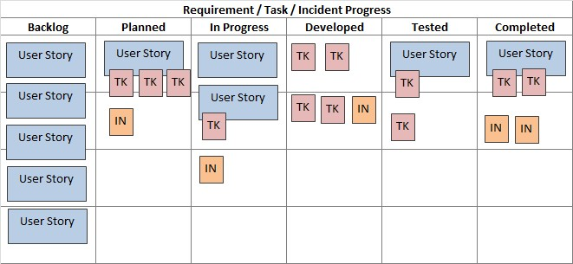

The researchers utilized Kanban methodology as a visual project management framework to enhance their workflow efficiency and foster continuous improvement throughout their project. This approach is particularly effective in

software development, as it allows teams to visualize work, limit work in progress, and manage flow. By employing Kanban, the researchers aimed to promote collaboration, swiftly respond to changes, and deliver incremental value (Wang et al., 2021).

Backlog. In this initial stage, all potential tasks and features needing attention are collected and prioritized. The backlog serves as a comprehensive repository for all work items, including user stories, bugs, and feature requests. Maintaining a well-organized backlog is crucial for additional project flexibility, as it allows the team to assess and adjust priorities based on feedback, changing requirements, or shifts in stakeholder needs. Regular backlog grooming sessions can help ensure that the items are not only relevant but also adequately detailed to facilitate smooth transitions into subsequent stages (Mann & Maurer, 2020).

In the Backlog phase, the team gathered and documented all features and tasks required for the development of the admin and customer frontends, the shared backend, the database schema, and the dashboard. This included major features such as product listing and browsing, order handling and management, and integration of the Dash-powered analytics dashboard app. Tasks were written as user stories, bug reports, and enhancement ideas. Frequent review sessions were conducted to prioritize based on urgency, dependencies, and stakeholder input.

Planned. In the planned phase, the researchers engage in collaborative sessions to outline how selected tasks will be executed. This involves breaking down high-level features into actionable subtasks, estimating the effort required, and identifying necessary resources and dependencies. Effective planning is essential for aligning the team’s efforts and ensuring that everyone is on the same page regarding project goals, timelines, and deliverables. This stage fosters a sense of ownership and accountability among team members, as they have clear understanding of what they need to accomplish collectively (Vujic & Masic, 2022).

During this phase, larger features were broken down into smaller, more manageable subtasks. For example, the dashboard’s “Top 5 Products per Category” feature was divided into subtasks for query creation, bar graph rendering, and layout integration. Similarly, customer-side features like order tracking and product display with pagination were scoped out with effort estimates and dependencies clearly identified. Planning sessions helped

ensure clarity of roles and timelines, while aligning frontend and backend development with shared goals.

Developed. The development stage is where the actual work takes place. Team members engage in coding and

implementing tasks in this phase, focusing on collaboration and communication. Developers often work on subtasks simultaneously, leading to synergy within the team. Daily stand-up meetings can enhance cohesion and ensure that everyone is aligned on progress and blockers. This stage emphasizes continuous integration and delivery practices, allowing features to be developed iteratively and modified swiftly based on immediate feedback from stakeholders or team members (Hoda et al., 2021).

Development encompassed building the core functionality of SalesVista across its three components. The customer website was built with product listings, commission forms, order tracking, and secure browsing experiences with watermarking and download restrictions. On the admin website, the developer created interfaces for managing products, tracking orders, and embedding the data analytics dashboard via iframe. Meanwhile, the Dashboard App itself was implemented in Dash and included dynamic graphs, dropdown filters, a time aggregation feature, and product-level analytics. The development phase also included integration between systems, such as pulling live sales data into the dashboard.

Tested. Once a component or feature has been developed, tasks move into the testing phase. This rigorous quality assurance process involves conducting various tests, unit tests, integration tests, and user acceptance tests, to verify that new features work as intended and meet all specified requirements. In this stage, testers also look for any unintended side effects that recent changes may have introduced. Thorough testing is essential to identify and resolve defects before reaching production, resulting in a smoother release process and improved user satisfaction. (Paasivaara et al., 2021).

In the testing phase, the team validated both functional and usability aspects of the SalesVista system. For the customer website, 100 participants from the public either interacted with the site directly or watched a walkthrough before completing the USE Questionnaire standardized tool assessing Usefulness, Satisfaction, and Ease of Use on a 1 to 7 scale. This provided valuable quantitative insights into the effectiveness and user-friendliness of the customer experience. For the admin website, usability was evaluated through interviews conducted with the partner organization following hands-on testing. These sessions captured qualitative feedback on ease of navigation, task completion, and clarity of the integrated analytics dashboard. Alongside usability

testing, functional tests (unit, integration, and edge-case scenarios) were performed across all systems reliability, secure authentication flows, and accurate data processing.

Completed. Finally, tasks that pass testing and adhere to the final defined criteria for completion are moved to the “Completed” column. This stage not only signifies the successful completion of tasks but also serves as a motivational tool for the team, providing a visual representation of their progress over time. Regularly reviewing completed tasks can facilitate discussion about lessons learned, potential areas of improvement, and celebrate team’s accomplishments, contributing to a culture of recognition and continuous learning (Kumar et al., 2023).

Finished and tested tasks were moved to the “Completed” column. These included fully functional modules like the customer shop and commission system, admin product management and analytics access, and all seven major dashboard features, such as top products, category breakdowns, and exportable data tables. The team celebrated these milestones in retrospective, recognizing their progress and discussing opportunities for process and feature improvements. The completion of these tasks marked the delivery of a cohesive and data-driven e-commerce platform tailored for Gallery ErGo artists and their customers.

By implementing the Kanban methodology, the researchers not only achieved a flexible and adaptive project management approach but also significantly enhanced the overall quality and efficiency of their software development process.

Figure 2

Design Thinking 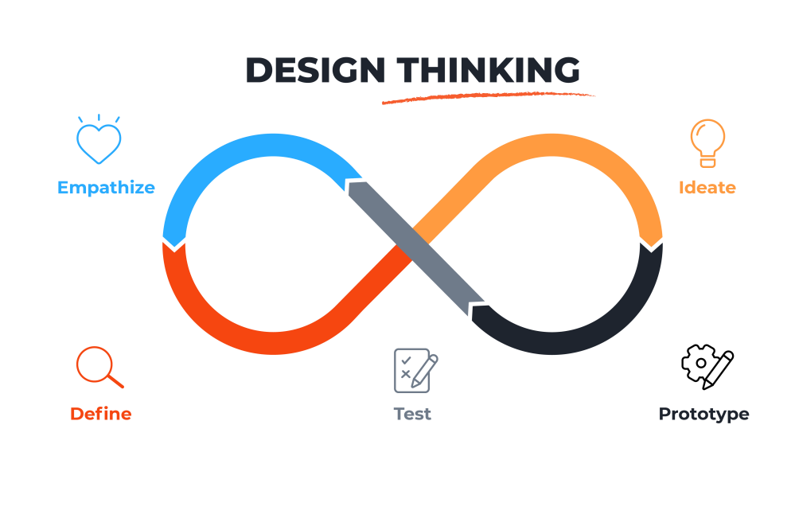

Design thinking is a user-centric methodology that fosters innovative solutions by deeply understanding and addressing the needs of users. It involves a non-linear, iterative process that encourages teams to challenge assumptions, redefine problems, and create effective solutions. This approach is particularly valuable for tracking complex, ill-defined, or unknown problems.

Empathize. This stage allows the researchers to gain a deep understanding of user’s experiences, emotions, and needs. The researchers engage with users through

observations and interviews, setting aside their own assumptions to gather genuine insights. This empathetic approach is crucial for uncovering the real issues users face. As noted by the Interaction Design Foundation, empathy allows the researchers to “understand the human needs involved” and “gain real insight into users and their needs” (Dam, 2024).

Define. The researchers analyzed and synthesized the information gathered during the Empathize phase to identify core problems. This involves organizing observations and distilling them into clear, actionable problem statements. A well-defined problem statement focuses on specific user needs and insights, guiding the researchers’ efforts. The Interaction Design Foundation emphasizes that this stage is about “bringing clarity and focus to the design space” and crafting a “meaningful and actionable problem statement” (Dam, 2024).

Ideate. The researchers generate a wide range of creative ideas and potential solutions. This stage encourages thinking beyond obvious solutions and exploring innovative possibilities. Techniques such as brainstorming,

mind mapping, and sketching are commonly employed to facilitate idea generation. The goal is to harness the collective perspectives and strengths of the team to uncover unexpected areas of exploration. As described by the Interaction Design Foundation, ideation allows team to “combine the understanding you have of the problem space and people you are designing for with your imagination to generate solution concepts” (Dam, 2024)

**Scope and Delimitation**

This project focuses on the development of Gallery ErGo, an e-commerce platform dedicated to showcasing and selling various forms of art, including original paintings, art prints, crochet items, magnets, bags, and commissioned works. The primary users of the system are artists who will manage their artworks on the platform and customers who are interested in browsing and purchasing art pieces.

The system will allow artists to upload their works, add descriptions, set prices, and manage commissions. Customers will be able to view art pieces, add them to cart, and proceed to checkout without the need for account registration. Additionally, the system will include art management, order processing, and secure checkout process.

To protect artists’ works, the platform will incorporate features to prevent unauthorized copying of displayed images. This project is limited to the development of core ecommerce functionalities specific to Gallery ErGo and focusses on the needs of artists and

customers. Only the admin will have the capability to register and manage the products on the platform. Customers will not be required to create and account to make purchases but will still have access to the cart and checkout features.

The system will not include features such as reviews or a messaging system between artists and customers. It will also not support multi-vendor functionality; only the shop owner or admin can upload and manage products.

Additionally, the platform will not integrate with third-party companies or partners for delivery and payment services. All payment and delivery processes will be managed manually by the shop owner or through direct arrangements with customers, ensuring full control over transactions and logistics.

**Data Gathering Techniques**

Data gathering is the process of collecting and analyzing information to support research objectives.

Various methods can be used to obtain data, and the choice of technique depends on the research goals, questions, and type of data required. For this study, the researchers employed interviews, document analysis, and usability testing to gather relevant data for the development of the Gallery ErGo website.

Interview.The researchers conducted interviews with Baguio and Manila locals to gather feedback on the prototype, focusing on usability, design preferences, and key features for an online gallery. An interview with Gallery ErGo was also conducted to determine website requirements, including product catalog management, artist profiles, and purchase options.

Document Analysis. The researchers analyzed Gallery ErGo’s Facebook page and their old website to assess branding, customer engagement, and existing digital strategies. Common customer inquiries and engagement patterns informed features such as FAQs and customer support, while previous website designs provided insights for improvements.

**Sources of Data**

The researchers obtained the system content—such as paintings, artwork descriptions, and artist profiles—directly from their primary stakeholder, Gallery ErGo. This

data formed the core of the website’s content. To guide the development and refinement of the platform, the researchers also conducted interviews and usability testing with potential users. Participants, including residents of Baguio and Manila, were presented with the website prototype and asked to provide feedback on usability, aesthetics, and overall user experience.

**Software Development Tools**

A software tool is a program designed to automate various tasks involved in the management, design, coding, testing, inspection, or maintenance of other software applications. These tools vary in size and complexity, ranging from simple utilities that assist individual programmers and end-users to advanced systems capable of supporting multiple software projects at once

The following software development tools were utilized by the researchers in the creation of the proposed website and mobile application.

Visual Studio Code. To develop and create the Gallery ErGo website. The researchers used Visual Studio Code as

the primary integrated development environment (IDE). Visual Studio Code was chosen for its versatility, lightweight nature, and extensive support for various programming languages and extensions. It provided an efficient coding environment, featuring syntax highlighting, debugging tools, and git integration, which streamlined and development process. The use of extensions further enhanced productivity, allowing for seamless collaboration and efficient project management.

ChatGPT. The researchers used ChatGPT as a debugging assistant throughout the development process. It helped identify coding errors, provided explanations for programming concepts, and suggested possible fixes for encountered issues. This tool was especially useful when troubleshooting backend logic and optimizing front end functionalities.

Obsidian. The researchers used Obsidian for project management and documentation. Obsidian is a markdown-based note-taking application that allows for efficient organization of research materials and development notes. It provided a structured and flexible way to track

progress, manage documentation, and link related information, ensuring seamless workflow management.

Git. The researchers used Git for version control. Git allowed them to track changes, manage branches, and collaborate efficiently on code development. It enabled developers to maintain a structured workflow by committing and merging code updates systematically.

GitHub. To host and manage the project repository, the researchers used GitHub. GitHub provided a cloud-based platform for version control, collaboration, and code sharing. It facilitated team coordination, code reviews and issue tracking, ensuring a seamless development process.

Node.js. For backend development, the researchers used Node.js. Node.js is a JavaScript runtime environment that enables scalable and efficient server-side applications. Its event-driven architecture allowed for fast processing and smooth handling of multiple requests, making it a suitable choice for web application development.

React.js. The researchers used React.js to develop the frontend of the application. React.js was chosen for its component-based structure, which made the user interface more interactive and responsive. It allowed the team to create reusable UI components, ensuring a consistent design across the application.

PostgreSQL. For database management, the researchers used PostgreSQL to store and organize project data. PostgreSQL was selected for its reliability, scalability, and ability to handle complex queries efficiently. It ensured secure data storage and smooth retrieval operations within the system.

pgAdmin. To manage and monitor the database, the researchers used pgAdmin. This tool provided a user-friendly interface for interacting with PostgreSQL, making it easier to create tables, run queries, and optimize database performance. It helped streamline database administration and maintenance tasks.

Postman. The researchers used Postman to test and validate API endpoints. It allowed the team to send HTTP requests, check responses, and debug API interactions between the frontend and backend. Postman played a key role in ensuring that data was transmitted correctly and that API functionalities worked as expected.

Figma. The researchers used Figma to design and prototype the website. Figma allowed the team to create wireframes and interactive mockups, providing a visual representation of the website's layout and user interface

before development. The prototype served as a reference during development, helping maintain consistency in the final implementation.

Render. The researchers used Render, a cloud-based platform, for the deployment of the Gallery ErGo website. Render allowed for seamless hosting, providing a reliable environment for the web application. It facilitated easy management of resources and ensured smooth, scalable deployment, allowing for real-time access and automatic updates.

Cron Job. The researchers implemented cron jobs to ensure the continuous operation and availability of the Gallery ErGo website. Cron jobs are scheduled tasks that automatically run scripts at specified intervals. By setting up regular tasks for server maintenance, such as clearing cache and checking server status, the researchers ensured that the website remains active and responsive without manual intervention.

Chapter 3

**FINDINGS OF THE STUDY**

This chapter outlines the study's findings, detailing the results obtained from data analysis. It aims to utilize the collected data to address the research objectives and determine the key features of the proposed website.

**Information Requirements of the System**

This chapter presents the Information Requirements of the proposed system, focusing on the data and resources essential for its effective implementation and operation. It outlines the necessary user data, software specifications, and hardware components identified through the research and development phases. These requirements ensure that the system meets its intended functions, supports secure transactions, and provides smooth user experience. By clearly defining these needs, the study aims to guide the development of a reliable, scalable, and user-centered platform for Gallery ErGo.

User information. User information refers to how the system collects and utilizes data to provide access to its functionalities. The gathered user information will be securely stored in the PostgreSQL database, ensuring protection against fraudulent activities, hacking, phishing, and identity theft. The system allows users to

make purchases either as guest users or as registered users.

Guest users can proceed with a transaction without creating an account but are required to provide their full name, contact number, and delivery address.

Registered users, on the other hand, can access the full features of the system by logging in with their Google account. They must also provide their full name, contact number, and delivery address to complete transactions.

The admin panel is accessible only to authorized personnel of Gallery ErGo and requires a unique username and password. Admins are responsible for managing product listings, transactions, and ensuring that the system operates smoothly.

The payment process requires users to manually transfer funds to the seller’s provided payment accounts. Upon checkout, the buyer will be presented with the seller’s GCash and BDO account details for payment. Once the transaction is completed, the buyer must upload a proof of payment (such as a screenshot of the transaction) before the order is confirmed.

The system does not process online payments directly but serves as a platform for facilitating transactions between buyers and sellers. Payment verification is handled by the admin to ensure the legitimacy of each transaction before confirming the order.

Software system Requirements. Gallery ErGo will ensure compatibility with all major web browsers and devices. The platform is compatible with Android-based smartphones, requiring a minimum Android version of 6 (Marshmallow) to ensure full functionality. However, Android version 12 (Snow Cone) is recommended for an enhanced user experience, aligning the platform with modern features and security standards. Access to the internet, whether through Wi-Fi or mobile data, was crucial for both the customer and the Gallery Ergo admin to ensure the platform functioned properly and delivered the full Gallery Ergo experience.

Table 1

Software Requirements on Customer-Side

|  |  |  |  |
| --- | --- | --- | --- |
| Specifications | Minimum Requirement | | Recommended Requirement |
| Web Browser | Chrome, Firefox, Safari (latest 2 versions) | Latest versions of Chrome, Firefox, Safari, or Edge | |
| Operating System | Android 9+, iOS 13+, Windows 10+, macOS 10.15+ | | Android 12+, iOS 16+, Windows 11, macOS Ventura |
| JavaScript | Enabled | | Enabled (for full interactivity) |

Hardware Requirements. In the development and deployment of the Gallery ErGo website, it is essential to identify the necessary hardware components that will ensure the system’s smooth operation, efficiency, and scalability. Hardware requirements refer to the physical elements of a computer system that are needed to support software operations, including web hosting, development activities, and client-side usage. These requirements are categorized according to specific roles involved in the use of the system: server-side, developer-side, and client side.

Table 3

Hardware Requirements on Customer-Side

|  |  |  |
| --- | --- | --- |
| Specifications | Minimum Requirements | Recommended Requirements |
| Device Type | Smartphone, tablet, laptop, or desktop | Mid-range or high-end smartphone, laptop, or desktop |
| Processor | Dual-core processor | Quad-core processor |
| Memory (RAM) | 2 GB RAM | 4 GB RAM or higher |
| Storage | At least 200 MB free space for caching and media | At least 1 GB free space |
| Graphics | Integrated GPU (mobile or desktop) | Dedicated mobile or desktop GPU |
| Internet Connection | Stable 3G or minimum 5 Mbps broadband | 4G LTE / 5G or 25 Mbps fiber connection |
|  |  |  |

**Architecture Framework of SalesVista**

An architectural framework is a structured and standardized methodology designed to guide the design, development, and documentation of complex systems, particularly in software engineering and enterprise environments. It establishes a comprehensive set of principles, practices, templates, and tools that facilitate the organization of system architecture in a clear, logical, and consistent manner. Through the application of an architectural framework, complex systems can be decomposed into multiple interrelated views or components, each addressing specific concerns such as data, processes, infrastructure, and security. This decomposition enables developers and architects to analyze, design, and implement systems in a modular and manageable way, improving clarity and reducing complexity.

Architectural frameworks play a critical role in aligning system development with business objectives, technical requirements, regulatory standards, and user expectations. They introduce a common vocabulary and conceptual structure that supports communication among various stakeholders, including developers, project managers, business analysts, and clients. This shared

understanding enhances collaboration and reduces ambiguity during both the design and implementation phases.

Furthermore, architectural frameworks contribute to system scalability, adaptability, and component reusability. By encouraging the use of standardized patterns and modular components, they enable organizations to respond more effectively to changing requirements and evolving technologies. The use of a consistent architectural foundation also streamlines maintenance and integration efforts across different projects and departments.

Figure 3

Architecture View Model

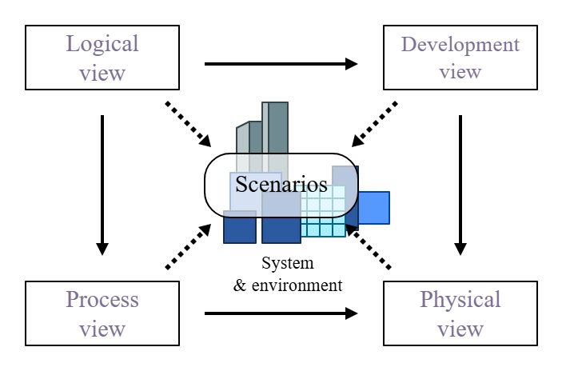

The 4+1 View Model of Architecture, proposed by Philippe Kruchten, is a practical example of an architectural framework in action. It organizes a system’s

architecture into five views to address different stakeholder concerns. The Logical View focuses on the system’s functionality and object models, mainly for developers and analysts. The Development View shows the system from a programmer’s perspective, revealing software modules and their organization in the development environment. The Process View addresses the system’s dynamic aspects, such as performance and concurrency, which are vital for the system integrators and engineers. The Physical View illustrates how the system is developed on hardware, aiding system administrators in understanding

infrastructure requirements. Lastly, +1 refers to Scenarios or Use Cases, which describe how the other views work together through real-world applications. These scenarios help validate the architecture and ensure it meets functional requirements.

Logical View. The Logical View, one of the perspectives in the 4+1 architectural model, focuses on representing the system’s functionality by identifying the key classes, their attributes, behaviors, and the relationships between them. It serves as a blueprint for developers and designers to understand how the system is structured conceptually. This view is often illustrated

using a class diagram, which provides a detailed look into the core components of the system. In the context of the Gallery Ergo system, the class diagram showcases various classes such as Admin, Customer, Order, Product, Cart, Store Location, Category, and Sales Analytics. Each class has a specific role in the system. The admin class manages products, orders, and events, while the Customer class enables users to browse products, place orders, and view store locations. The Order class handles purchase transactions and includes products, while the Cart class temporarily stores selected items. The Product class represents sellable items, each linked to a specific

Category, and is managed by Admin. Store Location allows for managing the physical or virtual presence of stores. Lastly, the Sales Analytics class is responsible for generating reports and analyzing sales trends based on product and order data. The relationships among these classes—such as management, placement, and containment—reflect the logical structure of the system. By capturing these interactions in Logical View, the system’s design becomes clearer, more maintainable, and easier to translate into code.

Figure 4

SalesVista Class Diagram

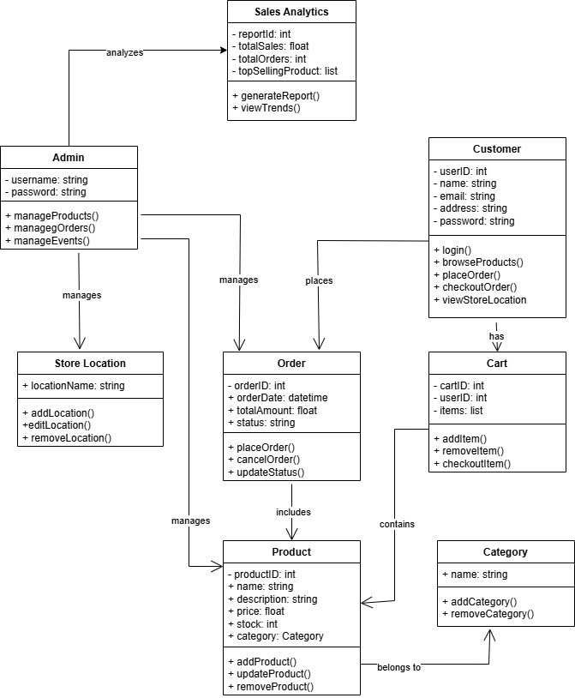

Development View. Deployment View, a crucial aspect of software architecture, provides a comprehensive blueprint of the system’s runtime configuration, illustrating the distribution of software artifacts across physical or virtual processing nodes. This view employs deployment diagrams to depict the underlying hardware infrastructure, including servers, devices, networks, and cloud resources, alongside the software components deployed onto them. It

highlights deployment dependencies, communication pathways between nodes, performance considerations, and the physical location of executable files, libraries, and configuration data. This detailed visualization is essential for planning the deployment process, optimizing resource allocation, ensuring compatibility between components, facilitating communication with infrastructure and operations teams, and proactively identifying potential deployment challenges or bottlenecks.

Complementing this physical perspective is the Package Diagram, a structural diagram that focuses on the logical organization of the system’s model elements. Packages serve as encapsulated namespaces used to group related UML elements such as classes, interfaces, use cases, and other model components, thereby managing design complexity and improving overall understandability. Package diagrams clearly illustrate dependencies, usage relationships, and import interactions between these logical units, showcasing how different subsystems interact and rely on each other during both design and execution. By defining explicit boundaries and relationships between packages, this diagram promotes modularity, enhances reusability, supports incremental development, and contributes to a well-structured architectural design. It also aids in impact analysis, version control, and systematic software evolution, making it an indispensable tool for organizing, scaling, and maintaining large-scale software systems across distributed development environments.

Figure 5

SalesVista Package Diagram

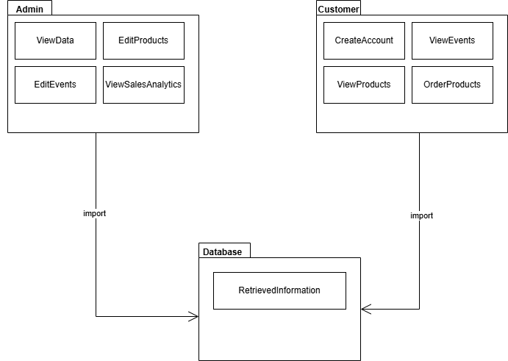

Physiccal View. The Physical View, often used interchangeably or considered synonymous with the Deployment View in software architecture, focuses on the tangible elements that host and execute the software system in a real-world environment. It illustrates the physical infrastructure, encompassing hardware components like

servers, workstations, mobile devices, and network elements, and how software artifacts are deployed onto these physical or virtual nodes. The Deployment View uses deployment diagrams to visually represent these nodes, the software artifacts (such as executables, libraries, and configuration files) residing on them, and communication paths that connect these nodes, specifying the physical or network connections and protocols used for interaction. This view is crucial for understanding the topology of the system, how software components are distributed across the infrastructure, and for planning and managing the actual deployment process. By detailing the location distribution of software, Physical/Deployment View helps potential bottlenecks, scalability limitations related to hardware and is essential for effective communication infrastructure and operations teams responsible for setting up maintaining the system's physical environment. In essence, it provides a concrete picture of where the software lives and how its different parts physically connect and interact at runtime.

Figure 6

SalesVista Deployment Diagram

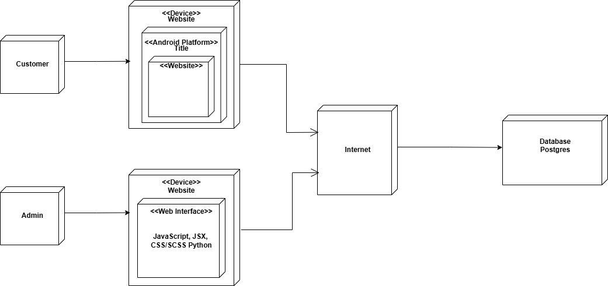

Process View. The Process View of a software system explains its dynamic behavior at runtime, focusing on the active elements such as processes and threads and their interactions. Unlike the static deployment of components onto hardware described in the Deployment View, the Process View illustrates how these deployed elements execute and communicate to deliver the system's functionality. It models concurrency and parallelism by showing how multiple threads within processes, or independent processes operate and exchange information through mechanisms like message passing, shared memory, or remote procedure calls. This perspective is critical for understanding the system's

performance characteristics, its ability to handle concurrent users or tasks, and for identifying potential

bottlenecks in its runtime architecture. By visualizing the flow of control and data between active components, the Process View provides essential insights into the system's dynamic nature, supporting considerations of scalability, responsiveness, and overall runtime efficiency.

Activity Diagram on Standard Ordering Process. This UML Activity Diagram illustrates the process flow for a customer interacting with an online shopping system, leading to the checkout. The process begins with the customer opening the website and then viewing products. Subsequently, the customer can add a product to their cart and is then presented with a decision point: whether to add more products. If the customer chooses "yes," they loop back to adding another product to the cart. If they choose "no" they proceed with the checkout process. The checkout process then involves the customer entering their delivery information, followed by placing the order, and finally receiving an order ID, marking the end of this specific activity flow. The diagram clearly outlines the sequential steps, and the conditional loop involved in a typical online shopping experience from browsing products to completing an order.

Figure 7

Activity Diagram on Standard Ordering Process

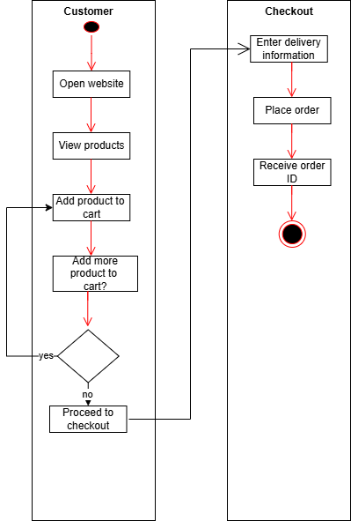

Activity Diagram on Post Order Actions. This UML Activity Diagram illustrates the process flow for a customer interacting with an order tracking and potential cancellation system, along with the continuation and return processes. Initiated by the customer tracking their order and entering their email and order ID, the system checks the order status, which initially shows as pending. The customer then faces a decision point to either cancel the order ("yes" leading to the end) or continue ("no" leading to the "Continue" process). The "Continue" process involves the customer potentially uploading a receipt and waiting for the order status to update to "Order shipped."

Following shipment, the customer can actively "Click Receive?" ("yes" leading to marking the sale complete) or wait for an automatic receive confirmation ("no" leading to "Auto receive" and then marking the sale complete). Separately, there's a "Return" process initiated by the customer contacting the seller, which can occur after the order has been processed. This diagram outlines the various paths a customer might take, from tracking their order to completion or cancellation, and includes a separate flow for initiating a return.

Figure 8

Activity Diagram on Post Order Actions

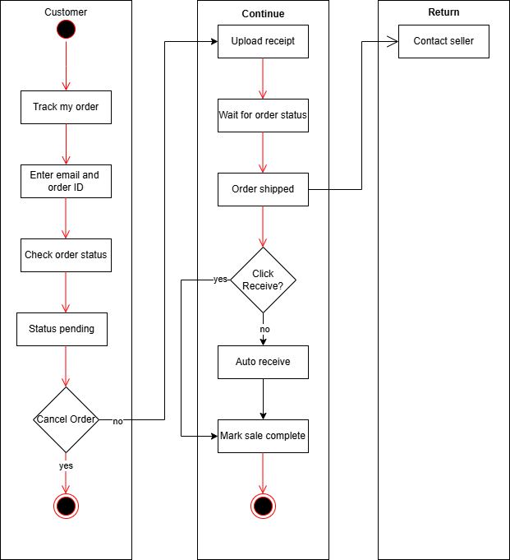

Activity Diagram on Order Fullfilment. This UML Activity Diagram illustrates the process flow for an administrator managing new orders, including the decision to accept or reject them. The process begins with the administrator logging in and then viewing new orders. A decision point follows: "Accept?". If the administrator chooses "no," the process ends. If the administrator chooses "yes," the process flows into the "Accept" activity. Within the "Accept" activity, several sequential steps occur, setting the order status, reviewing the receipt, setting the payment status, preparing the shipment, and updating the order status again. Following shipment preparation, the administrator enters the tracking ID and the expected delivery date. Another decision point arises: "Customer confirmed receipt?". If "yes," the order is counted as a sale and the process ends. If "no," an "Auto received" action occurs, after which the order is counted as a sale and the process concludes. This diagram clearly outlines the steps an administrator takes to process new orders, including the acceptance workflow and the handling of order fulfillment and confirmation.

Figure 9

Activity Diagram on Order Fulfillment

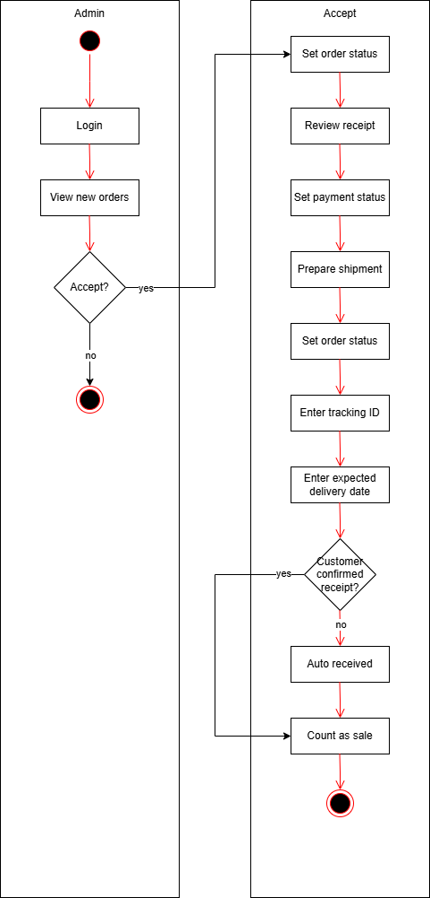

Activity Diagram on Custom Commission Order. This UML Activity Diagram illustrates the process flow for a customer submitting a commission request and proceeding to checkout. The process begins with the customer going to the commission page, reading the commission policy, and clicking "I acknowledge," which then causes the commission form to appear. The customer then moves to the "Submit

Request" activity, where they fill out the form, providing details such as the title/description of the request, budget, medium/category, and reference images, before finally submitting the request and proceeding to checkout. The "Checkout" activity involves the customer entering their customer information and delivery information, then placing the order and receiving an order ID, which marks the end of the process. The diagram clearly outlines the steps a customer takes to initiate a commission, provide the necessary details, and complete the checkout process.

Figure 10

Activity Diagram on Custom Commission Order

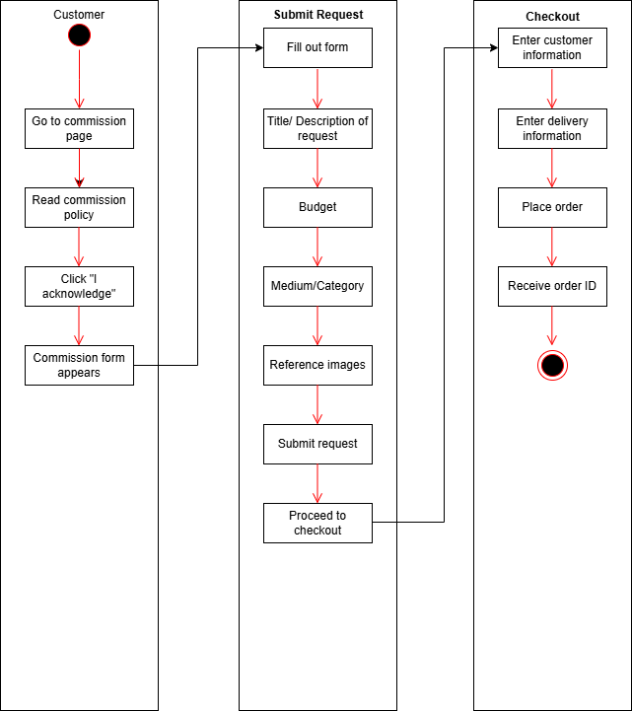

Activity Diagram on Handle Custom Commission Request. This UML Activity Diagram illustrates the process flow for an administrator handling incoming commission orders and acting on them. The process begins with the administrator logging into the system, which grants access to the interface where incoming commission orders are displayed. Once logged in, the administrator proceeds to view the list of commission orders and selects one for review. The administrator then carefully examines the order, checks the proposed budget, requests further details if needed, and reviews any attached files to ensure all necessary information is available.

Following this review, the process moves to the "Take Action" activity. Here, the administrator chooses one commission to act upon and then faces a decision point: "Accept commission?". If the administrator chooses "no," indicating the commission is not suitable for acceptance, the process ends. However, if the administrator chooses "yes," indicating approval, the order status is updated to reflect this decision, marking the commission as accepted or in progress, and the process then concludes.

This diagram clearly outlines the steps an administrator takes to examine new commission orders, the decision-making process involved in accepting or rejecting them, and the subsequent action of updating the order status upon acceptance. It serves as a visual representation of the administrative workflow, highlighting the logical sequence of actions and decisions required to manage and process incoming commission orders effectively

Figure 11

Activity Diagram on Handle Custom Commission Request

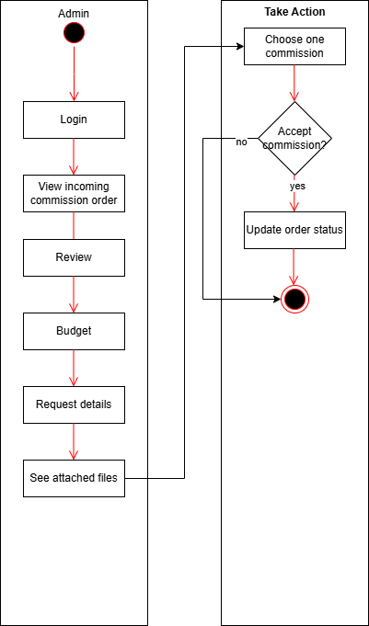

Activity Diagram on Add/Edit Products. This UML Activity Diagram illustrates two distinct processes: "Add Product" and "Edit Product." The "Add Product" process begins with navigating to the products page and clicking the "add product" button. The administrator then fills in the product details sequentially, including the product name, artist(s), category, price, stocks, images, and descriptions. After inputting all the necessary information, clicking the "Add product" button triggers the system to add the product, which then automatically updates the product listing. This ensures that the newly added product is immediately available for viewing and purchase.

The "Edit Product" process begins by locating the product record, clicking on three vertical dots (likely representing a menu), and selecting "edit." This redirects the administrator to the edit product page, where they can modify the desired product fields. After making changes, clicking the "update product" button prompts the system to save these changes, redirecting the administrator back to the products page, where the product listing is automatically updated. The diagram clearly outlines the step-by-step procedures for both adding new products and modifying existing ones within the system, ensuring that all product information is kept accurate and up to date.

Figure 12

Activity Diagram on Add/Edit Products

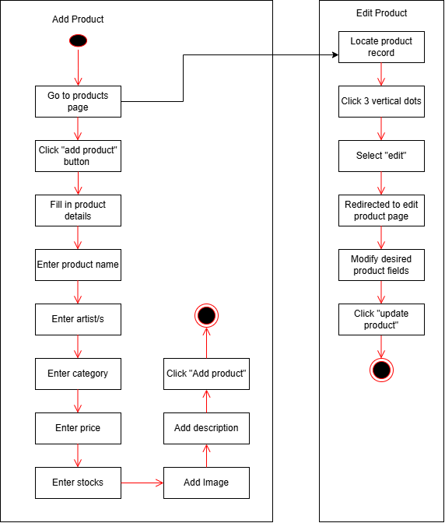

Scenarios. In a case diagram, scenarios represent the specific sequences of actions or events that occur when an actor interacts with the system to achieve a particular goal. These scenarios describe how a certain use case functions in real-world situations, providing a clear

understanding of user interaction and system behavior. A scenario typically includes the normal or main flow of events, where everything proceeds as expected, as well as alternative flows, which account for exceptions or errors. For instance, in a “Place Order” use case, the main scenario would involve steps like selecting items, entering shipping details, confirming the order, and completing payment successfully. An alternative scenario might occur if the payment fails, prompting the system to display an error and request a different payment method. By outlining these possible paths, scenarios help in visualizing the system's functionality and in identifying potential issues during development and testing. They also ensure that edge cases are considered, making the system more robust and reliable. Furthermore, scenarios play a critical role in refining user interface design by demonstrating the interaction between the user and the system, ensuring that all user actions are intuitive and seamless.

The use case diagram illustrates the interaction between two primary actors—the Artist and the Customer—within the Website System. It highlights the system's core functionalities related to commission-based services and customer interaction. The Customer interacts with the system primarily to request art commissions. They do this by initiating the Commissions use case, which includes filling out a form and sending a request. Once the request is submitted, the Artist can view and respond to it. The artist can either approve or reject the commission request, both of which are included in the Commissions process. After a commission is handled, both actors can access Order Updates/Status, a use case that allows tracking the progress of the request. This use case includes various stages such as Pending, Accept, and Reject, which represent the status of the commission as it moves through the workflow. These statuses ensure transparency and communication between the customer and the artist throughout the commission process. Additionally, both the Artist and the Customer can provide and view Feedback, which promotes interaction and helps maintain quality assurance within the system. The Login use case, also accessible to both actors, ensures that only authorized users can access their respective features, maintaining security and personalized user experience. The use case diagram thus serves as a vital tool for understanding system interactions, streamlining processes, and ensuring that all necessary steps are clearly defined for both actors.

Figure 13

Use Case Diagram

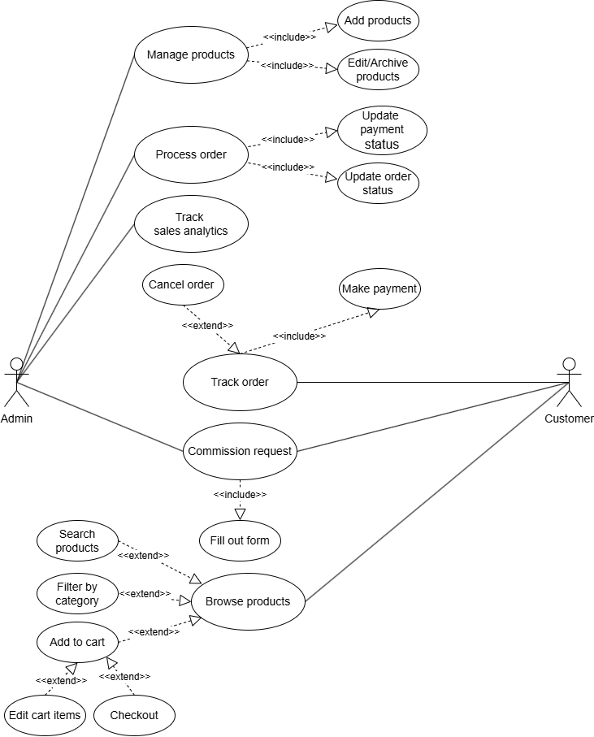

Model-View-Controller. The Model-View-Controller (MVC) is a widely adopted architectural pattern used in software development to separate the concerns of an application into

three interconnected parts. The Model is responsible for managing the application's data and business logic, interacting with the database and handling data operations. The View is the user interface, responsible for displaying data to the user and capturing user interactions. The Controller acts as an intermediary between the Model and the View, receiving input from the user (via the View), processing it, updating the Model accordingly, and then refreshing the View to reflect the changes. Figure 14 visually represents this pattern. The "Model" box is shown handling business logic and database operations for entities like Product, Category, Cart, Order, Customer, Admin, Event, and Sales Analytics. It updates the "View," which displays the user interface elements such as product pages, order pages, cart displays, admin dashboards, and sales graphs. The "Controller," contains components like ProductController, OrderController, CartController, CustomerController, AdminController, EventController, and AnalyticsController, receives input from the user through the View and manipulates the Model. The View sometimes directly interacts with the Controller, and the Controller then updates the View after interacting with the Model, completing the cycle of user interaction, data management, and presentation.

Figure 14

Model-View-Controller

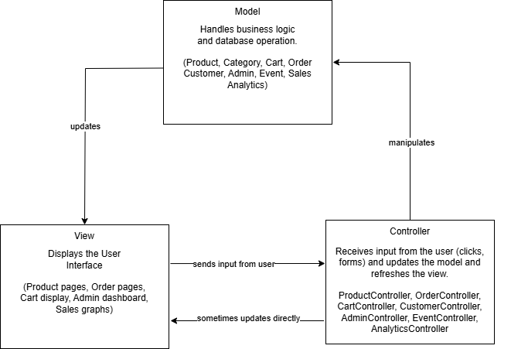

**Features of the SalesVista**

This section highlights the key features integrated into the Gallery ErGo website, which were designed to provide users with a seamless, secure, and engaging online shopping experience. These features reflect the core functionalities required to meet the needs of both buyers and administrators. From user authentication and product browsing to manual payment verification and administrative controls, each feature was carefully developed to support the system's goals. By outlining these components, this

section aims to demonstrate how the website operates to facilitate smooth transactions, maintain data security, and ensure efficient system management.

Figure 15

Dashboard Options

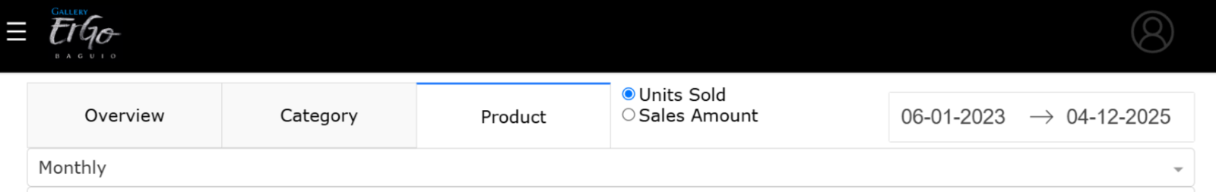 The dashboard menu remains visible across all its tabs, always allowing for easy navigation. It is divided into three distinct tabs, each displaying different sets of graphs and data. Users can customize the displayed information by selecting a specific date range using the date range picker located at the top right corner. Additionally, the dashboard offers filtering options that allow users to toggle between viewing data based on either unit sold or total sales amount, using radio buttons positioned to the left of the date picker. To further refine the data presentation, users can group the results by day, week, or month through a dropdown selection.

Figure 16

Dashboard Overview

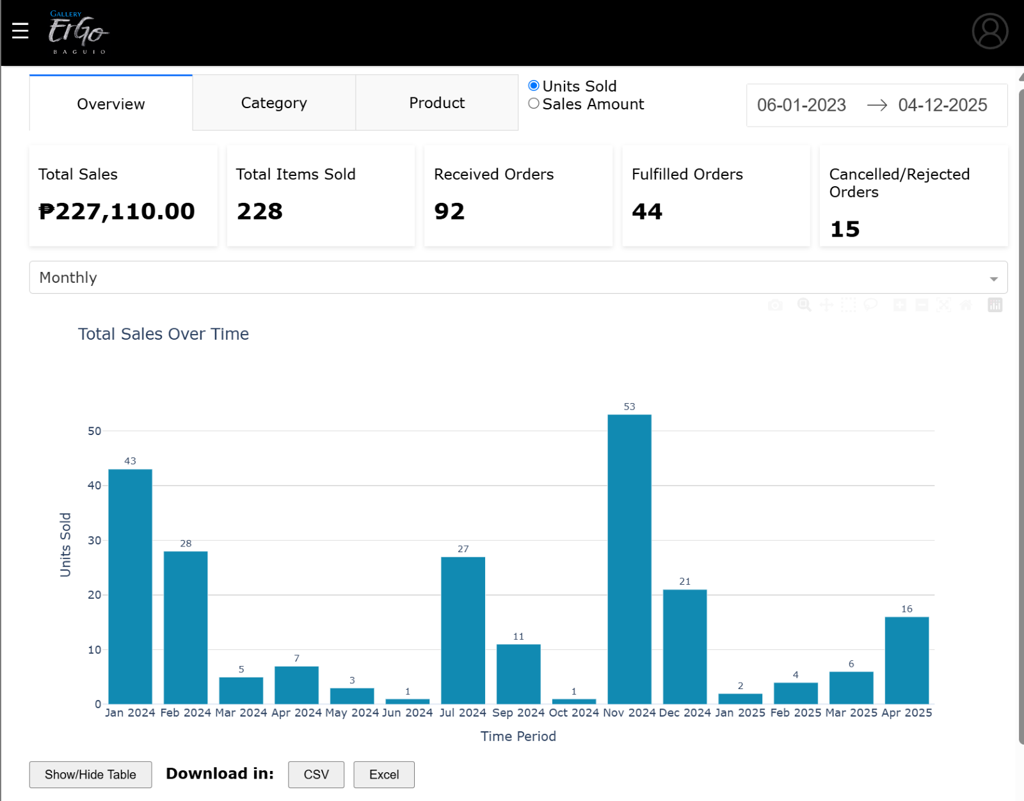

The Overview tab provides a summarized view of key sales and order metrics, including total sales, total items sold, received orders, fulfilled orders, and cancelled or rejected orders. It features a grouped bar chart titled Total Sales Over Time, accompanied by a table that users can both view and download in .csv or .xlsx format. In addition, the tab includes two more visualizations: a horizontal bar chart displaying the Top 10 Products, and a pie chart representing Sales Performance by Category.

Figure 17

Dashboard Category

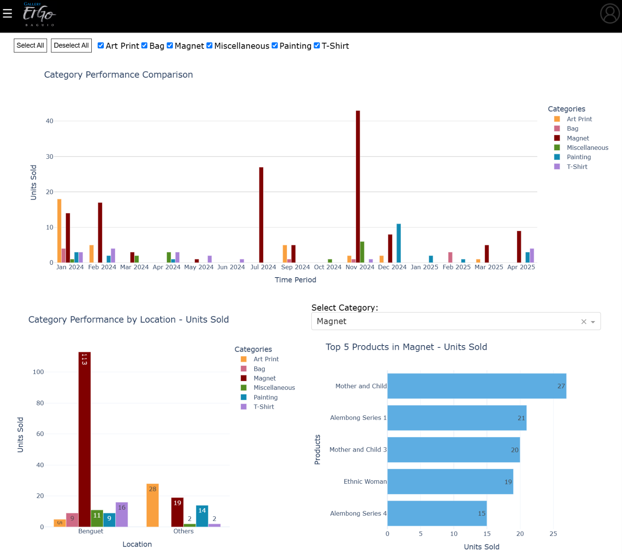 The Category tab offers a detailed visual breakdown of product performance across various categories. It includes three interactive charts: the Category Performance Comparison grouped bar chart, which highlights the overall performance of each category; the Category Performance by Location grouped bar chart, which displays how each category performs across different delivery areas; and the

Top 5 Products per Category horizontal bar chart, which showcases the best-selling items within each product category. These visualizations help administrators and sellers identify trends, evaluate category strengths, and make data-driven decisions to improve inventory and marketing strategies.

Figure 18

Dashboard Products

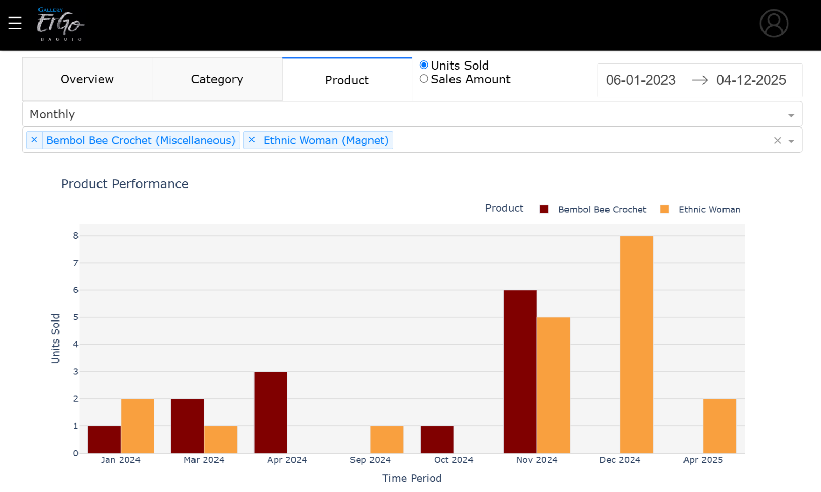 The Products tab enables administrators to search for and compare the performance of up to five individual products simultaneously. This is done by using the input field located beneath the time aggregation dropdown menu, where product names or categories can be entered for quick

filtering. If a selected product does not appear in the resulting graph, it indicates that no sales have been recorded for that item within the specified timeframe. This feature helps administrators monitor product performance and make informed decisions regarding inventory and sales strategies.

Figure 19



Figure 20

Manage Orders

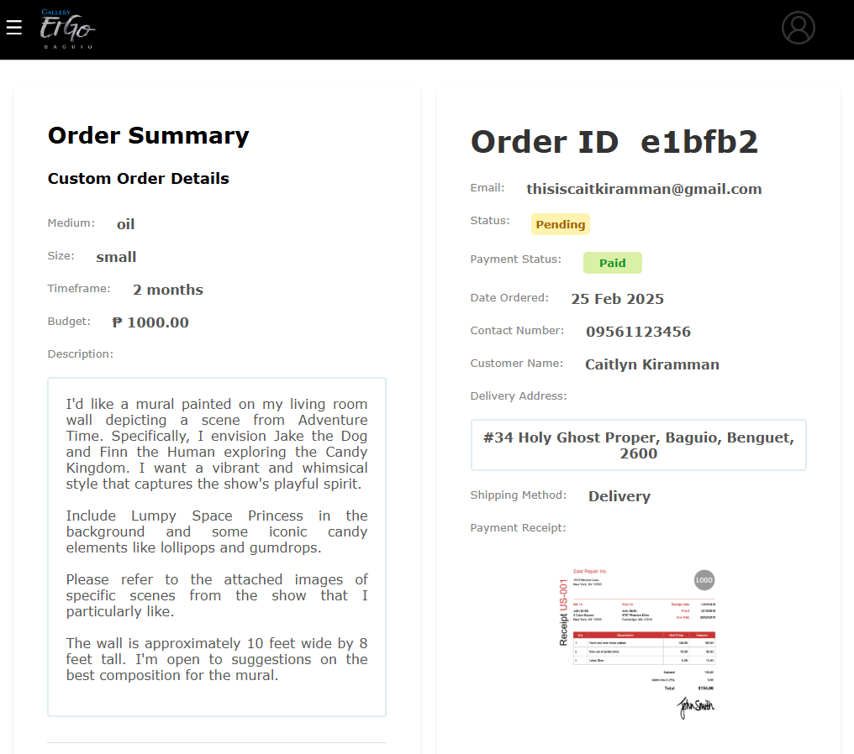

As shown in Figure 20, the Manage Orders feature provides the seller with access to all incoming customer orders. This includes information such as order ID, product details, quantity, buyer name, and shipping status. Admins can update the status of each order (e.g., processing, shipping, delivered), helping ensure timely fulfillment and customer satisfaction.

Figure 21

Downloadable Sales Table

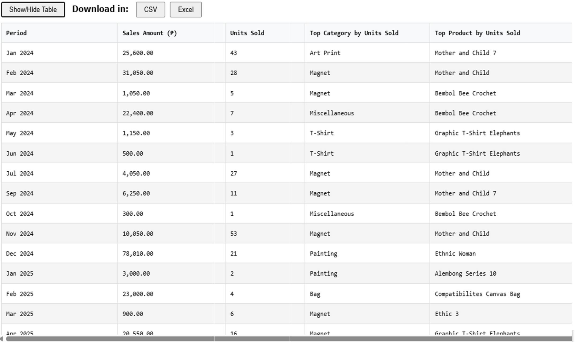

Figure 21 presents the Downloadable Sales Table feature in the Dashboard App. This functionality provides the admin with a detailed sales record that can be exported as a CSV or Excel file. The table displays comprehensive monthly sales data including sales amounts, units sold, top-selling categories, and best-performing products for each period. The downloadable table allows for external analysis, report generation, and record-keeping. It supports administrative tasks such as financial tracking, sales performance reviews, and inventory planning based on real-time and historical data.

Figure 22

Customer Landing Page

 The Customer Landing Page serves as the welcoming interface for users visiting the Gallery ErGo website. It is designed to provide a clean, visually engaging introduction to the platform while highlighting featured products, categories, and ongoing promotions. The landing page includes an intuitive navigation bar, allowing users

to easily browse collections, search for specific items, and access their shopping cart or account settings. Whether the user is a first-time guest or a returning customer, the landing page ensures a smooth and inviting entry point to the online shopping experience. It is optimized for both desktop and mobile devices, ensuring accessibility and responsiveness across all screen sizes.

Figure 23

Shop Page

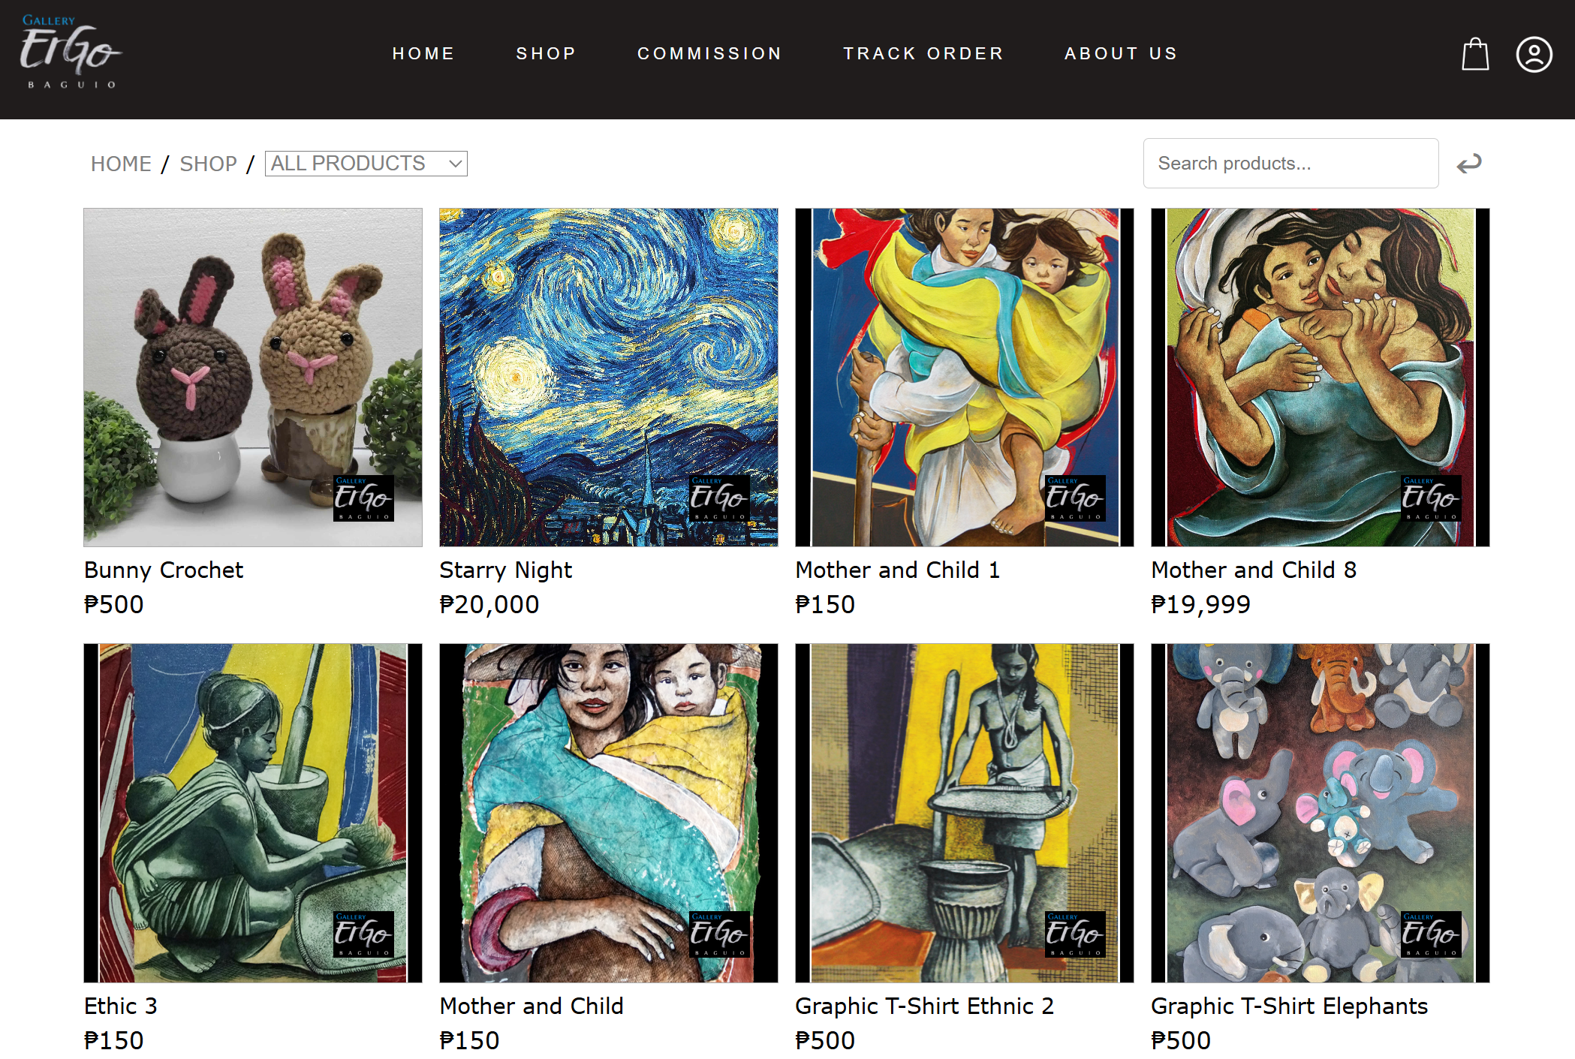

On the Shop page, customers can easily browse available products either by selecting a category from the menu located at the upper left corner or by using the search bar positioned at the upper right. This allows for quick filtering based on preferences or specific product names. Once a product is found, customers can click on the item to view detailed information, including images, descriptions, price, and availability. This streamlined

browsing experience helps users navigate the catalog efficiently and make informed purchasing decisions.

Figure 24

Product Details

 Customers can easily add products to their shopping cart by clicking the "Add to Cart" button available on each product's detail page. Before confirming the addition, users have the option to adjust the quantity based on the available stock using the increment and decrement controls. This feature ensures flexibility and allows customers to manage their desired purchases efficiently while keeping track of stock availability in real time.

Figure 25

Recommended Products

 A maximum of five related products are displayed in this section, selected based on similarities in either category or product name. This feature helps customers discover additional items that align with their interests, encouraging further browsing and potential purchases. It enhances the shopping experience by offering relevant suggestions tailored to the product currently being viewed.

Figure 26

Cart

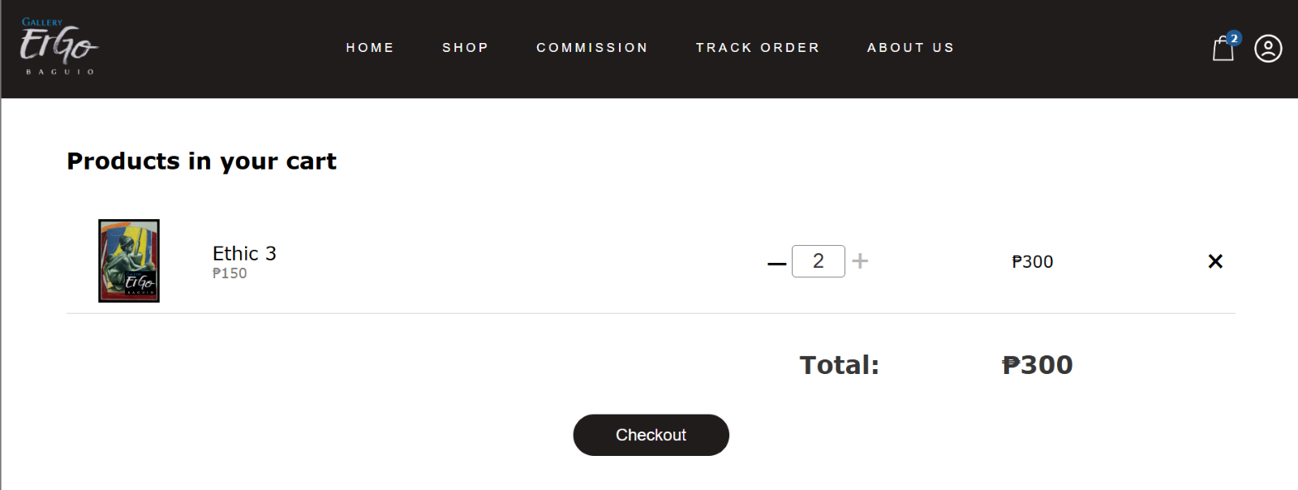

Customers have full control over the items in their cart. They can update the quantity of each product using the provided controls or remove items entirely if needed. Once the cart is finalized, clicking the "Checkout" button allows the customer to proceed with placing their order. This feature ensures a smooth and flexible shopping experience, giving users the ability to review and adjust their selections before completing the transaction.

Figure 27

Checkout

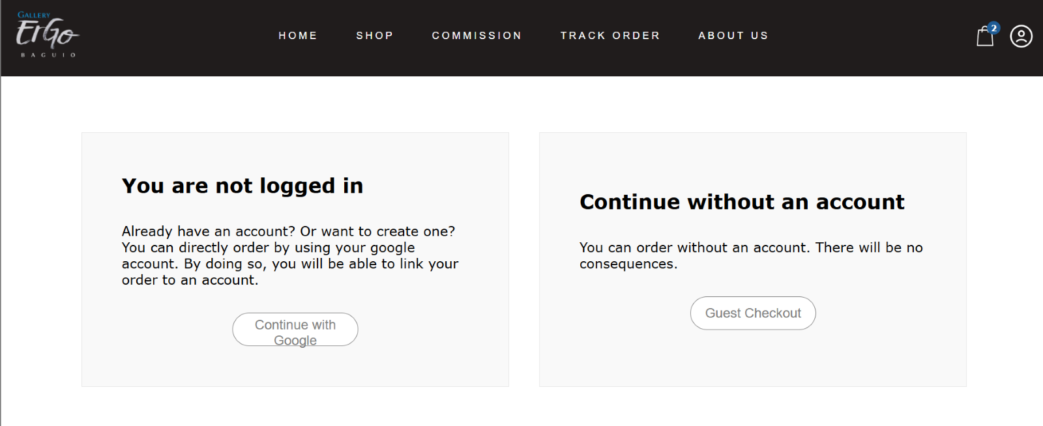 Upon proceeding to checkout, customers are given the option to place an order either by logging in with their Google account or by continuing as a guest. Selecting "Continue with Google" redirects the user to the Google login page for a quick and secure sign-in process. Alternatively, customers can choose "Guest Checkout" to complete their purchase without creating or logging into an

account. This flexibility allows for a convenient and user-friendly shopping experience, accommodating both new and returning users.

Figure 28

Login

  
 Clicking on “Sign in with Google” will redirect the customer to Google’s login page, where they can securely sign in to the website using their Google account credentials. This provides a quick and seamless authentication process, eliminating the need for manual account creation. By leveraging Google’s secure authentication protocols, the website ensures user data privacy and reduces the risk of unauthorized access. Additionally, this integration allows customers to access their personalized settings and preferences without needing to remember multiple passwords. The process enhances the overall user experience, making it more convenient and secure.

Figure 29

Checkout Form

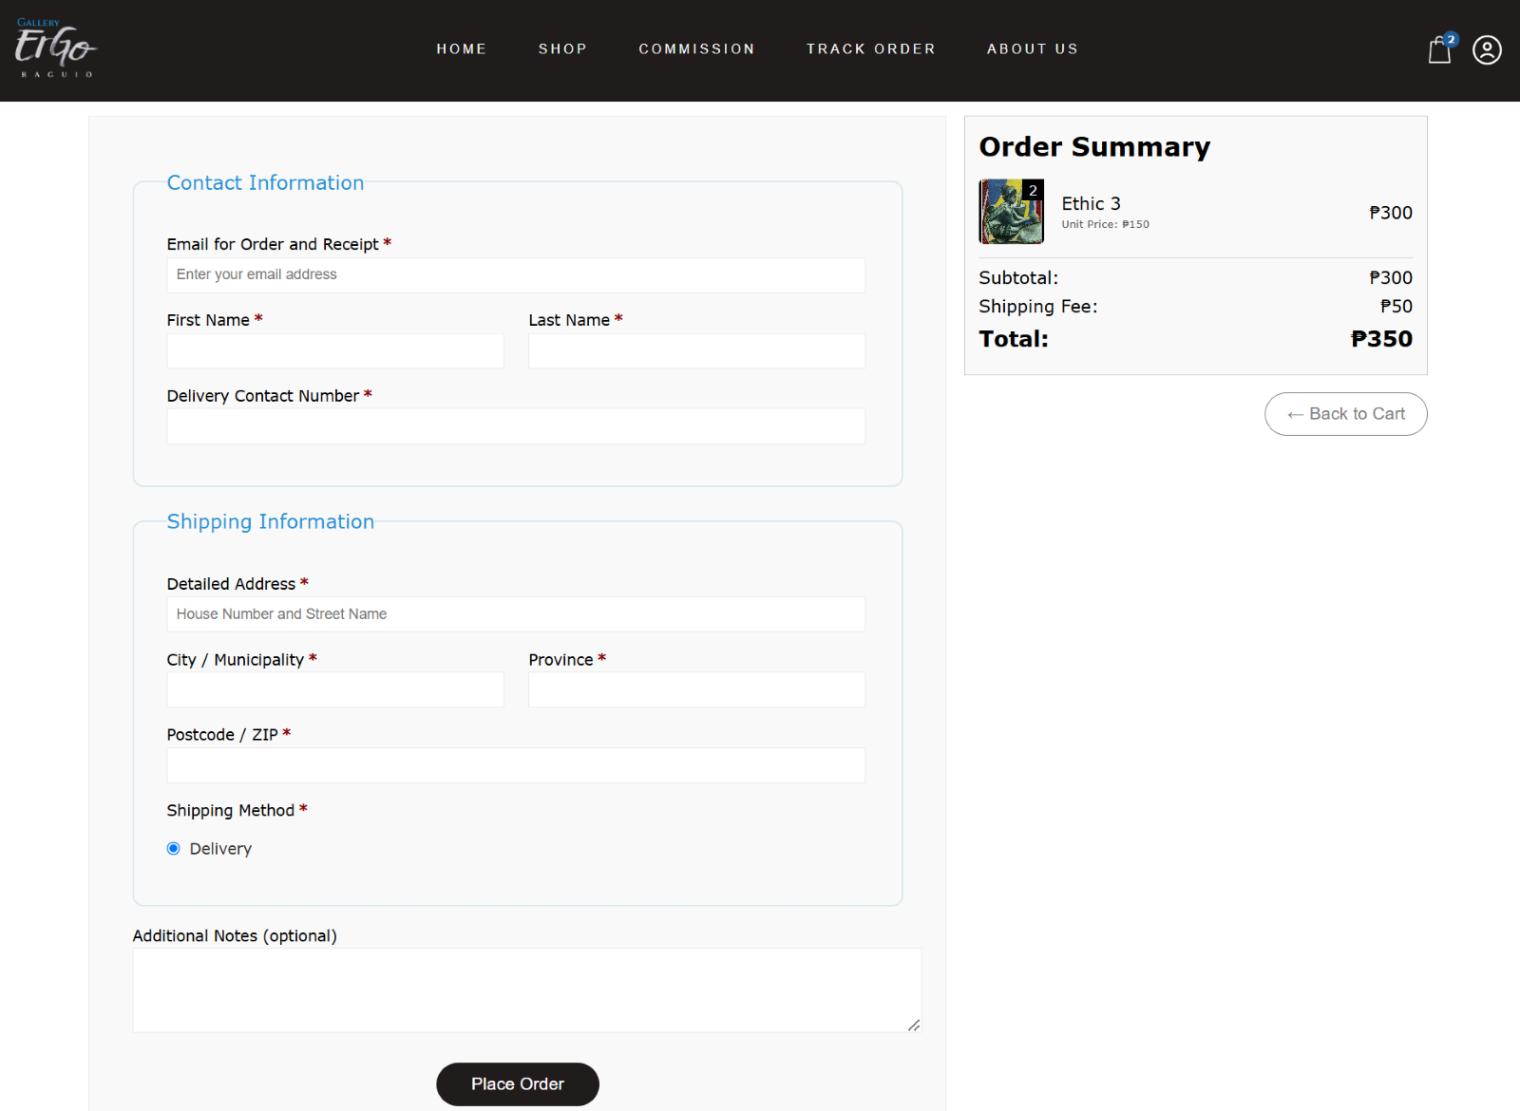  
 Before completing an order, customers are required to provide essential contact and shipping details. This includes their full name, contact number, and delivery address to ensure accurate order processing and successful delivery. These details are also used to verify the identity of the customer and prevent fraudulent activities. Additionally, the system may offer an option to save this information for future orders, streamlining the checkout process for returning customers

Figure 30

Commission

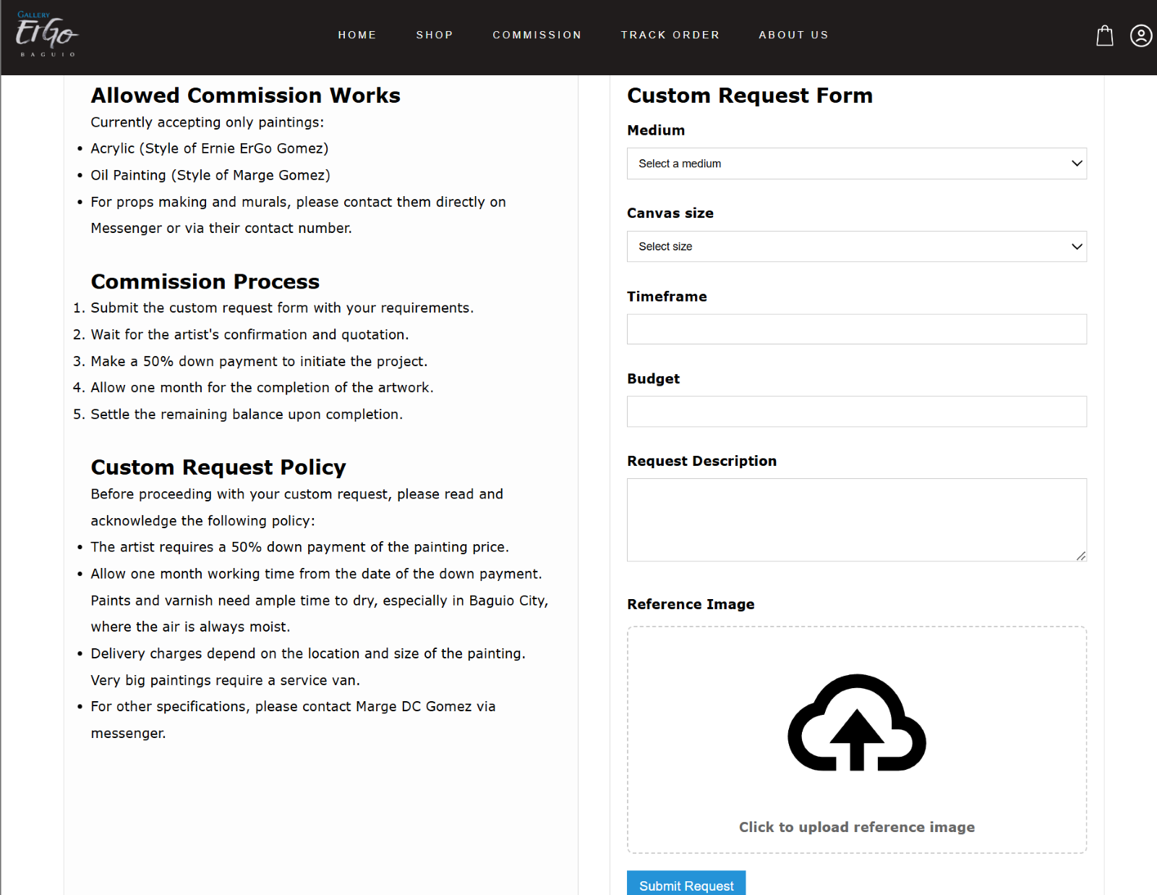 To request a custom painting from the artist, customers must first confirm that they have read and understood the commission policy and process by clicking the “I Acknowledge” button. Once acknowledged, the custom request form will appear, allowing the customer to enter specific details about their desired artwork. After completing the form, the customer can click “Submit

Request” to send their commission request to the artist for review and confirmation.

Figure 31

Art Protection Feature



Figure 31 shows that artworks displayed on the platform are protected through embedded watermarks and by disabling options for downloads or prints. These protection mechanisms prevent unauthorized use or reproduction of the artists’ original work, ensuring their intellectual property remains secure.

**Usability Testing**

This section discusses the usability metrics of the proposed Gallery ErGo website and how it impacts its intended users.

The researchers utilized the Usefulness, Satisfaction, and Ease of Use (USE) usability scale to assess the system’s usefulness, ease of use, learnability, and satisfaction level. The USE scale was selected due to its clear and structured format, using a seven-point Likert

scale (1 for strongly disagree, 7 for strongly agree), which provided a more precise interpretation of the users’ responses and avoided neutral answers.

To determine the number of participants required for the usability testing, the researchers employed Slovin’s formula:

Where:

n = sample size

N = population size

e = margin of error

Figure 32

Slovin’s Formula

Given the estimated average number of visitors to Gallery ErGo—around 100 individuals based on weekend and weekday foot traffic—the researchers applied the following calculation:

$n=\frac{100}{1+{100(0.00499)}^{2}}=$ 100

$n$ = 100respondents

Thus, the researchers gathered responses from 100 participants, including students, art enthusiasts, potential buyers, and artists.

The USE questionnaire was used to evaluate the usability of the Gallery ErGo platform, composed of 30 items covering the dimensions of usefulness, ease of use, ease of learning, and satisfaction. The simplicity and

reliability of the USE scale made it suitable for assessing how intuitive and efficient the system was for different user types.

During the usability testing, data was collected from participants who explored and interacted with the website. The researchers used a seven-point Likert scale to capture opinions, with 1 signifying strong disagreement and 7 indicating strong agreement.

The results provided valuable insights into how users perceived the website’s usability and its effectiveness in showcasing and facilitating the purchase of artwork. Table 2 presents the average scores for each usability category and the overall evaluation of the Gallery ErGo website’s usability.

Table 4

Weighted Mean Description

|  |  |  |
| --- | --- | --- |
| Weighted Mean |  | Interpretation |
| 1.00 - 1.85 | 1 | Strongly Disagree |
| 1.86 - 2.71 | 2 | Disagree |
| 2.72 - 3.57 | 3 | Somewhat Disagree |
| 3.58 - 4.43 | 4 | Neutral |
| 4.55 - 5.29 | 5 | Somewhat Agree |
| 5.30 - 6.15 | 6 | Agree |
| 6.16 - 7.00 | 7 | Strongly Agree |

Based on the results of the usability evaluation conducted using the USE (Usefulness, Satisfaction, and Ease of Use) questionnaire, the Usefulness component of the Gallery Ergo system received a mean score of 5.25 on a 7-point Likert scale. This result falls under the "Somewhat Agree" category, indicating that users found the system to be highly useful in achieving their intended goals. The score reflects a positive reception from users regarding the platform’s functionality, specifically in terms of its capability to support tasks such as browsing, viewing, and purchasing artworks. This high level of usefulness suggests that the system effectively meets user’s needs and plays a significant role in delivering the core value of the Gallery Ergo platform.

Table 5

SALESVISTA Usability: Usefulness

|  |  |  |  |  |  |  |  |  |
| --- | --- | --- | --- | --- | --- | --- | --- | --- |
|  | Frequency | | | | |  |  | Weighted Mean |
|  | 1 | 2 | 3 | 4 | 5 | 6 | 7 |  |
| 1. It helps me to be more effective. | 2 | 1 | 1 | 9 | 14 | 36 | 37 | 4.88 |
| 1. It helps me be more productive. | 0 | 1 | 4 | 13 | 16 | 36 | 30 | 4.74 |
| 1. It is useful. | 0 | 2 | 1 | 7 | 9 | 19 | 62 | 5.29 |
| 1. It gives me more control over the activities in my life. | 0 | 1 | 2 | 12 | 18 | 35 | 32 | 5.03 |
| 1. It makes the things I want to accomplish easier to get done. | 0 | 1 | 2 | 5 | 18 | 32 | 42 | 5.33 |
| 1. It saves me time when I use it. | 0 | 0 | 4 | 7 | 13 | 23 | 53 | 5.65 |
| 1. It meets my needs. | 0 | 0 | 6 | 5 | 17 | 26 | 46 | 5.51 |
| 1. It does everything I would expect it to do. | 0 | 0 | 2 | 8 | 12 | 39 | 39 | 5.59 |
| MEAN |  |  |  |  |  |  |  | 5.25 |

The Ease-of-Use component of the Gallery Ergo system received a mean score of 5.72 based on the responses from the usability evaluation using the USE questionnaire. This score is within the "Agree" range on the 7-point Likert scale, indicating that users found the system extremely easy and intuitive to use. Such a high rating reflects that

user experienced minimal difficulty when navigating the website, interacting with features, or completing tasks such as exploring artworks, adding items to the cart, and proceeding through the checkout process. This result highlights the platform's strong focus on user-friendly design and reinforces its effectiveness in delivering a seamless user experience.

Table 6

SALESVISTA Usability: Ease of Use

|  |  |  |  |  |  |  |  |  |
| --- | --- | --- | --- | --- | --- | --- | --- | --- |
|  | Frequency | | | | |  |  | Weighted Mean |
|  | 1 | 2 | 3 | 4 | 5 | 6 | 7 |  |
| 1. It is easy to use. | 0 | 1 | 1 | 4 | 11 | 19 | 64 | 5.77 |
| 1. It is simple to use. | 0 | 1 | 3 | 5 | 6 | 22 | 63 | 5.74 |
| 1. It is user friendly. | 0 | 3 | 0 | 5 | 11 | 18 | 63 | 5.99 |
| 1. It requires the fewest step possible to accomplish what I want to do with it. | 0 | 1 | 2 | 10 | 12 | 26 | 49 | 5.68 |
| 1. It is flexible. | 0 | 1 | 4 | 6 | 12 | 29 | 48 | 5.69 |
| 1. Using it is effortless. | 0 | 1 | 2 | 8 | 13 | 27 | 49 | 5.72 |
| 1. I can use it without written instructions | 0 | 1 | 3 | 11 | 10 | 23 | 52 | 5.69 |
| 1. I don’t notice inconsistencies as I use it. | 0 | 0 | 6 | 10 | 15 | 27 | 42 | 5.49 |
| 1. Both occasional and regular users would like it. | 0 | 1 | 3 | 6 | 14 | 29 | 47 | 5.69 |
| 10. I can recover from mistakes quickly and easily. | 0 | 0 | 3 | 10 | 13 | 32 | 42 | 5.66 |
| 11. I can use it successfully every time. | 0 | 2 | 1 | 7 | 9 | 30 | 51 | 5.79 |
| MEAN |  |  |  |  |  |  |  | 5.72 |

The Ease of Learning aspect of the Gallery Ergo system received a mean score of 5.76, which falls within the "Agree" category on the 7-point Likert scale. This indicates that users found the system very easy to learn, even with little to no prior experience using similar platforms. The high score demonstrates that users were able to quickly understand how to navigate the site, use its features, and perform essential tasks such as browsing artworks and placing orders. This result suggests that the

system has a well-structured and intuitive interface, making it accessible to a wide range of users, including first-time visitors.

Table 7

SALESVISTA Usability: Ease of Learning

|  |  |  |  |  |  |  |  |  |
| --- | --- | --- | --- | --- | --- | --- | --- | --- |
|  | Frequency | | | | |  |  | Weighted Mean |
|  | 1 | 2 | 3 | 4 | 5 | 6 | 7 |  |
| 1. I learned to use it quickly. | 0 | 2 | 2 | 6 | 9 | 25 | 56 | 5.88 |
| 1. I easily remember how to use it. | 0 | 1 | 3 | 7 | 12 | 24 | 53 | 5.79 |
| 1. It is easy to learn to use it. | 0 | 1 | 3 | 8 | 6 | 29 | 53 | 5.79 |
| 1. I quickly became skillful with it. | 0 | 2 | 4 | 6 | 10 | 42 | 36 | 5.56 |
| MEAN |  |  |  |  |  |  |  | 5.76 |

The Satisfaction component of the Gallery Ergo system achieved a mean score of 5.74, placing it within the "Agree" category on the 7-point Likert scale. This high score indicates that users were highly satisfied with their overall experience using the platform. It reflects positive user sentiments regarding the system’s design,

functionality, responsiveness, and overall usability. The elevated satisfaction level suggests that the platform successfully delivers a pleasant and engaging user experience, contributing to user trust, repeat engagement, and potential word-of-mouth promotion.

Table 8

SALESVISTA Usability: Satisfaction

|  |  |  |  |  |  |  |  |  |
| --- | --- | --- | --- | --- | --- | --- | --- | --- |
|  | Frequency | | | | |  |  | Weighted Mean |
|  | 1 | 2 | 3 | 4 | 5 | 6 | 7 |  |
| 1. I am satisfied with it. | 0 | 1 | 2 | 6 | 7 | 32 | 52 | 5.85 |
| 1. I would recommend it to a friend. | 1 | 2 | 1 | 6 | 12 | 18 | 60 | 5.75 |
| 1. It is fun to use. | 1 | 1 | 3 | 7 | 17 | 23 | 48 | 5.59 |
| 1. It works the way I want it to work. | 0 | 1 | 0 | 8 | 11 | 35 | 45 | 5.89 |
| 1. It is wonderful. | 0 | 1 | 2 | 6 | 13 | 28 | 50 | 5.86 |
| 1. I feel I need to have it. | 0 | 2 | 1 | 16 | 19 | 28 | 34 | 5.45 |
| 1. It is pleasant to use. | 0 | 1 | 3 | 7 | 12 | 25 | 52 | 5.82 |
| MEAN |  |  |  |  |  |  |  | 5.74 |

Table 9

Summary of Result

|  |  |
| --- | --- |
|  | Mean |
| * Usefulness | 5.25 |
| * Ease of Use | 5.72 |
| * Ease of Learning | 5.76 |
| * Satisfaction | 5.74 |
| Overall Mean Level of Agreement | 5.62 |

As shown in Table 10, the Gallery Ergo system received high usability ratings across all four components of the USE questionnaire. The Usefulness scored a mean of 5.25, indicating that the system is perceived as highly effective in helping users accomplish their tasks. The Ease of Use and Ease of Learning components received means of 5.72 and 5.76, respectively, both falling under the "Excellent" category, which suggests that users found the system highly intuitive and easy to operate. The Satisfaction component also received an Excellent rating with a mean score of 5.74, reflecting a high level of user approval and enjoyment when interacting with the platform. Overall, the

system obtained an Overall Mean Level of Agreement of 5.62, reinforcing that the Gallery Ergo website delivers a well-rounded, user-friendly, and satisfying experience. These results validate the effectiveness of the design and implementation choices made during development. Additionally, users expressed that the system’s layout and navigation were particularly helpful in enhancing their experience. The high ratings indicate that the platform meets users' expectations for functionality and performance. It is evident that the focus on user-centric design has led to a highly positive reception. Furthermore, these results highlight the potential for the Gallery Ergo system to be widely adopted in real-world settings. As the platform continues to evolve, maintaining this level of usability will be crucial to ensuring long-term user satisfaction. The consistent positive feedback across the board suggests that the system’s core features, such as its seamless user interface and fast response times, have been effective. This will likely result in increased user retention and engagement as the system matures. The positive perception of the system also implies that users feel confident in relying on the platform for their needs.

Chapter 4

**CONCLUSIONS AND RECOMMENDATIONS**

This chapter presents the summary of the study, along with the conclusions derived from the findings. It also provides recommendations for current and future researchers and developers, based on the objectives of the study.

**Conclusions**

Below are the conclusions derived from the findings of the study;

1. The Gallery ErGo website successfully meets its objectives by providing users with relevant information and a functional, accessible platform. It fulfills the content, design, and usability requirements needed by both users and administrators.

2. The study established a solid structural foundation for the website, ensuring intuitive navigation, responsive design, and proper flow of interaction between users and site features.

3. The website’s main features—including artist profiles, secure checkout, and art protection function as intended and provide a reliable and user-friendly experience for both artists and customers.

4. The system’s usability was validated through user feedback, confirming the website's effectiveness and ease of use. The integration of data analytics also supports better business decision-making and contributes to the long-term sustainability of Gallery ErGo in the digital marketplace.

**Recommendations**

Based on the conclusions of the study for the Gallery ErGo website, the following recommendations may be considered to improve the platform:

1. Future researchers may consider integrating into a more advanced inventory management system to help artists and administrators manage products and sales more efficiently.

2. Future researchers may consider implementing more robust anti-piracy tools and automatic image tracking to further safeguard the intellectual property of artists.

3. Future researchers may consider including a review system to allow customers to share feedback and experiences.

4. Future researchers may consider integrating marketing tools such as email newsletters or promotional campaigns to boost visibility and sales, especially during off-event periods.

**REFERENCES**

Architectural Digest. (2021, February 11). Consumers have never been more comfortable shopping e-commerce. How do brands remain digitally relevant? Retrieved April 23, 2025, from <https://www.architecturaldigest.com/story/consumers-> have-never-been-more-comfortable-shopping-e-commerce- how-do-brands-stay-digitally-relevant

Arcarta. (2024, September 11). Art market risk: Hackers and data security. Retrieved from https://www.arcarta.com/stories/artmarket-datasecurity

Asana. (2025, January 19). What is Kanban? A beginner's guide for agile teams. Asana. https://asana.com/resources/what-is-kanban

Ashraf, A., Aqeel, S., & Muhammad, A. H. (2023). Evaluation of usability of e-commerce websites in Pakistan using system usability scale and heuristics methods. In Fraud Prevention, Confidentiality, and Data Security for Modern Businesses (pp. 150–164). IGI Global. <https://www.igi-global.com/chapter/evaluation-of-> usability-of-e-commerce-websites-in-pakistan-using- system-usability-scale-and-heuristics-methods/317958

Artwork Archive. (2024, March 5). Tips for selling your art online. Retrieved from

<https://www.artworkarchive.com/blog/tips-for-selling-> your-art-online

BlockByte. (2024, November 24). Model view controller (MVC) architecture: Basic principles. <https://blockbyte.tech/p/model-view-controller-mvc-> architecture-basic-principles

Canvas for Painting. (2024, June 29). Avoiding common mistakes when selling art online. Retrieved from <https://canvasforpainting.com/2024/06/29/avoiding-> common-mistakes-when-selling-art-online/

Center for Art Law. (2020, December 3). Fairs and auctions going digital: How to keep transactions secure. Retrieved from <https://itsartlaw.org/2020/12/03/fairs-> and-auctions-going-digital-how-to-keep-transactions- secure/

Creative Flair. (2024). The evolution of art: How technology and social change are transforming the art world. <https://blog.creativeflair.org/the-evolution-> of-art-how-technology-and-social-change-are- transforming-the-art-world-2/

Dam, R. F. (2025, March 13). The 5 stages in the design thinking process. Interaction Design Foundation. Retrieved April 23, 2025, from <https://www.interaction-> design.org/literature/article/5-stages-in-the-design- thinking-process

Dias, R. P., Vidanapathirana, C. S. L., Weerasinghe, R., Manupiya, A., Bandara, R. M. S. J., & Ranasinghe, Y. P. H. W. (2023). Automated use case diagram generator using NLP and ML. arXiv. https://arxiv.org/abs/2306.06962

Dudhat, A., & Ali Abbasi, M. (2021). Discussion of Agile Software Development Methodology and its Relevance to Software Engineering. ADI Journal on Recent Innovation, 3(1), 105–114. https://doi.org/10.34306/ajri.v3i1.536

Dunne, D., Eriksson, T., & Kietzmann, J. (2022). Can design thinking succeed in your organization? (First edition). MIT Sloan Management Review.

EdrawMax. (2020, December 30). Online shopping UML activity diagram. EdrawMax Templates. https://www.edrawmax.com/templates/1001715

EdrawMax. (2024, November 27). Online shopping website activity diagram. EdrawMax Templates. <https://www.edrawmax.com/templates/online-shopping-> website-activity-diagram-1060292/

Forbes. (2024). A 2024 report reveals small business marketing challenges.

<https://www.forbes.com/sites/allbusiness/2024/04/30/a-> 2024-report-reveals-small-business-marketing- challenges/

Freshmind. (2023). Technology impact on art: Exploring the digital revolution. Freshmind Magazine. <https://freshmindmag.com/2023/05/05/technology-impact-> on-art-exploring-the-digital-revolution/

GeeksforGeeks. (2024, July 8). MVC framework introduction. <https://www.geeksforgeeks.org/mvc-framework-> introduction/

Ghanem, A. O. (2022). Agile-Scrum backlog changes optimization in software engineering organizations (Master’s thesis, An-Najah National University). <https://repository.najah.edu/bitstreams/d5e74253-e59e-> 4d84-a221-5d61a8b92a69/download

GitHub. (2024, August). What is version control? <https://github.com/resources/articles/software-> development/what-is-version-control

Google Developers. (2025, January 23). Integrating Google Sign-In into your web app. Retrieved from <https://developers.google.com/identity/sign-> in/web/sign-in

Hardawar, D. (2025, March). How to use ChatGPT to write code—and my favorite trick to debug what it generates. ZDNet. <https://www.zdnet.com/article/how-to-use-> chatgpt-to-write-code-and-my-favorite-trick-to-debug- what-it-generates/

Hernandez, R. D. (2023, September 25). The model view controller pattern – MVC architecture and frameworks explained. freeCodeCamp. <https://www.freecodecamp.org/news/the-model-view-> controller-pattern-mvc-architecture-and-frameworks- explained/

Imtiaz, S., Khan, H. H., & others. (2022). Challenges of Agile–Crowd software development: A systematic literature review. International Journal of Software Engineering and Its Applications. https://doi.org/10.1142/S0218126623300015

Interaction Design Foundation. (2025, March 25). What is design thinking? Interaction Design Foundation. Retrieved April 23, 2025, from <https://www.interaction-> design.org/literature/topics/design-thinking

Intanny, V. A., Widiyastuti, I., & Perdani, M. D. K. (2021). Measuring usability and user experience of the marketplace of Jogjaplaza.id using UEQ and USE questionnaire. Jurnal Pekommas, 6(2), 123–132.

<https://jurnal.kominfo.go.id/index.php/pekommas/articl> e/view/1584

Jain, S., & Purandare, P. (2021). Study of the usability testing of e-commerce applications. Journal of Physics: Conference Series, 1964(4), 042059. https://doi.org/10.1088/1742-6596/1964/4/042059

Khalisatifa, A., & Ibrahim, A. (2024). Usability evaluation of an e-commerce integrated with a fan community platform using cognitive walkthrough. Journal of Applied Informatics and Computing, 9(1), 15–25. <https://jurnal.polibatam.ac.id/index.php/JAIC/article/> view/8865

Khan, T., et al. (2023). Risk prioritization using a fuzzy based approach in software development design phase. International Journal of Recent Innovation Trends in Computing and Communication. Retrieved from <https://ijritcc.org/index.php/ijritcc/article/view/915> 3

Kissflow. (2025, February 24). Kanban methodology: The simplest agile framework. Kissflow. https://kissflow.com/project/agile/kanban-methodology/

Lewrick, M. (2020). The design thinking toolbox: A guide to mastering the most popular and valuable innovation methods. John Wiley & Sons, Inc.

Lokuyaddage, S. (2024, May 31). MVC architecture | Understand model view controller pattern. Medium. <https://medium.com/@cydexcode/mvc-architecture-> understand-model-view-controller-pattern-b0dc38dc03ea

McKinsey Global Institute. (2021). Solving the paradox of growth and profitability in e-commerce. McKinsey & Company. <https://www.mckinsey.com/capabilities/growth-> marketing-and-sales/our-insights/whats-next-in- ecommerce

Metridev. (2024, May 17). Backlog in software engineering: A comprehensive guide. Metridev. <https://www.metridev.com/metrics/backlog-in-software-> engineering-a-comprehensive-guide/

Netsmartz. (2022). The ultimate Kanban software development guide for 2022. Netsmartz. <https://netsmartz.com/blog/kanban-software-> development/

Obsidian. (2020, March 30). Obsidian Release v0.0.1. https://obsidian.md

Organisation for Economic Co-operation and Development. (2021). OECD SME and entrepreneurship outlook 2021. OECD Publishing. <https://www.oecd.org/industry/smes/oecd-sme-and-> entrepreneurship-outlook-2021-97a5bbfe-en.htm

Patil, R. (2024, September). A guide to building reusable React components. Medium. <https://medium.com/@rashmipatil24/reusable-react-> components-7b025f232ca4

Phoasy. (2024). The intersection of art and technology: How digital platforms are shaping modern creativity. <https://phoasy.com/the-intersection-of-art-and-> technology-how-digital-platforms-are-shaping-modern- creativity/

Pivotal Moments. (2019). 1982: Boston Computer Exchange. <https://pivotal.digital/insights/1982-boston-computer-> exchange

Samantha Digital. (2023). 11 marketing challenges for small businesses. <https://samanthadigital.com/marketing-> challenges-for-small-businesses/

Schoon, B. (2021, October 19). Android 12 'Snow Cone' gets an AR statue. 9to5Google. Retrieved from <https://9to5google.com/2021/10/19/how-to-check-out-> googles-android-12-snow-cone-3d-statue/

Tessell. (2023, January). PostgreSQL – Concepts, benefits and use cases. <https://www.tessell.com/blogs/postgresql-concepts-> benefits-and-use-cases

The Abundant Artist. (2020). Legal aspects of selling art online: Copyrights, contracts, and more. Retrieved from <https://theabundantartist.com/legal-aspects-of-> selling-art-online-copyrights-contracts-and-more/

The Abundant Artist. (2020). Top 7 artist eCommerce shops - How to sell art online. <https://theabundantartist.com/top-7-artist-ecommerce-> shops/

Venni, F. (2024). Practical applications of Scrum: An empirical analysis of Product Backlog management practices (Master’s thesis, Fundação Getulio Vargas, Escola de Administração de Empresas de São Paulo). Fundação Getulio Vargas. <https://repositorio.fgv.br/server/api/core/bitstreams/> b1434e44-1b15-4213-b893-e58f4eb24060/content

Virto Commerce. (2023). eCommerce history — How did it all begin?. https://virtocommerce.com/blog/ecommerce-histo

Vogue Business. (2020, November 30). What to know about virtual stores. Retrieved April 23, 2025, from <https://www.voguebusiness.com/technology/what-to-know-> about-virtual-stores

Wade Lawyers. (2020). Navigating legal issues when selling art online: Copyright and licensing. Retrieved from

<https://wadelawyers.com/navigating-legal-issues-when-> selling-art-online/

Wagner, E. (2020). Crafting a future online: A study of how independent craftspeople adopt digital platforms. Journal of Research in Interactive Marketing, 14(3), 239–255. https://doi.org/10.1108/JRIM-03-2020-0046

**APPENDICES**

Appendix A

Communication Letter



Appendix B

Acceptance Letter



Appendix C

TBI Assessment Certification



Appendix D

USE Questionnaire



Appendix E

Sample Result of Testing

1. Survey sample from form

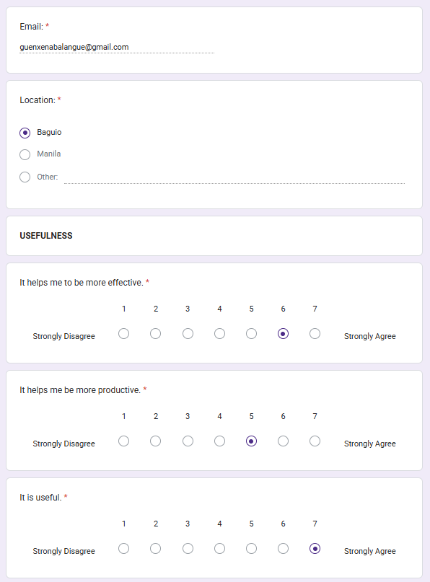 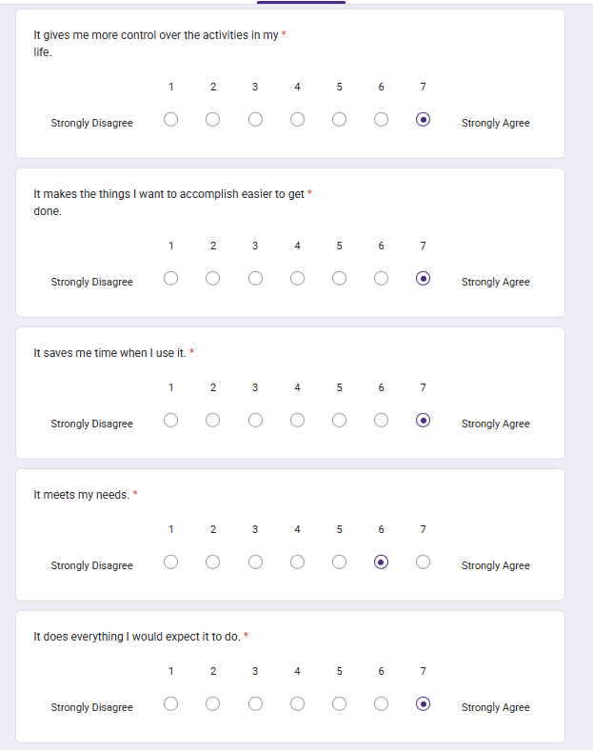

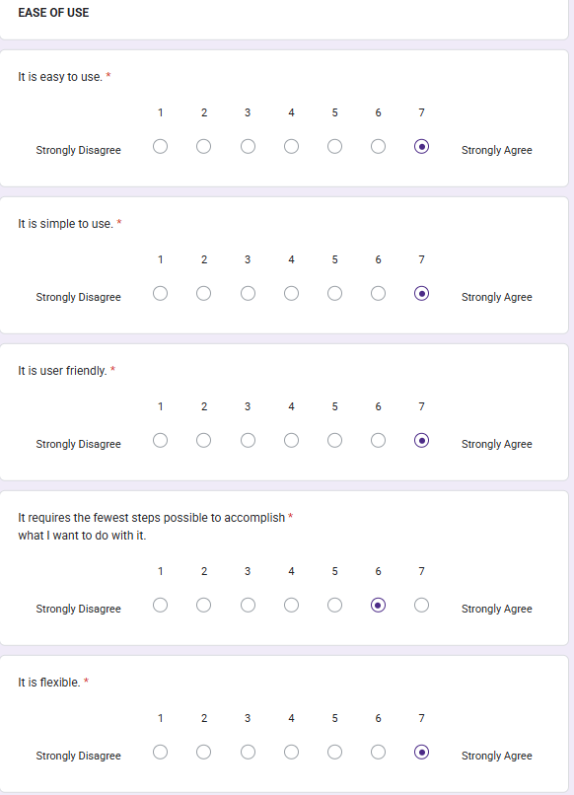 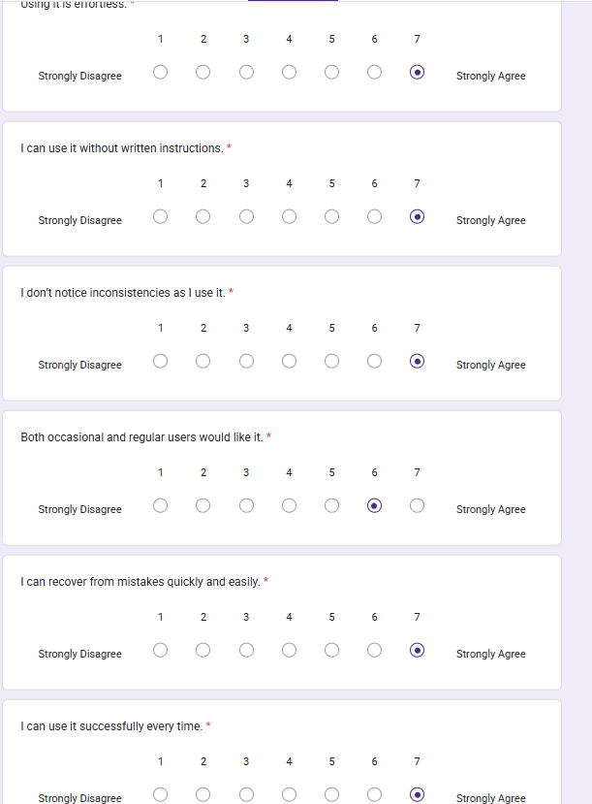

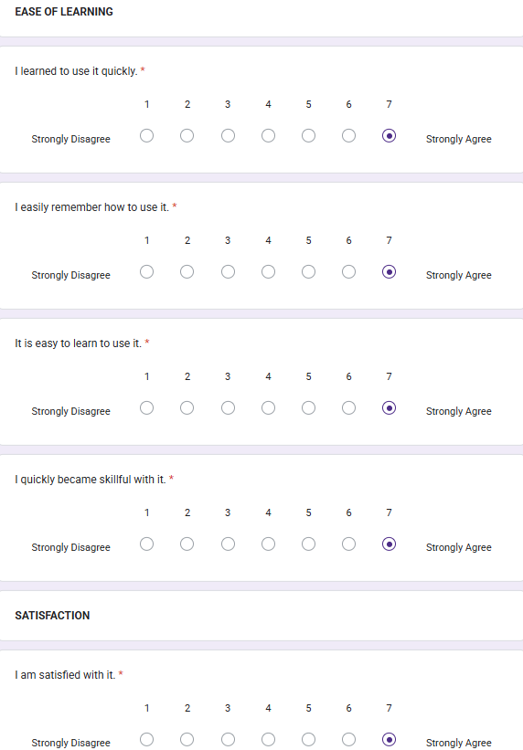 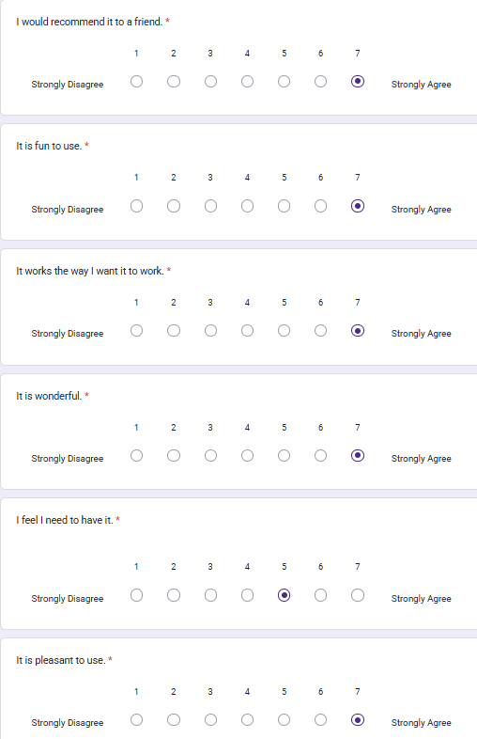

1. Survery sample from Hard copy

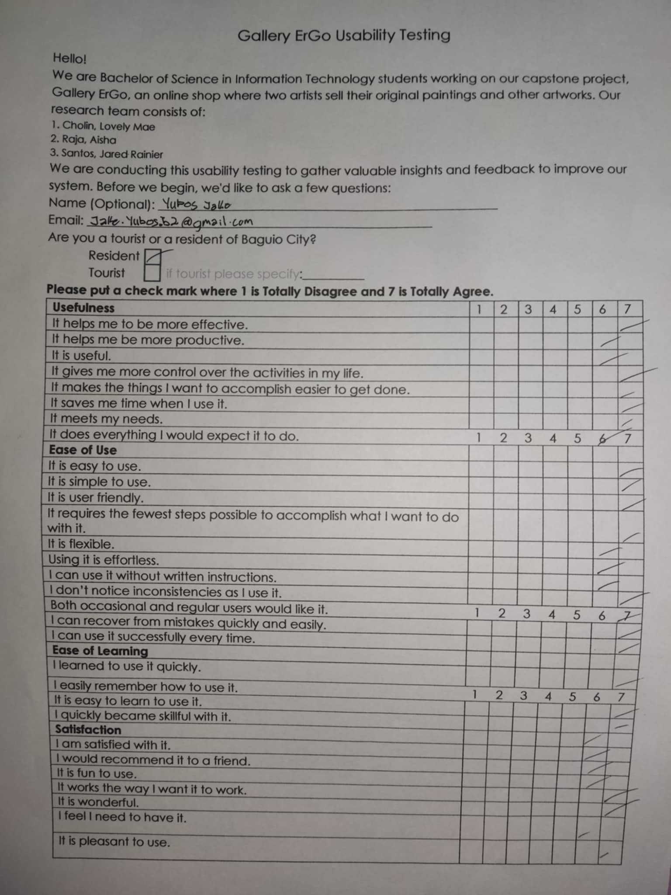

Appendix F

Tabular Form of the Test Result

|  |  |  |  |  |  |  |  |  |
| --- | --- | --- | --- | --- | --- | --- | --- | --- |
| **Usefulness** | 1 | 2 | 3 | 4 | 5 | 6 | 7 | Mean |
| 1. It helps me to be more effective. | 2 | 1 | 1 | 9 | 14 | 36 | 37 | 4.88 |
| 2. It helps me be more productive. | 0 | 1 | 4 | 13 | 16 | 36 | 30 | 4.74 |
| 3. It is useful. | 0 | 2 | 1 | 7 | 9 | 19 | 62 | 5.29 |
| 4. It gives me more control over activities in my life. | 0 | 1 | 2 | 12 | 18 | 35 | 32 | 5.03 |
| 5. It makes the things I want to accomplish easier to get done. | 0 | 1 | 2 | 5 | 18 | 32 | 42 | 5.33 |
| 6. It saves me time when I use it. | 0 | 0 | 4 | 7 | 13 | 23 | 53 | 5.65 |
| 7. It meets my needs. | 0 | 0 | 6 | 5 | 17 | 26 | 46 | 5.51 |
| 8. It does everything I would expect it to do. | 0 | 0 | 2 | 8 | 12 | 39 | 39 | 5.59 |
| **Ease of Use** | 1 | 2 | 3 | 4 | 5 | 6 | 7 | Mean |
| 9. It is easy to use. | 0 | 1 | 1 | 4 | 11 | 19 | 64 | 5.77 |
| 10. It is simple to use. | 0 | 1 | 3 | 5 | 6 | 22 | 63 | 5.74 |
| 11. It is user friendly. | 0 | 3 | 0 | 5 | 11 | 18 | 63 | 5.99 |
| 12. It requires the fewest steps possible to accomplish what I want to do with it. | 0 | 1 | 2 | 10 | 12 | 26 | 49 | 5.68 |
| 13. It is flexible. | 0 | 1 | 4 | 6 | 12 | 29 | 48 | 5.69 |
| 14. Using it is effortless. | 0 | 1 | 2 | 8 | 13 | 27 | 49 | 5.72 |
| 15. I can use it without written instructions. | 0 | 1 | 3 | 11 | 10 | 23 | 52 | 5.69 |
| 16. I don’t notice inconsistencies as I use it. | 0 | 0 | 6 | 10 | 15 | 27 | 42 | 5.49 |
| 17. Both occasional and regular users would like it. | 0 | 1 | 3 | 6 | 14 | 29 | 47 | 5.69 |
| 18. I can recover from mistakes quickly and easily. | 0 | 0 | 3 | 10 | 13 | 32 | 42 | 5.66 |
| 19. I can use it successfully every time. | 0 | 2 | 1 | 7 | 9 | 30 | 51 | 5.79 |
| **Ease of Learning** | 1 | 2 | 3 | 4 | 5 | 6 | 7 | Mean |
| 20. I learned to use it quickly. | 0 | 2 | 2 | 6 | 9 | 25 | 56 | 5.88 |
| 21. I easily remember how to use it. | 0 | 1 | 3 | 7 | 12 | 24 | 53 | 5.79 |
| 22. It is easy to learn to use it. | 0 | 1 | 3 | 8 | 6 | 29 | 53 | 5.79 |
| 23. I quickly became skillful with it. | 0 | 2 | 4 | 6 | 10 | 42 | 36 | 5.56 |
| **Satisfaction** | 1 | 2 | 3 | 4 | 5 | 6 | 7 | Mean |
| 24. I am satisfied with it. | 0 | 1 | 2 | 6 | 7 | 32 | 52 | 5.85 |
| 25. I would recommend it to a friend. | 1 | 2 | 1 | 6 | 12 | 18 | 60 | 5.75 |
| 26. It is fun to use. | 1 | 1 | 3 | 7 | 17 | 23 | 48 | 5.59 |
| 27. It works the way I want it to work. | 0 | 1 | 0 | 8 | 11 | 35 | 45 | 5.89 |
| 28. It is wonderful | 0 | 1 | 2 | 6 | 13 | 28 | 50 | 5.86 |
| 29. I feel I need to have it. | 0 | 2 | 1 | 16 | 19 | 28 | 34 | 5.45 |
| 30. It is pleasant to use. | 0 | 1 | 3 | 7 | 12 | 25 | 52 | 5.82 |
| **Average USE score** | 5.61 | | | | | | | |

Appendix G

SalesVista User Manual: Customer



**CUSTOMER LANDING PAGE**

The customer page contains the clickable product categories:

Original Paintings

Art Prints

T-Shirts

Bags

Magnets

Miscellaneous Items



**SHOP**

Customer can browse products in the shop page by clicking on the category on the upper left or by using the search function on the upper right, then click on an item to view its details.

**PRODUCT DETAILS**

Customer can add a product to cart by clicking on the ‘Add to Cart’ button. The quantity to be added can also be increased or decreased, depending on the number of stocks.

**RECOMMENDED PRODUCTS**

A maximum of 5 products related to the current product by

the category or product name can be seen in this section.

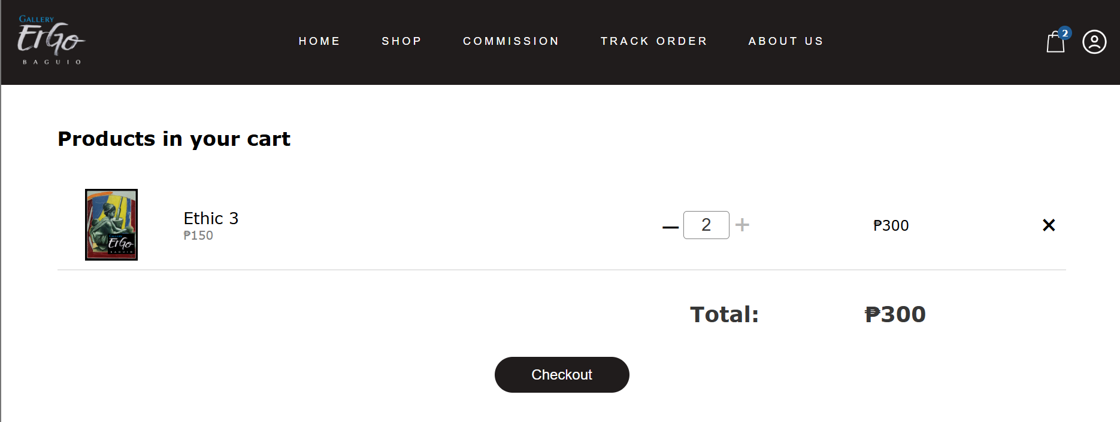**CART**

Customer can modify the items in the cart. An item can be removed, or its quantity can be increased or decreased. Click on the checkout to proceed with the order.

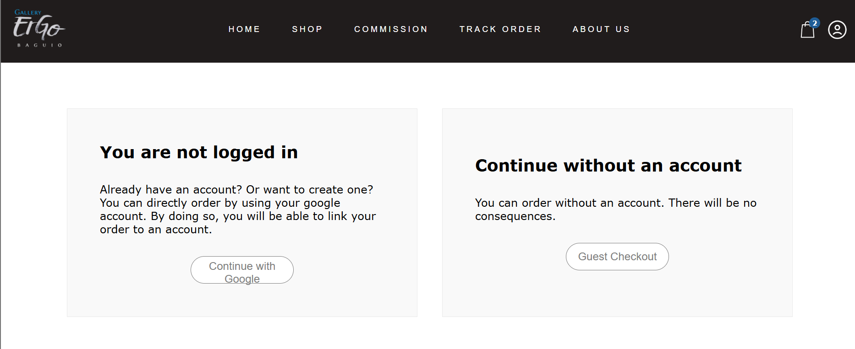**CHECKOUT**

Customer will be asked if they want to order with or

without logging in with Google. Click on ‘Continue with Google’ to go to the login page, or click on the ‘Guest Checkout’ to order without creating or logging into an account.



**LOGIN**

Clicking on ‘Sign in with Google’ will redirect the customer to Google’s login page, where they can login to the website using their Google account.

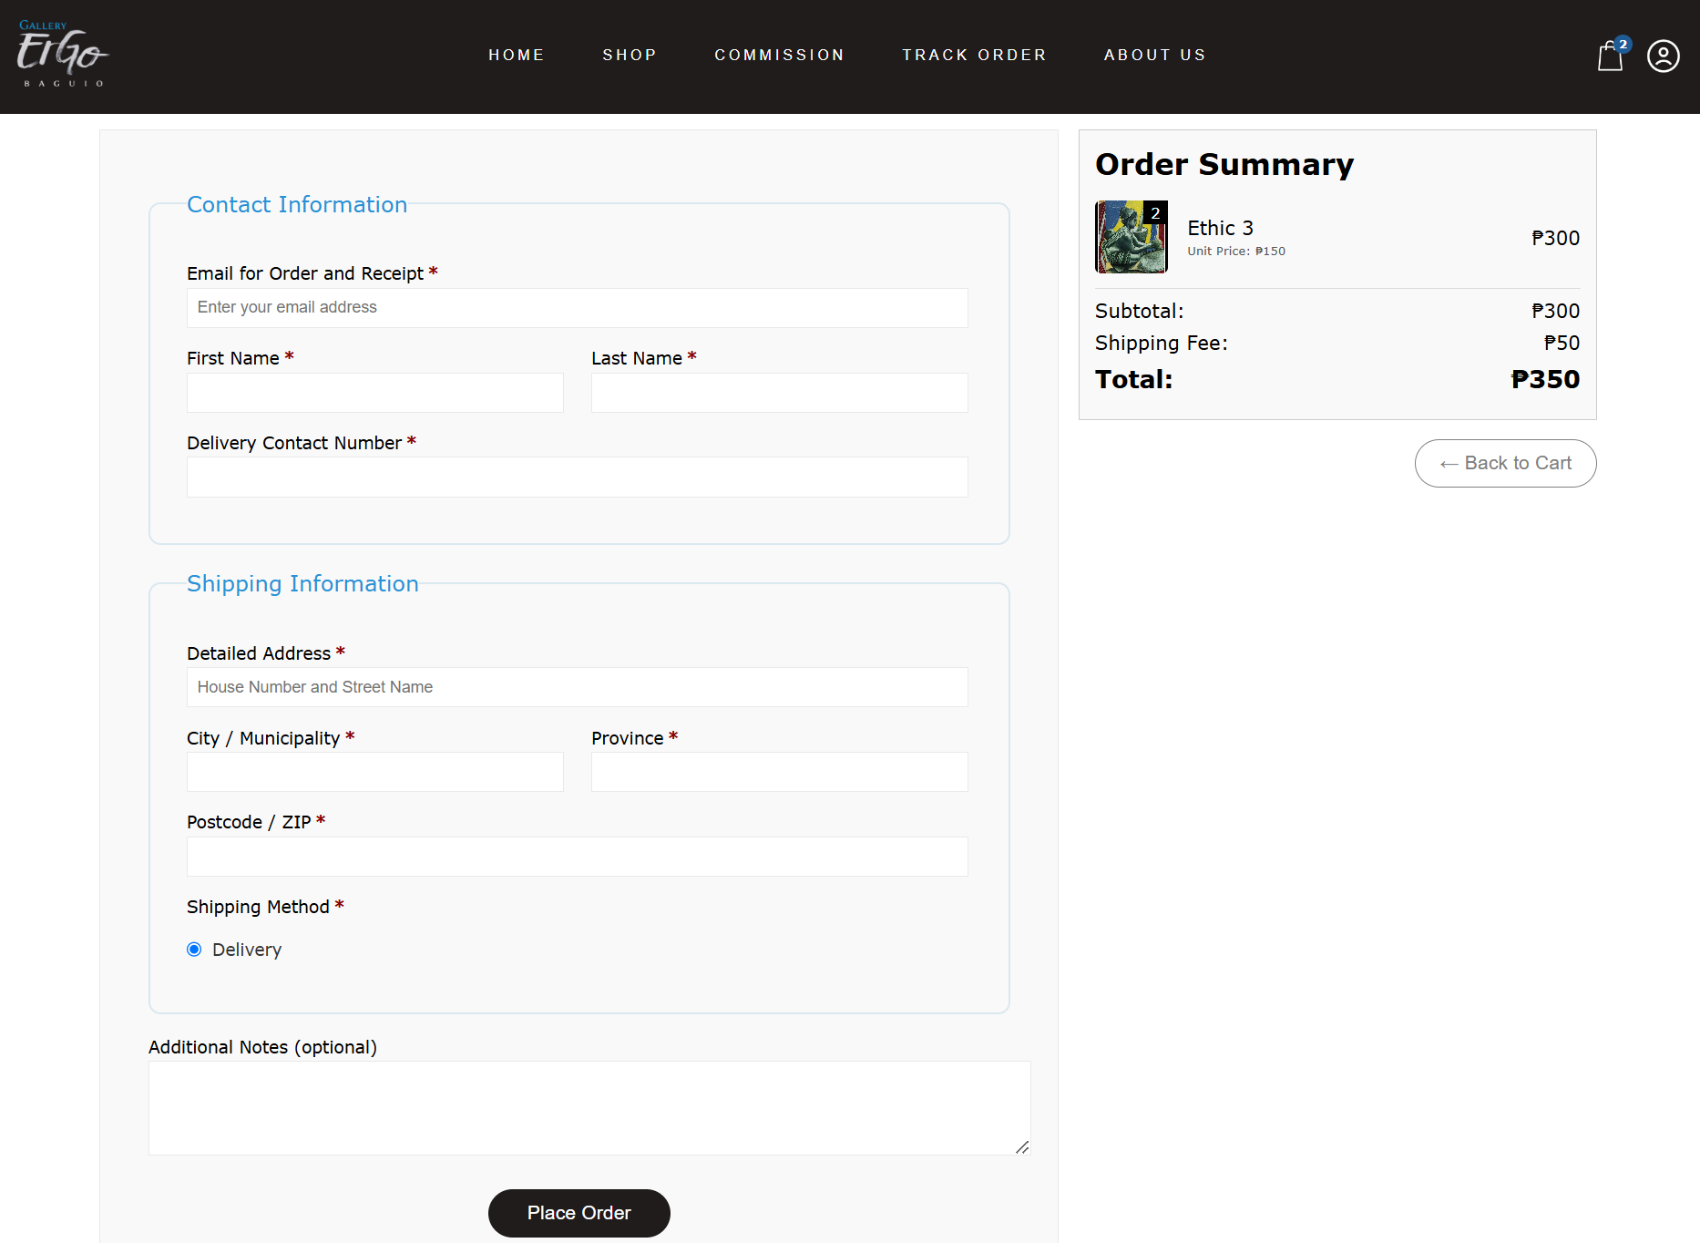

**CHECKOUT FORM**

Customer must enter their details before placing an order. These details include contact and shipping information.

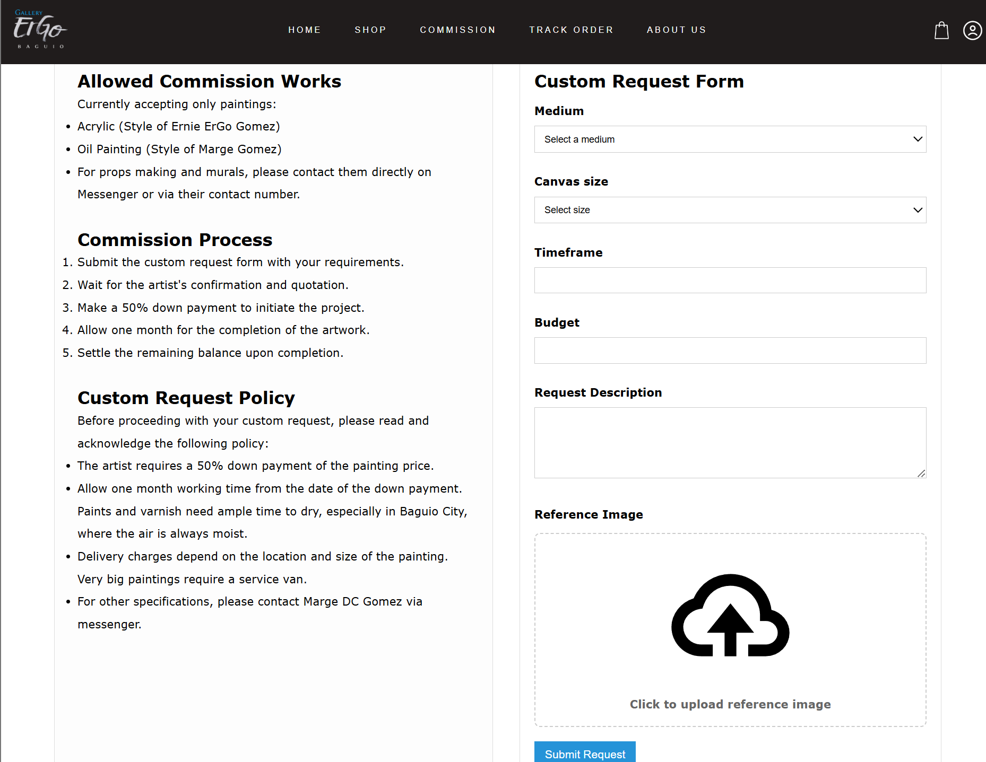**COMMISSION POLICY AND PROCESS**

To order a custom painting from the artist, the customer must acknowledge that they have read and understood the commission policy and process by clicking on the ‘I Acknowledge’ button. The custom request form will show up, and the customer must enter the details of their custom request, then click on ‘Submit Request’.

Appendix H

SalesVista User Manual: Admin

\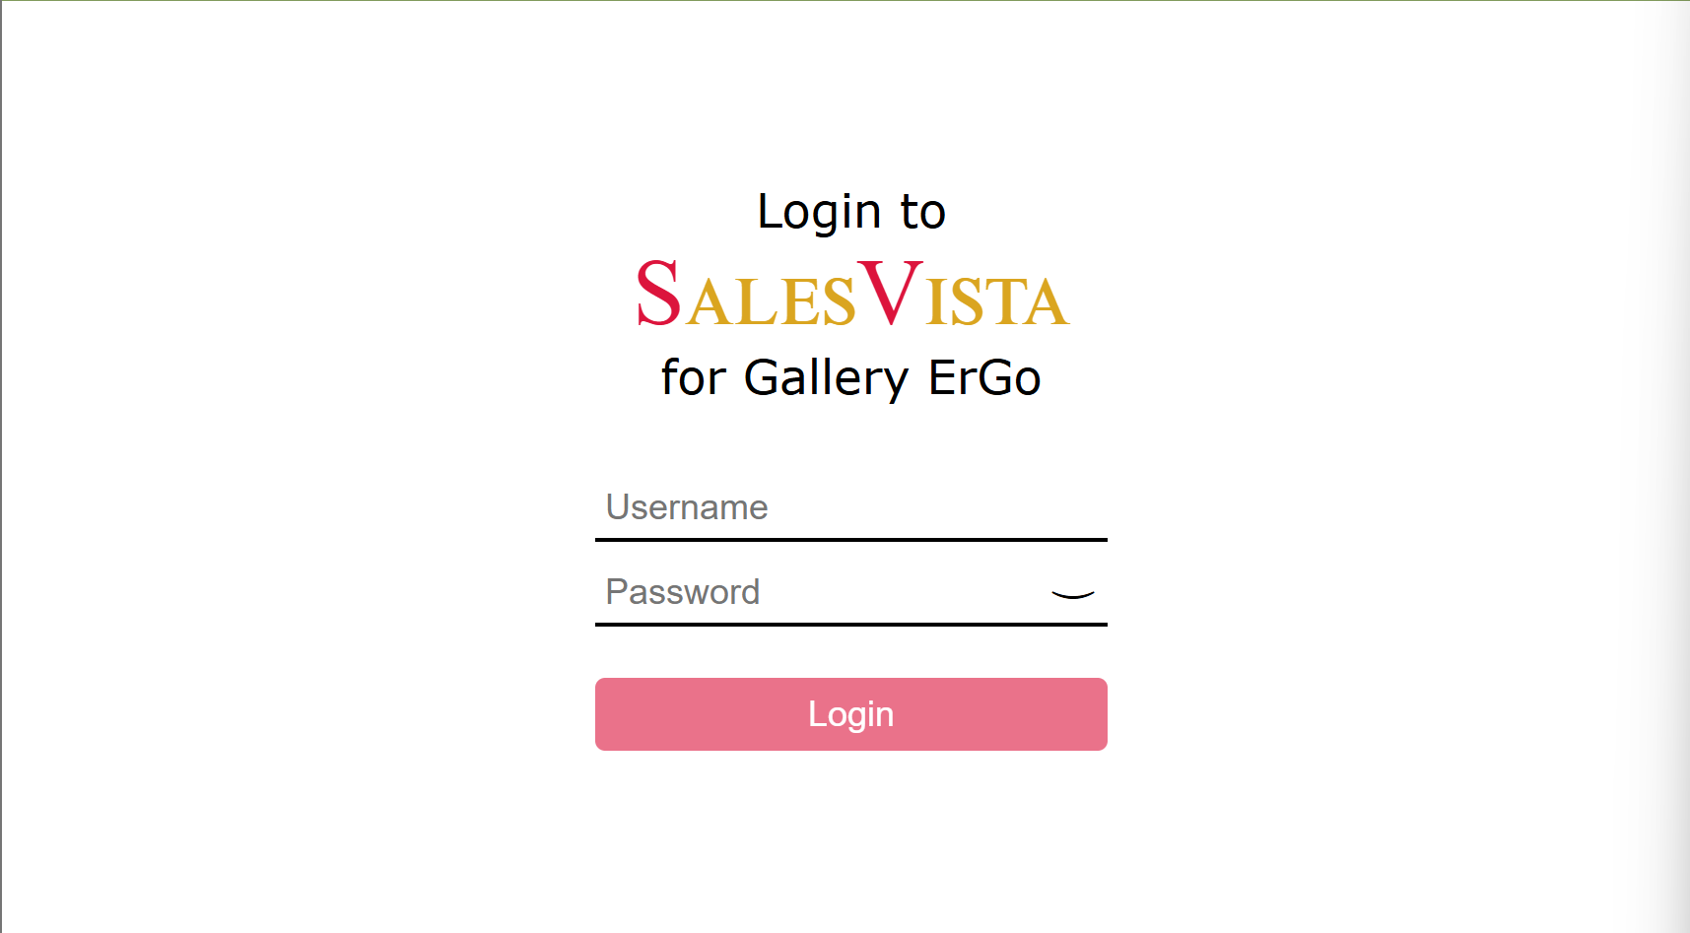

**LOGIN**

The admin will have to login by entering their username and password. After putting the username and password, click the ‘Login’ button.

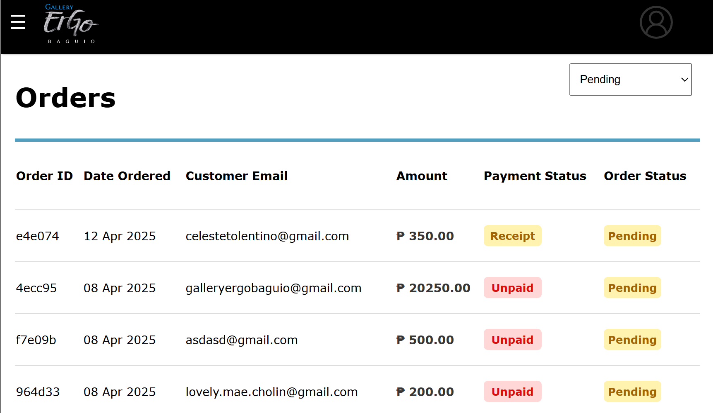

**ORDERS**

The admin can view the orders made on the website. It will display the order id, date ordered, customer email, amount, payment status, and order status. At the upper

right corner, you can filter the orders by the different order statuses. Click on an item to review an order.

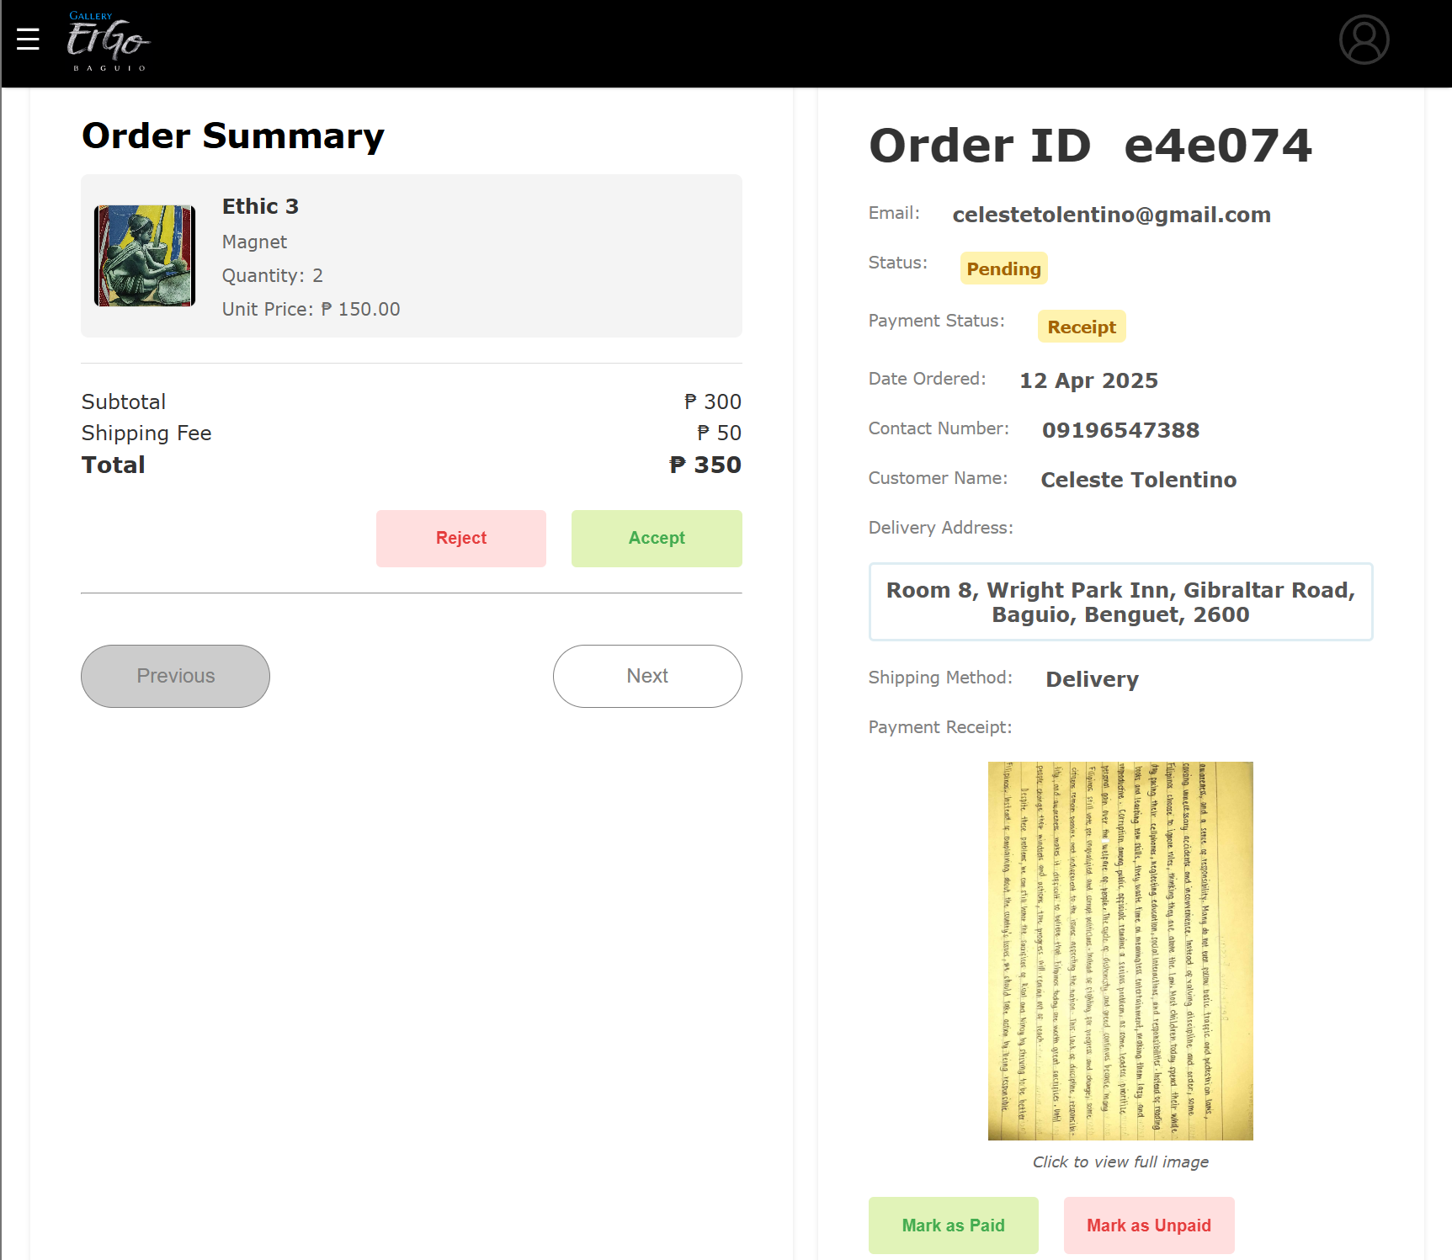

**ORDER DETAILS**

In the order details, the admin can accept or reject the order. The admin can also view if the customer has uploaded a receipt of their payment, then they can set the order as paid or unpaid.

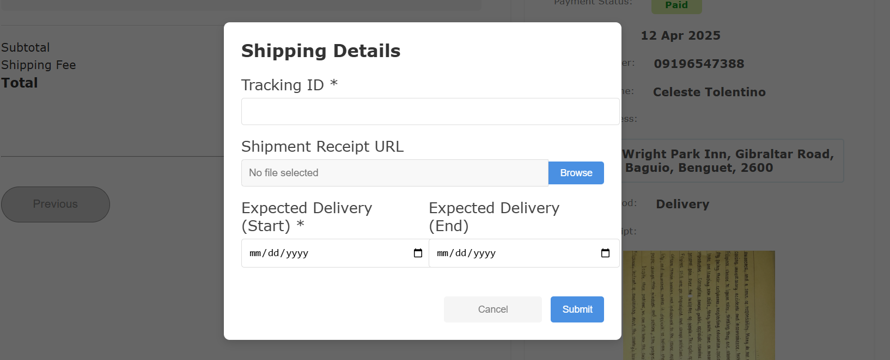

**SHIPPING AN ORDER**

The admin must enter the tracking ID and expected delivery date of the order, and an optional shipment receipt image.

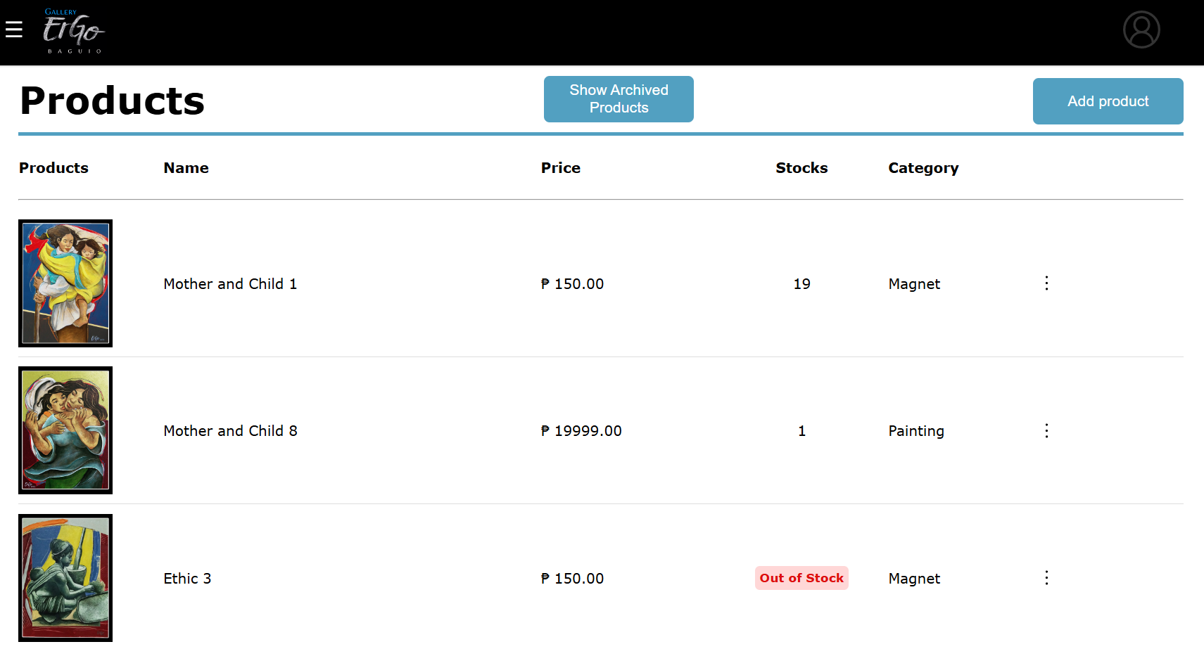

**PRODUCTS**

The admin can also view the products uploaded where it shows the product, name, price, stocks, and category. On the top corner, there is an add product button where the admin can add a product on the website. On the top middle, there is the show archived products where you can view the products that you have archived.

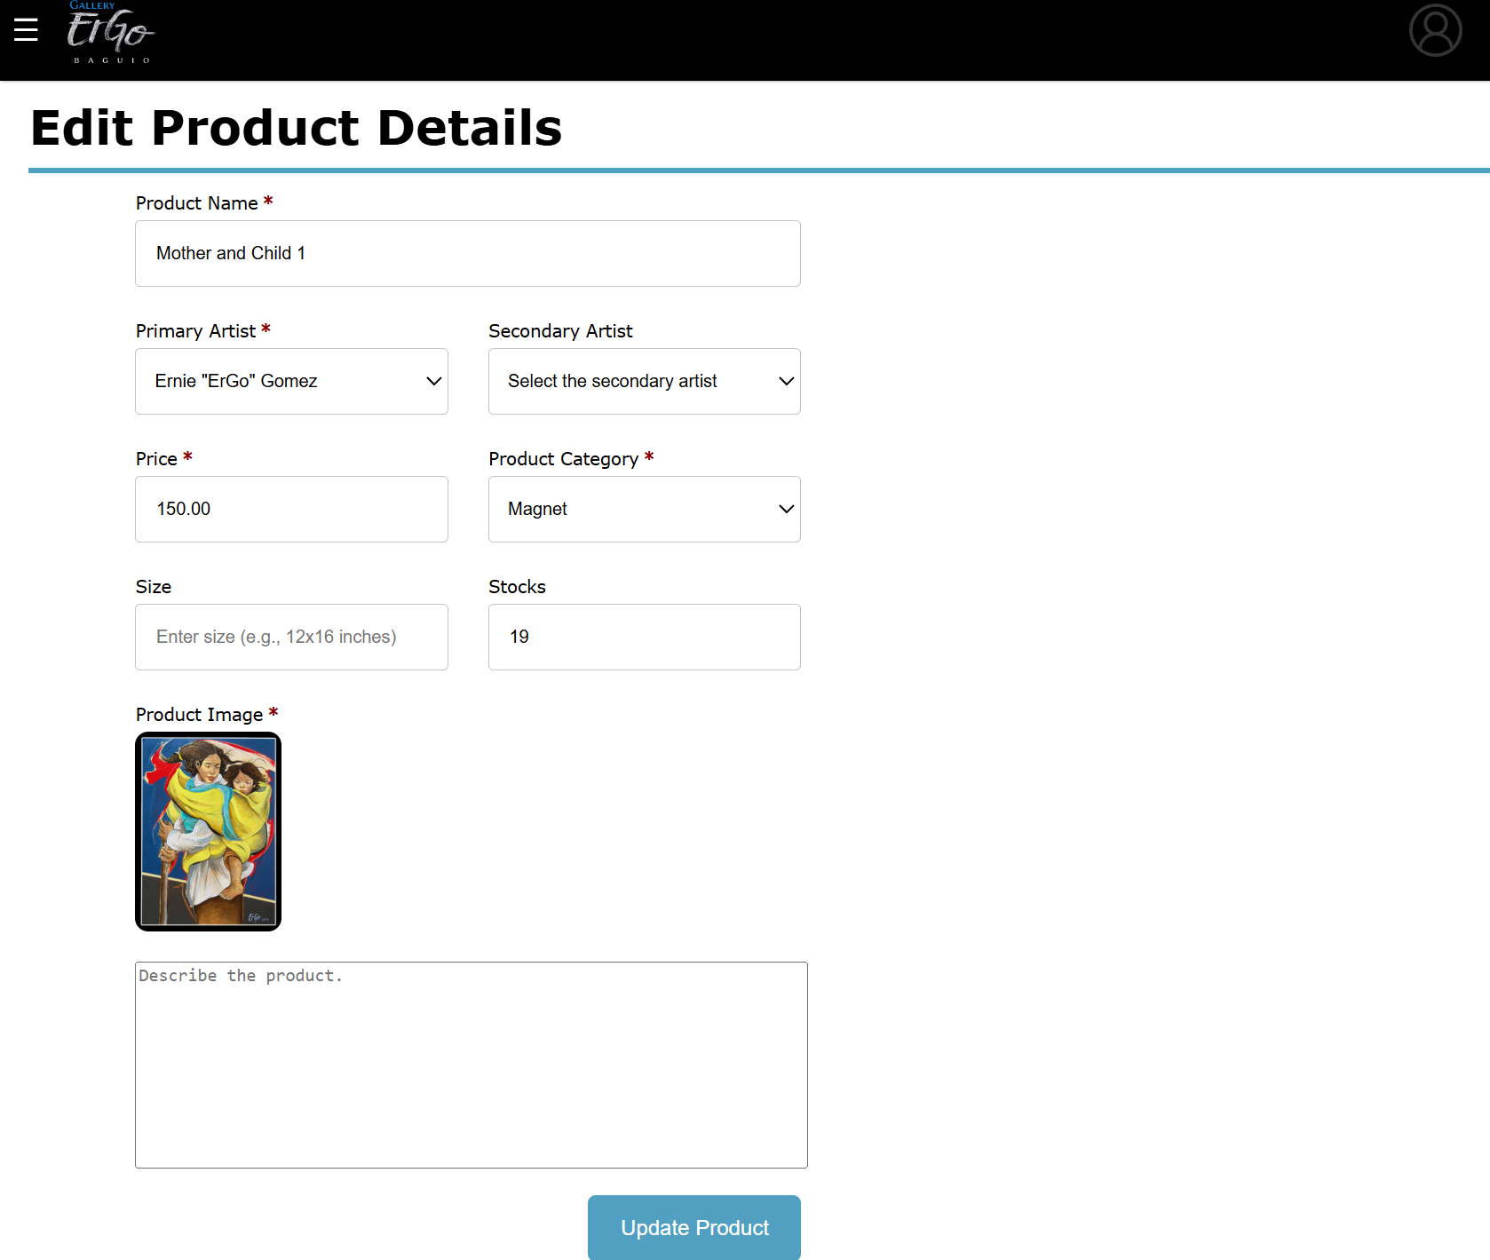

**EDIT PRODUCT**

A product can be edited by pressing the edit product button from the three bullets in the products page. The admin can edit the product name and other fields. After filling out the fields, click the update product below.

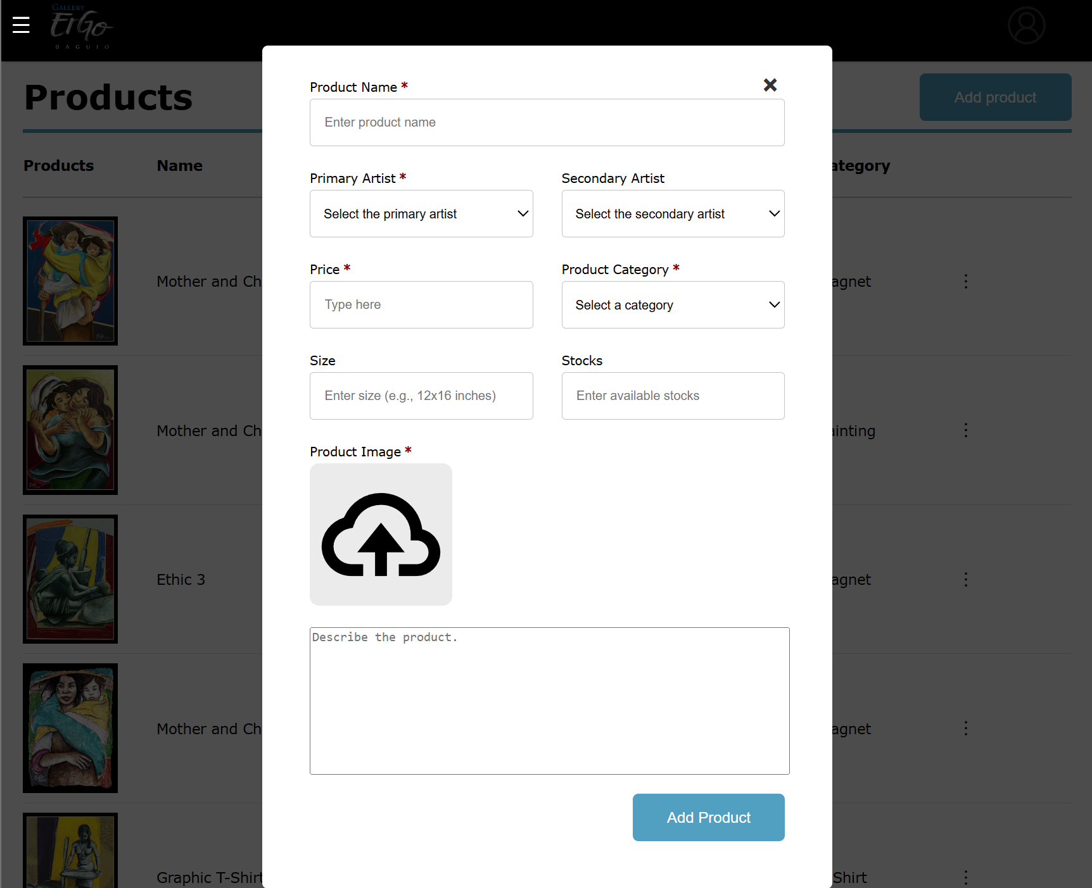**ADD PRODUCT**

The admin can add product by clicking the “Add Product” button at the top right corner of the products page. After clicking, there will be a pop up where you need to fill the fields with the product name, primary and secondary artists, price, category, size, stocks, product image and description. After filling the required fields, click the ‘Add Product’ below.

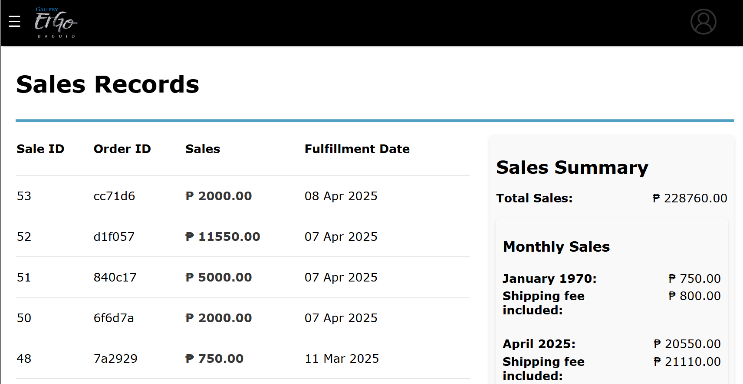**SALES**

The admin can view list of sales made where they can see the sale ID, order ID, sales, fulfillment dates, and the sales summary. In the sales summary, it is separated by the total sales and the sales per month.

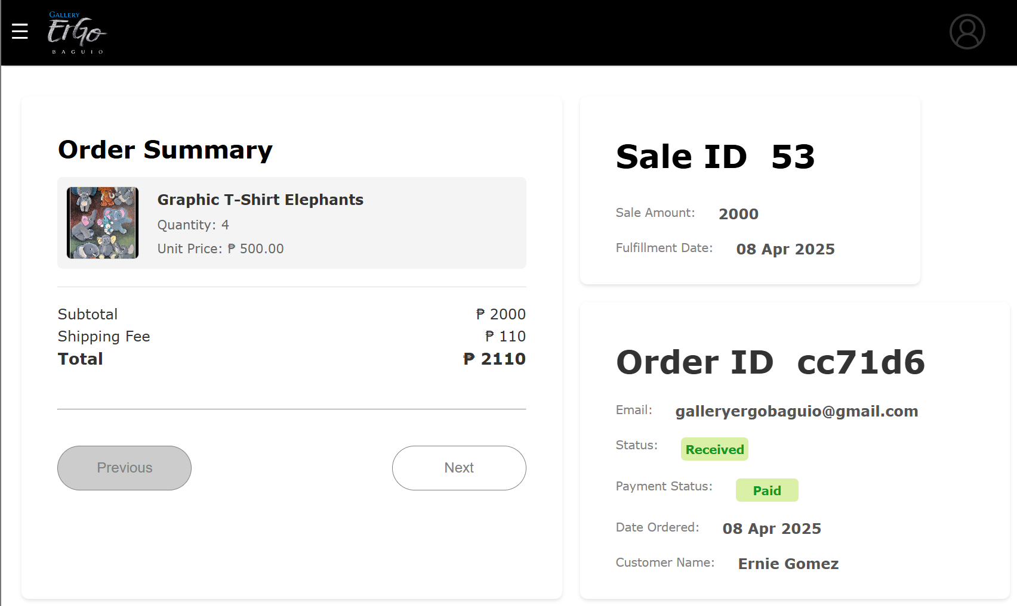**SALES RECORD**

A sales record contains the sale and order information. The admin can view the product/s sold, quantity, total prices, sale ID, and the information provided by the customers.

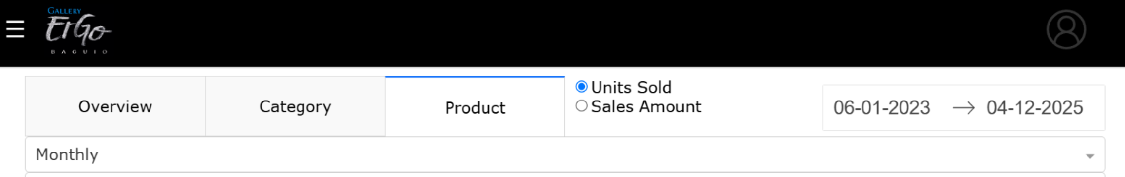**DASHBOARD OPTIONS**

The dashboard options can always be seen while in the dashboard, in all tabs, and the dashboard has three tabs that show different graph/s and data. The dashboard’s graphs and data can be manipulated to show data of a

specific date range by clicking the date range picker on the upper right and picking the start and end dates. The graphs and data can also be manipulated to display results based on the units sold or sales amount by choosing between the two radio buttons on the left of the date range picker. Data can also be grouped daily, weekly, or monthly by using the dropdown button.

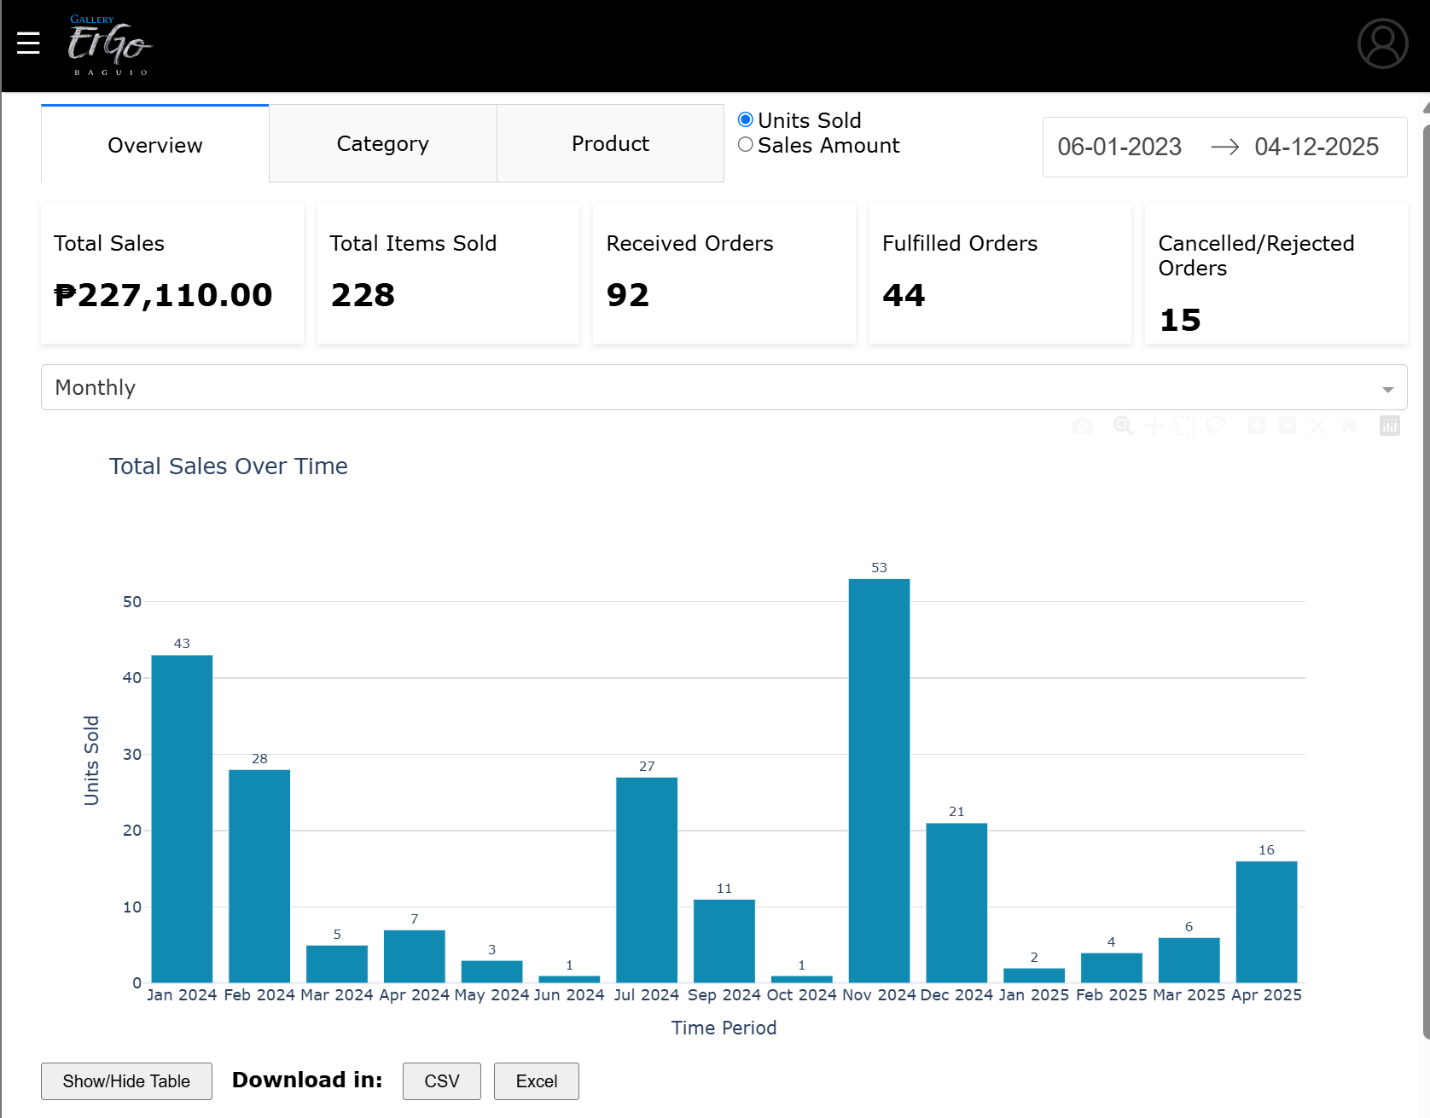**DASHBOARD OVERVIEW**

The Overview tab displays summary of total sales, total items sold, received orders, fulfilled orders, and

cancelled/rejected orders. It shows the Total Sales Over Time grouped bar chart, which has a viewable and downloadable (.csv and .xlsx) table. Two other graphs: Top 10 Products horizonal bar chart, and Sales Performance by Category pie chart.

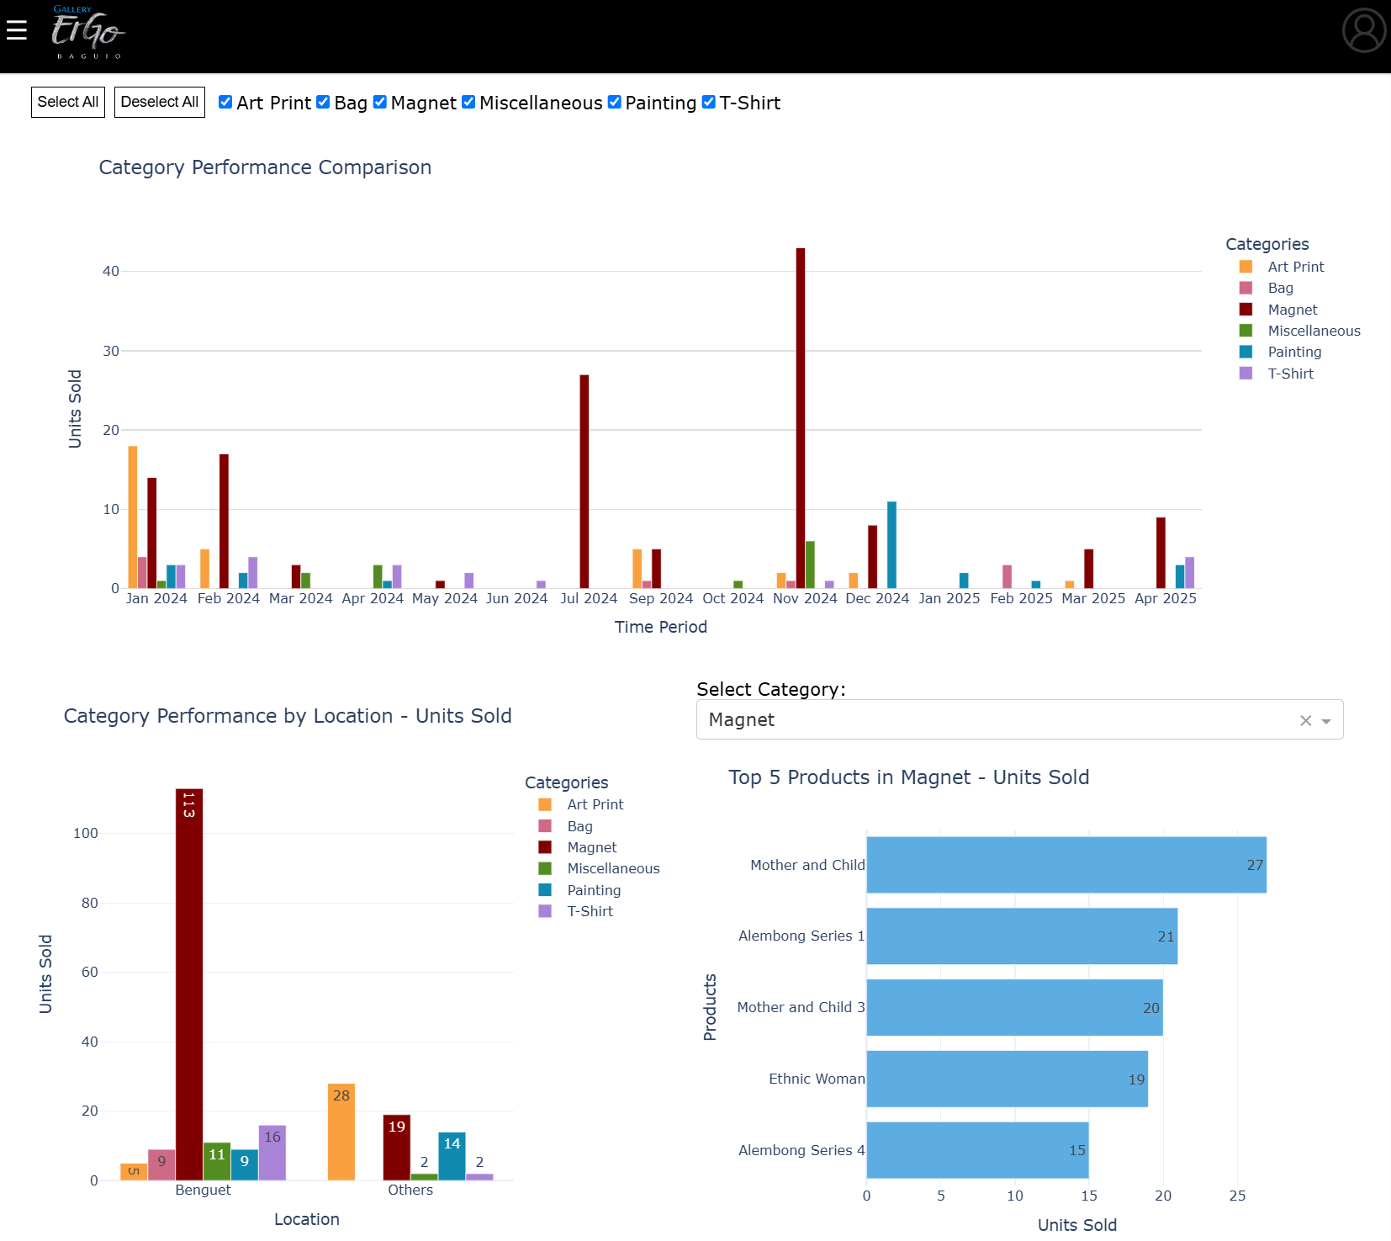**DASHBOARD CATEGORY**

The category tab displays three graphs: Category Performance Comparison grouped bar chart, Category

Performance by Location grouped bar chart, and Top 5 Products per Category horizontal bar chart.

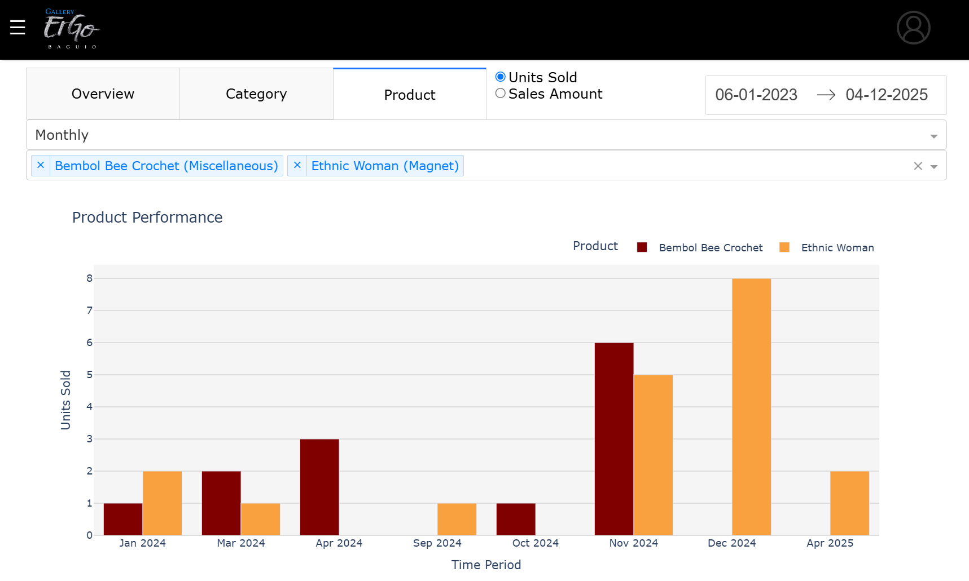

**DASHBOARD PRODUCTS**

The products tab allows the admin to search for and view the performance of up to 5 products for comparison. This can be done by clicking on the input field below the time aggregation dropdown button and searching for the product’s name or category. If a searched product does not appear in the graph, it means no sale has been made with that product.

Appendix I

Documentation



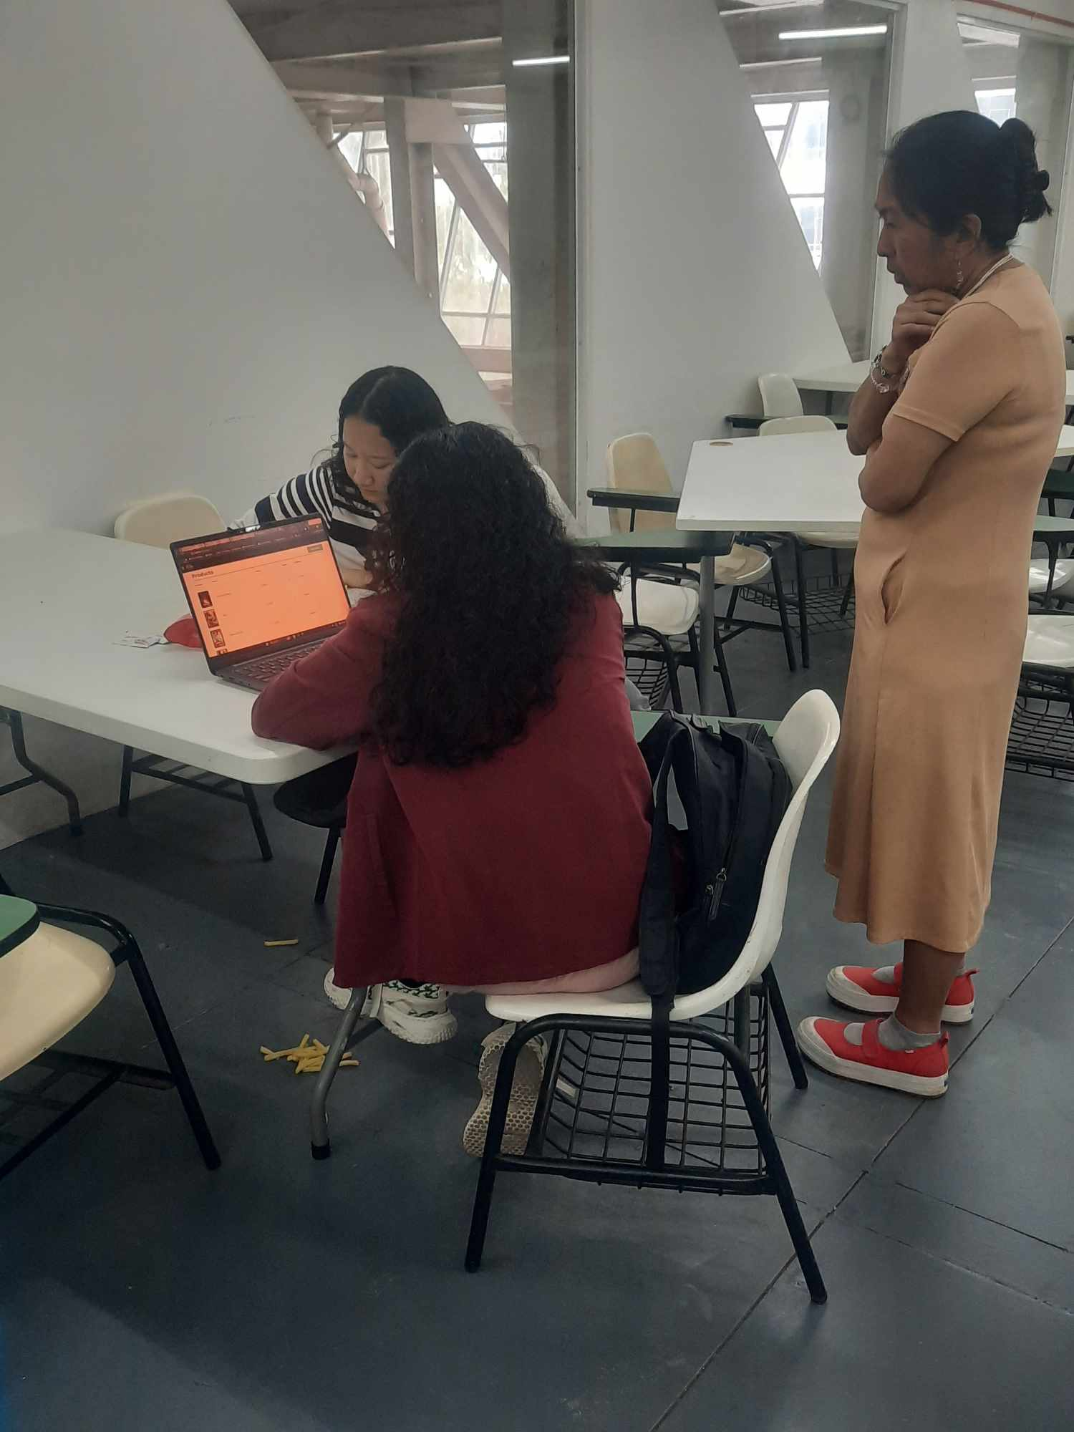





Appendix J

Important Codes

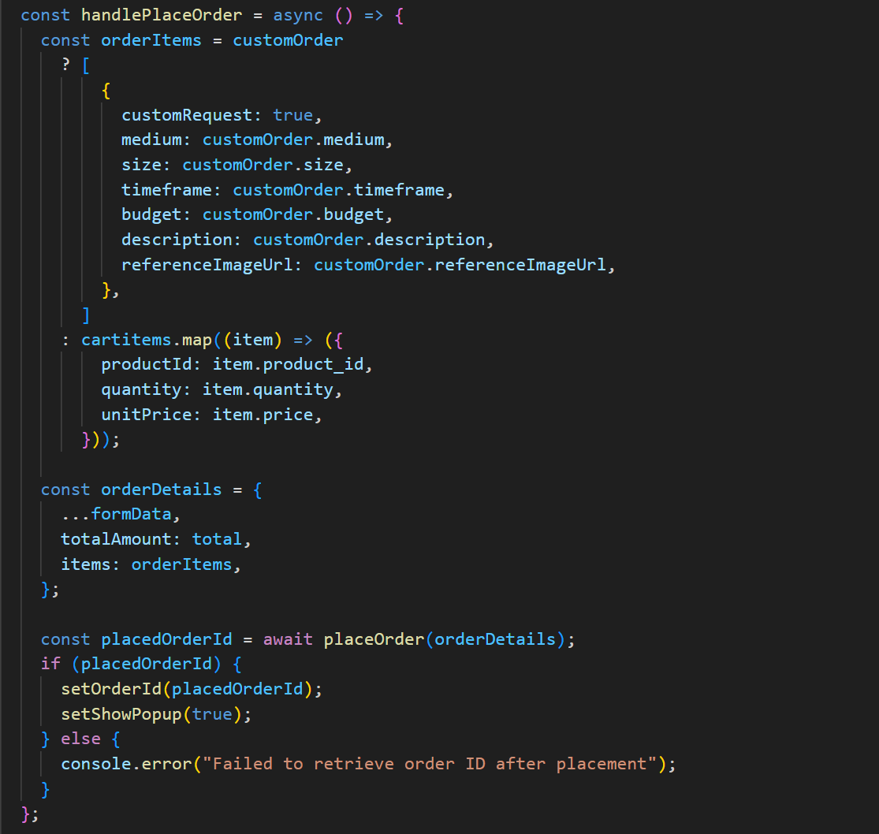

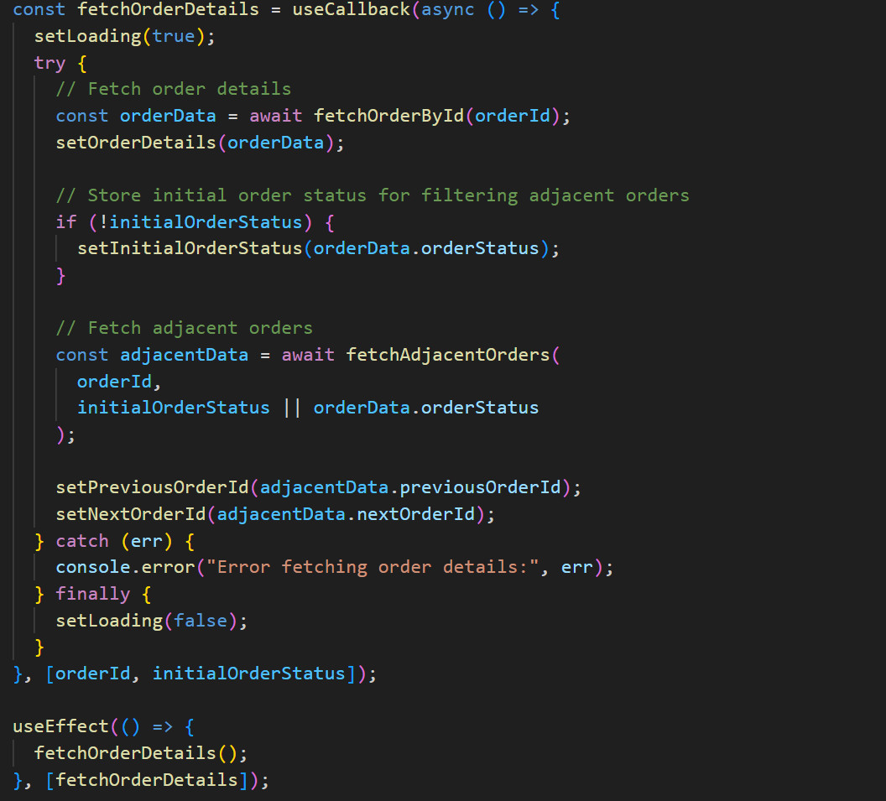

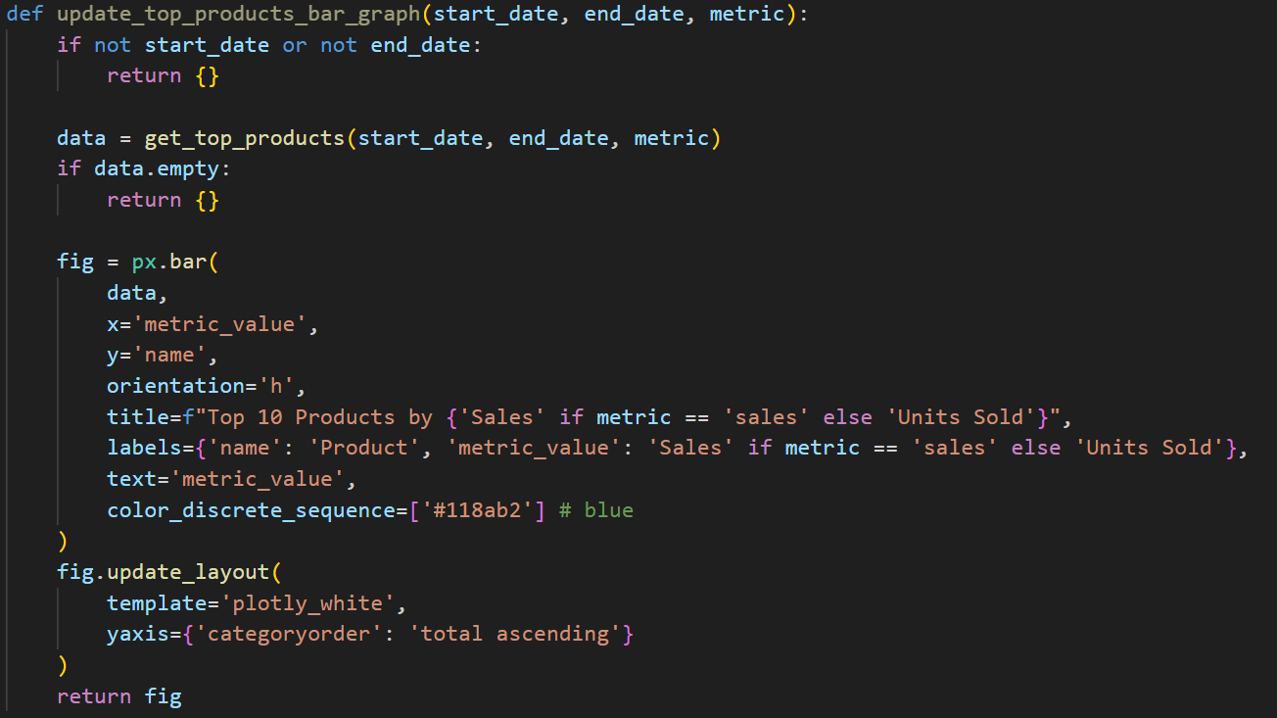

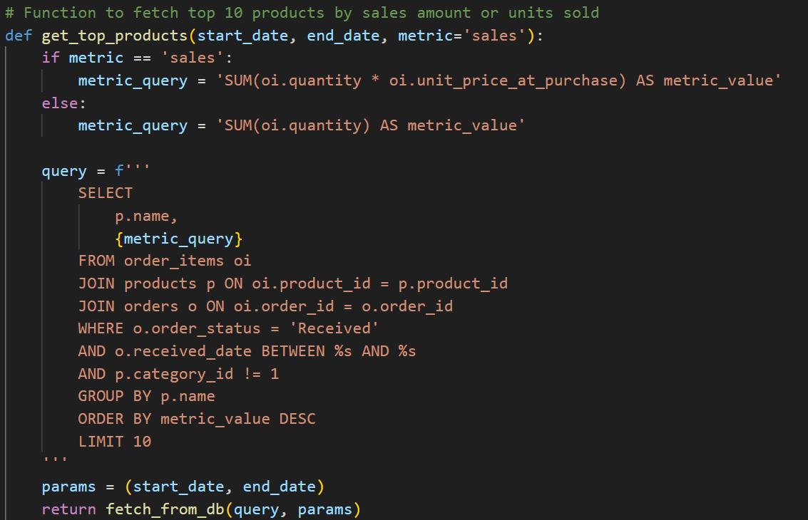

**CURRICULUM VITAE**

|  |  |  |
| --- | --- | --- |
| **AISHA G. RAJA**  - 42 Tony Agpaoa, Camp 7, Baguio City  ( +639476619402  : aisharaja3139@gmial.com | |  |
|  | | |
| **EDUCATIONAL ATTAINMENT** | | |
| **Tertiary** | **: Bachelor of Science in Information Technology**  **: Enterprise Resource Planning**  **:** University of the Cordilleras  : Gov. Pack Rd., Baguio City  **:** Expected Date of Graduation: September 2025 | |

|  |  |  |
| --- | --- | --- |
| **Secondary** | **:** University of the Cordilleras  **:** Gov. Pack Rd., Baguio City  : September 2022 | |
| **Primary** | : Doña Aurora H. Bueno Elementary School  : Camp 8, Baguio City  : March 2016 | |
| **SKILLS AND QUALIFICATIONS** | | |
| * Certified Information Technology Professional (FE) * Certified Proficient in Basic Office Productivity Tools * Knowledgeable in Frontend and Backend web development * Knowledgeable in React, Express, Node.js, and Dash Python Framework * Knowledgeable in different languages: Python, JavaScript, and Java * Knowledgeable in SQL * Strong leadership skills | | |
| **SEMINARS and TRAININGS ATTENDED** | | |
| * Agile Explorer by IBM * Data Science 101 by IBM * Big Data 101 by IBM * Basic Principles of Design by Adobe and IBM * Project Management Fundamentals by IPMA and IBM * Use Functions, Formulas, and Charts in Google Sheets by Google Cloud * Business Intelligence with Power BI Desktop End-to-End Solution * Exploring SAP Intelligent Agriculture by SAP * Transitioning to SAP S/4HANA for Utilities by SAP * Discovering SAP Ariba Contracts by SAP | | |
| **PERSONAL INFORMATION** | | |
| Date of Birth | | : April 16, 2004 |
| Age | | : 21 years old |
| Height | | : 5’1” |
| Weight | | : 50 kgs. |

|  |  |
| --- | --- |
|  |  |

|  |  |  |  |
| --- | --- | --- | --- |
| **JARED RAINIER M. SANTOS**  - #5D Sto. Nino, Bakakeng Central,  ( +639386240827  : jrmsantost12@gmail.com | | | Open photo |
|  | | | |
| **EDUCATIONAL ATTAINMENT** | | | |
| **Tertiary** | **: Bachelor of Science in Information Technology**  **: Network & Security Track**  **:** University of the Cordilleras  : Gov. Pack Rd., Baguio City  **:** Expected Date of Graduation: September 2025 | | |
| **Secondary (Senior High)** | **:** University of the Cordilleras  **:** Gov. Pack Rd., Baguio City  : September 2022 | | |
| **Primary** | : Dontogan Elementary School  : Dontogan, Baguio City  : April 2016 | | |
| **SKILLS AND QUALIFICATIONS** | | | |
| * Knowledgeable in basic switch and router configurations * Familiar with basic Microsoft Office tools | | | |
| **SEMINARS and TRAININGS ATTENDED** | | | |
| * Business Intelligence with Power BI Desktop End-to-End Solution * Common Cybersecurity Tools | | | |
| **PERSONAL INFORMATION** | | | |
| Date of Birth | | : April 09, 2004 | |
| Age | | : 20 years old | |
| Height | | : 5’7” | |
| Weight | | : 75.50 kg | |

|  |  |  |
| --- | --- | --- |
| **LOVELY MAE L. CHOLIN**  - #No 37 purok 5 brgy Ambiong Aurora Hill  Baguio City  ( +639381587114  : lovely.mae.cholin@gmail.com | |  |
|  | | |
| **EDUCATIONAL ATTAINMENT** | | |
| **Tertiary** | **: Bachelor of Science in Information Technology**  **: Network & Security Track**  **:** University of the Cordilleras  : Gov. Pack Rd., Baguio City  **:** Expected Date of Graduation: September 2025 | |
| **Secondary** | **:** Access Computer College  **:** Altan, Km21 Quirino Highway Novaliches, Novaliches, Quezon City, 1118 Metro Manila  : September 2022 | |

|  |  |  |
| --- | --- | --- |
| **Primary** | : Montessori Heights Christian School  : P3W6+QG4, Sunrise st, Maligaya, subd, Caloocan, 1441 Metro Manila  : March 2016 | |
| **SKILLS AND QUALIFICATIONS** | | |
| * Knowledgeable in CISCO LAN Switches and routers, installation and configuration (CCNA1 to CCNA 4) * Knowledgeable in Basic Video Editing and Graphic Design (Canva, Filmora) * Knowledgeable in Basic Office Productivity Tools * Basic knowledge in Programming (Python) * Strong attention to detail | | |
| **SEMINARS and TRAININGS ATTENDED** | | |
| * Business Intelligence with Power BI Desktop End-to-End Solution * Cybersecuriy for Critical Information Infrastructure Organization * Stay Safe Online: Cybersecurity Basics * CYBERSECURITY 101 | | |
| **PERSONAL INFORMATION** | | |
| Date of Birth | | : October 20 2004 |
| Age | | : 20 years old |
| Height | | : 5’3” |
| Weight | | : 77 kgs. |